Adding Rolled over Holiday into an Allowance

To access the system, click 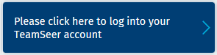 the log in button and enter your single sign on details.

When logged into the system, click on the tab for “My Admin” along the top ribbon.
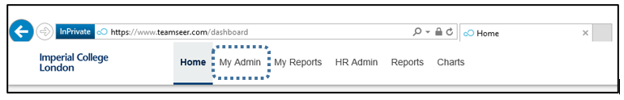

This page will always display your own details as a default view.
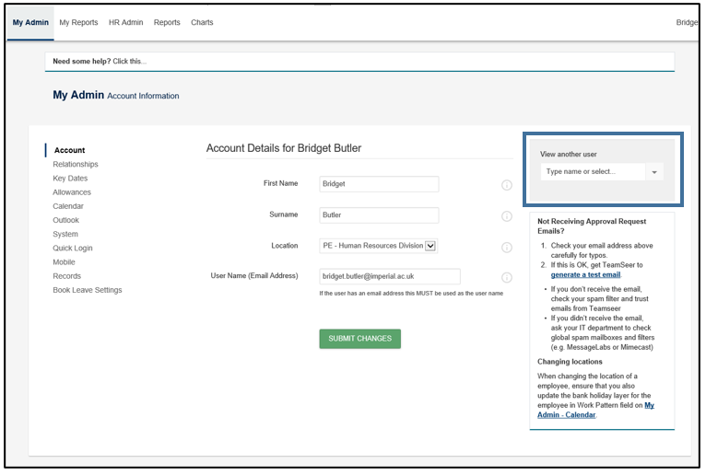

You will need to bring up the record for the individual who you wish to enter bought holiday allowance for. To do this, on the right hand side of the page you should see a box for “View another user” and enter the surname or CID.
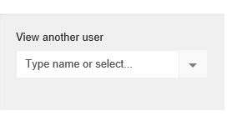
Once the staff member name has been selected the page will then automatically update to show the details of that individual;

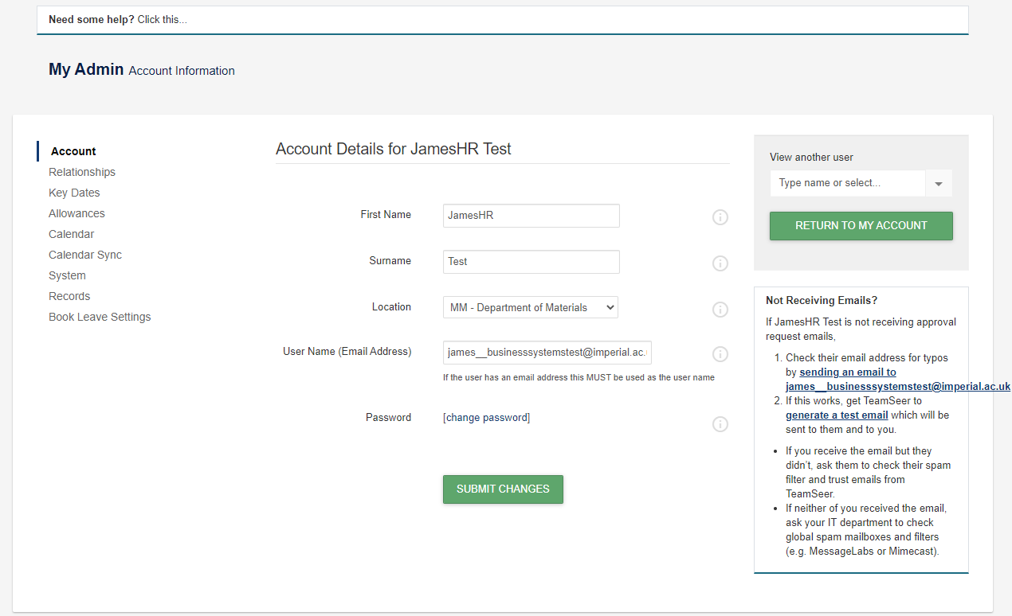

On the left-hand side of this page the following menu will be displayed and will currently be on the Account section. To add in additional bought leave to an individual’s allowance, click on the Allowances section;
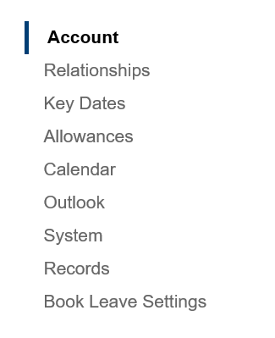

The current allowance details for that individual will be displayed.
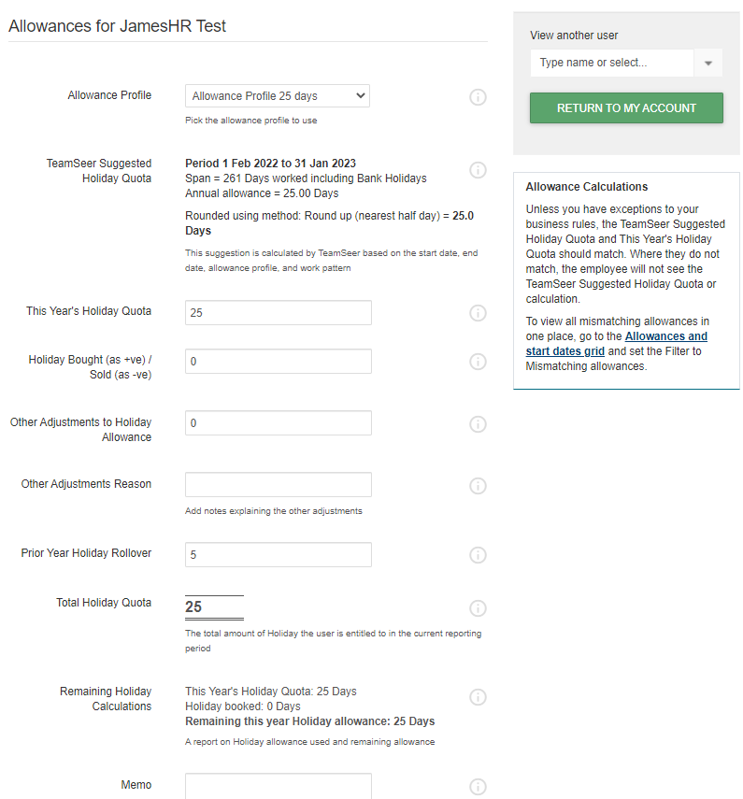
In the Rollover process up to 5 days holiday entitlement can be rolled over into the Prior Year Holiday Rollover field in day or hours.
DAYS:
HOURS:

- Add or adjust carried forward leave balance (approved by the department) in the Prior Year Holiday Rollover field
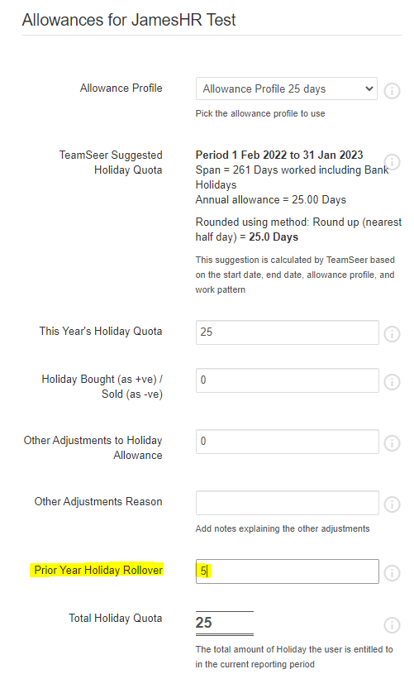

- Click into the Prior Year Holiday Rollover field and type the new allowance

Scroll to the bottom of the page and hit the green Submit Changes button to re-calculate the new allowance.
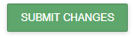
The allowance page will be refreshed with the Total Holiday Quota field updated with the new allowance;

