Adding an Admin Assistant

When to use the Admin Assistant field: Admin assistant permission allows the user to work on behalf of the Line Manager to approve planned Leave (like holidays or working from home) requests.

Who can set up an Admin Assistant: Departments Leave and Absence Administrators, HR Staff Hub or the HR Systems Team.

How does the Admin Assistant work: An Admin assistant needs to be added to the Line Manager’s profile, allowing the admin assistant to receive alerts for all the line manager’s direct reports.

Steps to assign an admin assistant against a line manager

- Click on the My Admin page and use the View another user search box to type in and select the Line managers name
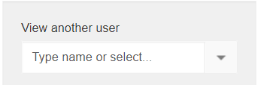

- Select Relationships.
*There are two different page types that can be seen if adding in a Line manager Admin Assistant.

  - Standard record
    - With two fields: the Line Manager and Admin Assistant
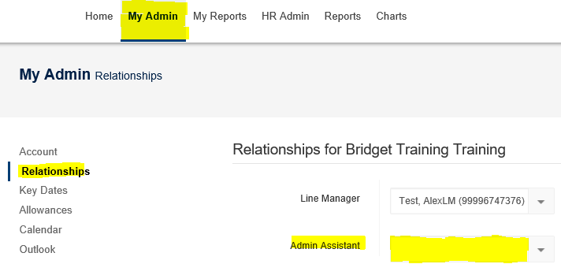

  - Management record (such as Head of a Department or Senior Manager). This will hold an extra line that shows the line manager own admin assistant.
    - With three fields: the Line Manager, the Line Managers own Admin Assistant and Admin Assistant
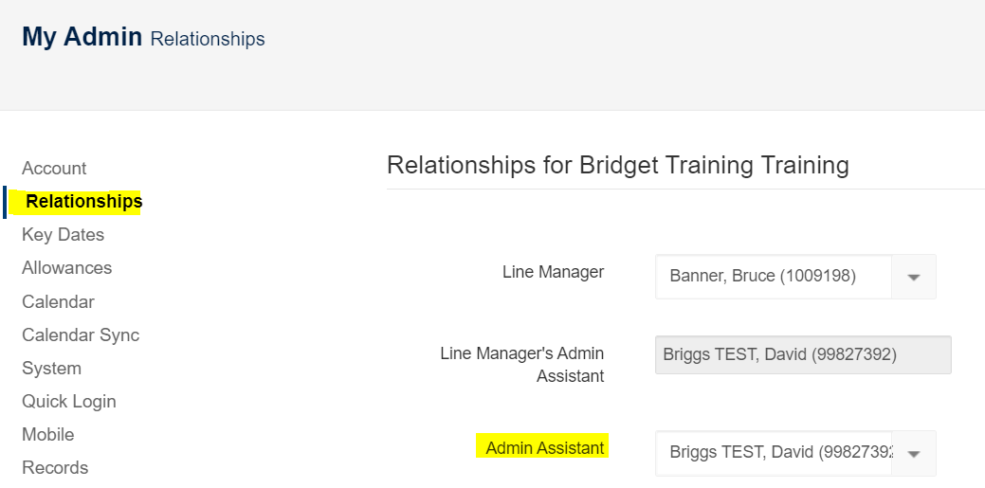

- Click into the Admin Assistant field and type name (or CID number). From the drop down box, search results select the appropriate name.
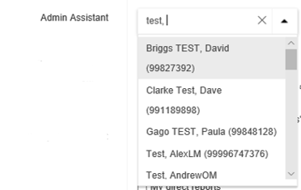

- Scroll down the page and hit the green button

APPROVERS WILL HAVE THE REQUESTS SITTING IN THE TASK LIST ON THE TEAMSEER HOME PAGE
When a Line Manager’s TeamSeer calendar is showing any of the below when a staff member submitted a planned leave request, the TeamSeer EMAIL notification will be sent to:
- No Leave book - Email notification is sent to the Line Manager.
- On Holiday - Email notification sent to both the Line Manager and Admin Assistant.
- Working from Home – Email notification sent to both the Line Manager and Admin Assistant.
- Sick or (any of the) Miscellaneous types – Email notification is sent to the Line Manager.
Email notifications can be managed by the Admin Assistant
An Admin Assistant is able to locally manage when they received approval emails with one of the three options: Always, Never or Only if the primary approver (line manager) in on holiday
- Go to the My Admin page

- Select Relationships and select from the three options in the Receive alternate approval emails
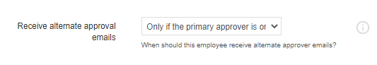
- Press the green button to save

