IMPERIAL COLLEGE

EXTERNAL INTERESTS

MANAGER APPROVAL

Table of Contents:
Approving a submitted External Interests using HR Self Service with ICIS ..………...3
Declining an submitted External Interest using HR Self Service with ICIS ..…………7

Approving a submitted External Interests via the Annual Declaration within ICIS Self Service:
The notes below provide instructions on how to approve or decline an external interest(s).

- Log into ICIS Self Service by entering your college username and password:

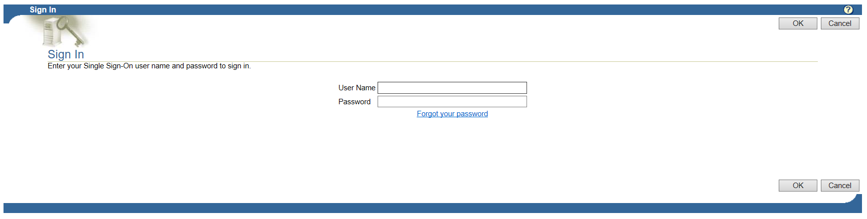

- From the Main Menu by pressing on the Click on Plus box icon to open the My Details folder to open up My Details folder and click on Annual Declarations:

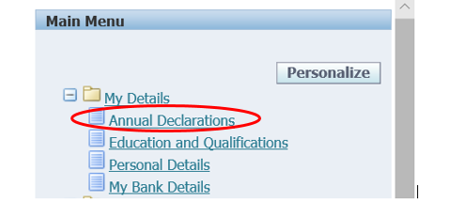

- To review approval requests, click on the View Request button:

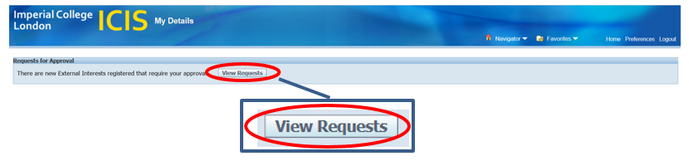

- Pending Approvals page will open with a full summary of the External Interest submitted:

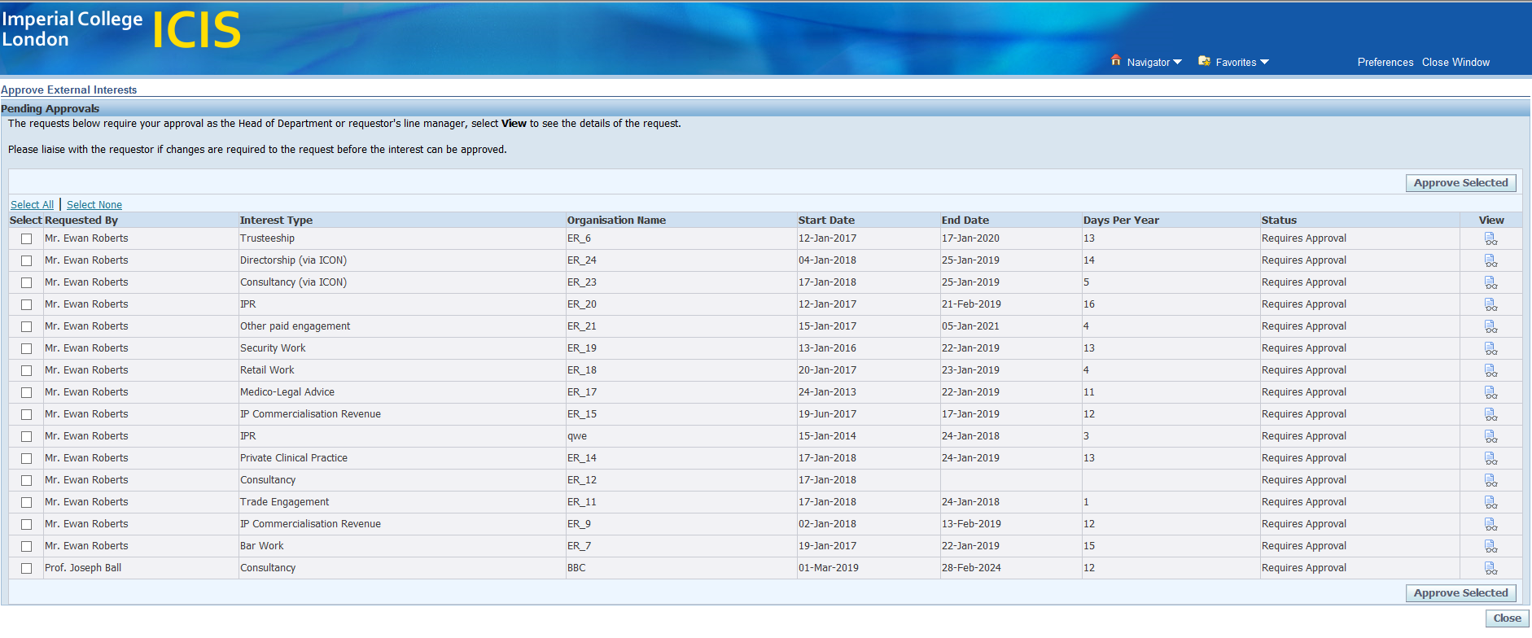
Note: As the Head of Department or line manager please liaise with the employee if changes are need to be made to a request before approving an External Interest.

- To view the full details of an External Interest click on the View icon per interest:

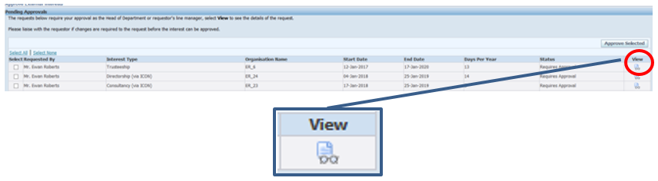

- Review and Approve/Decline External interest:

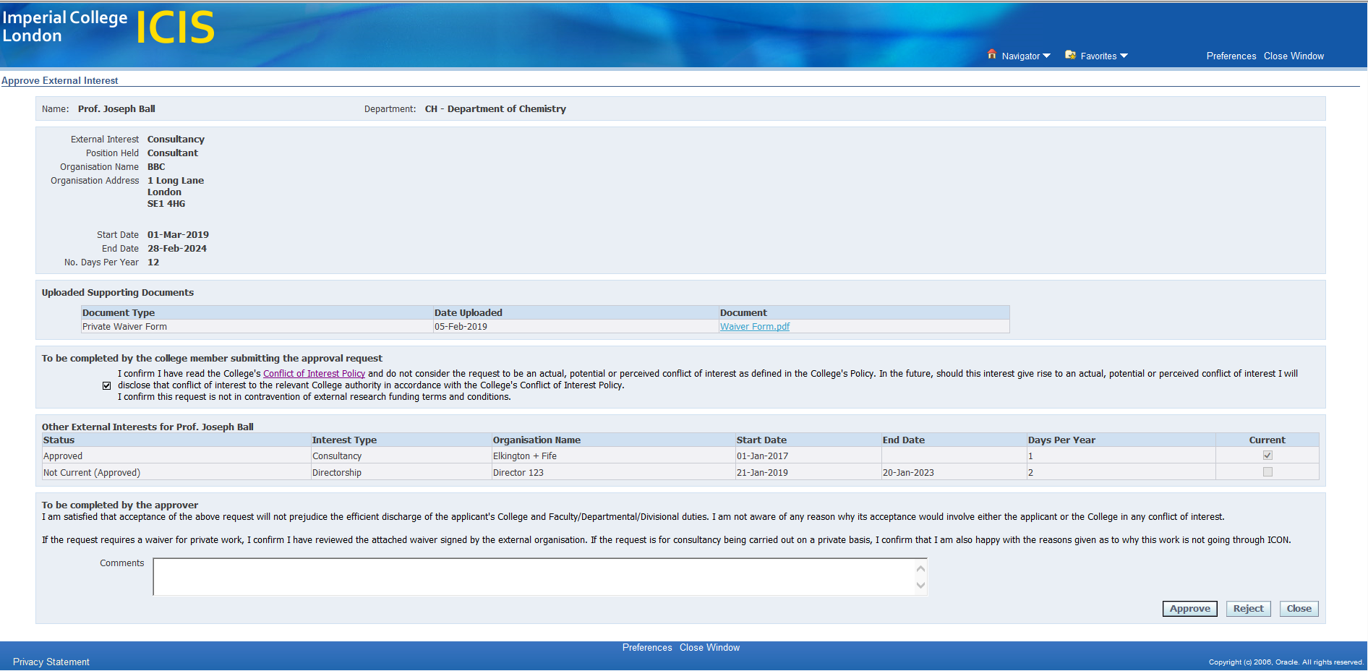
- Review Details of the External Interest
- Review supporting documents
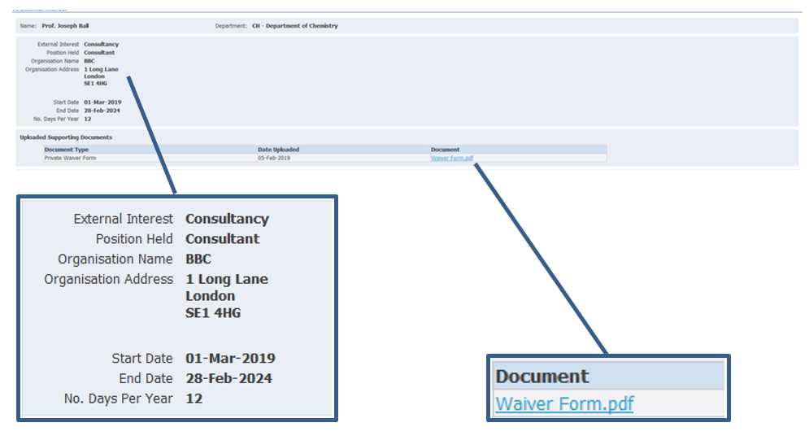

- Review conflict of Interest Policy, a tick confirms agreement to the college’s policy
- Review summary of External Interested approved and requiring approval

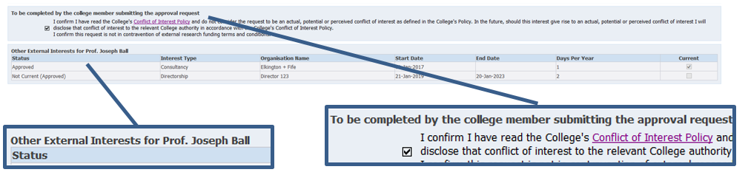

- To Approve and add any comments

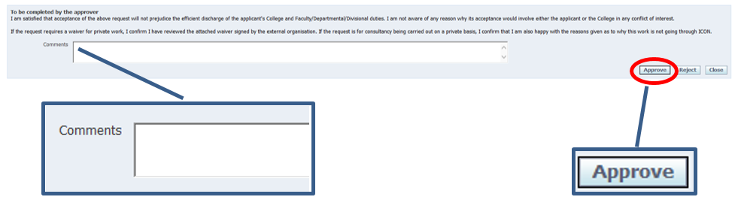

- Once approved the page will automatically return back to the Pending Approvals page and if you have further interests to approve repeat steps 5 to 6:

- To approve all in bulk:
- Select All
- Press Approve Selected

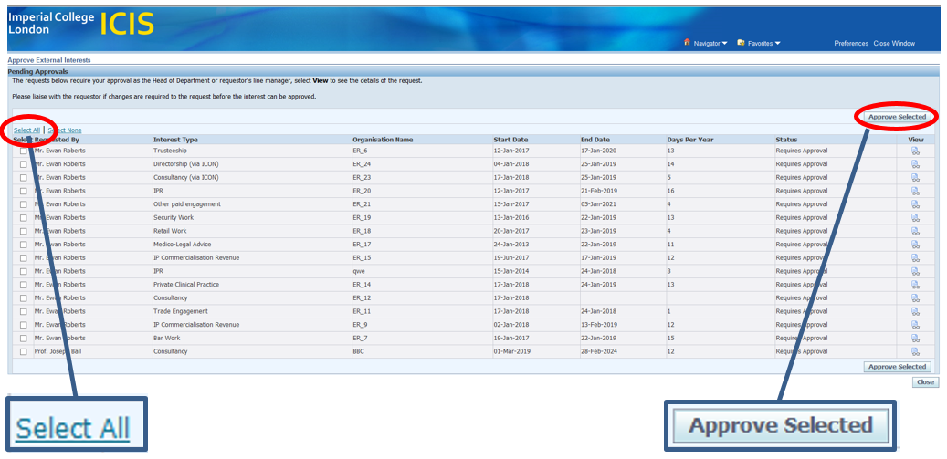

Note: Clicking on Close will return you to the Homepage without submitting any approved External Interests.

- Once submitted the page will automatically return back to a blank Pending Approvals page.

- Once submitted this will trigger an approval email as shown below.

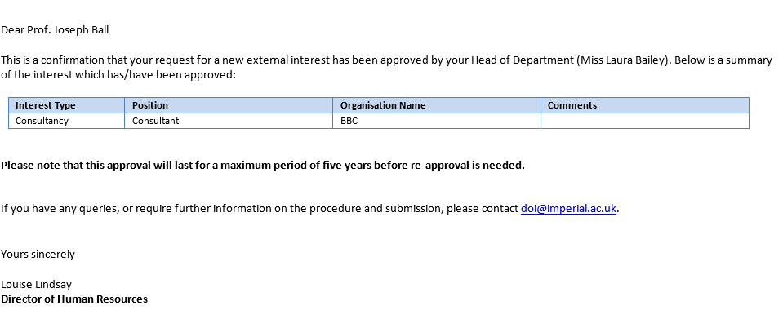

- If you wish to logout of ICIS after approving click on the Logout button in the top right hand corner.

Note: If you require any support please click on this link to contact the DOI team

Declining a submitted External Interests via the Annual Declaration within ICIS Self Service:
- Review the submitted External Interest by following steps 1 to 5:

- To decline:
  - Provide comments
  - Press the Reject button

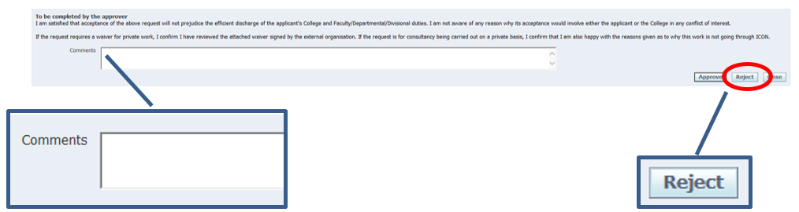

Note: Please liaise with the employee if they are only needing to make changes for an external interested to be approved

Clicking on Close will return you to the Homepage without submitting any approved External Interests.

- Once submitted the page will automatically return back to the Pending Approval page and repeat steps 12 to 13:

- Once all External Interest have been action the Pending Approvals page will blank.

- Once the rejected button has been pressed a trigger email to the employee with declining the request.

Note: If you require any support please click on this link to contact the DOI team.

