IMPERIAL COLLEGE

NOTHING TO DECLARE

NIL RETURNS

Table of Contents:
Declaration list that can all be completed within ICIS……………………………………3
Submitting a Nil Return using HR Self Service with ICIS:...……………………………..3
Submitting a Nil Return using email……..………………………………………………...5
Submitting information Governance and Security……………………………………......6
Submitting Animals Policy Declaration………………………………………………….....6
Category of employees exempt………………………………………………………….....6

Declaration of Interest
The three required declarations have been centralised under the Annual Declarations folder within Imperial College Information System (ICIS):
- My External Interests
- Information Governance and Security
- Policy on the Use of Animals Return

‘If you require further clarification on the process please click here to review the Imperial College’s ‘Register of External Interests and Annual Declaration Policy.’

Submitting a Nil Return via the Annual Declaration of Interests within ICIS Self Service:
The notes below provide instructions on how to declare a nil return.

- Log into ICIS Self Service by entering your college username and password.

Log in page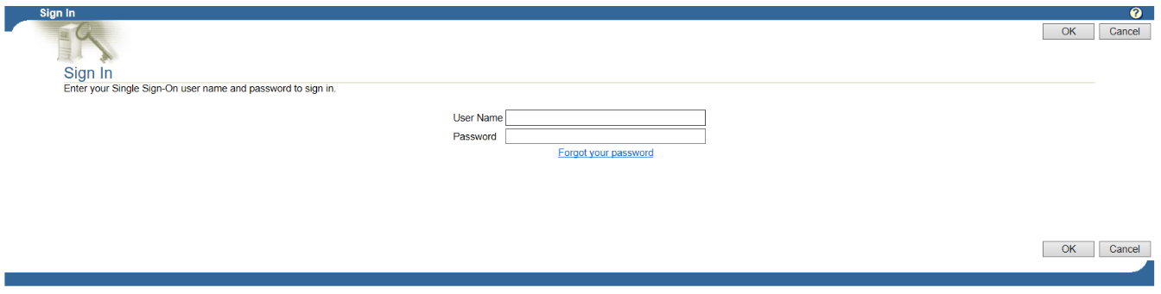

- From the Main Menu by pressing on the Click on Plus box icon to open the My Details folder to open up My Details folder and click on Annual Declarations

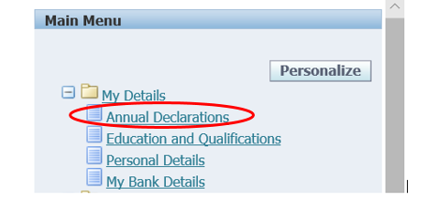

- To submit your nil return, click on the Submit Nil Return button shown below.
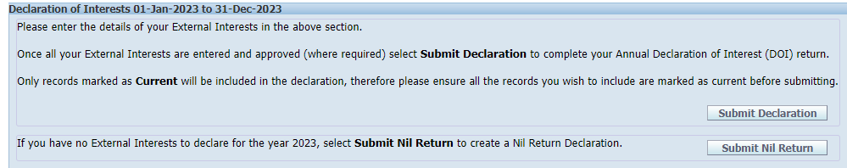

Useful links:
External Interests policy summary

Submitting a Nil Return via the Annual Declaration of Interests using email of Interest:
Email communication will go out across the college to those required to complete the Declaration of External Interests.
Example of Declaration Email sent out college wide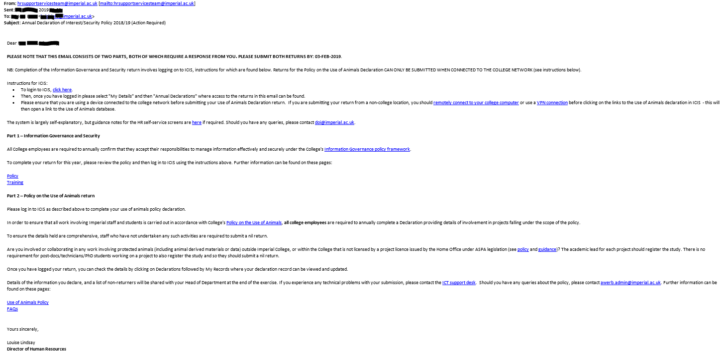

The log in link will direct you to the ICIS page and please follow steps 1 to 3.

Once submitted the page will automatically return back to the home screen with confirmation of the Nil Return Declaration.

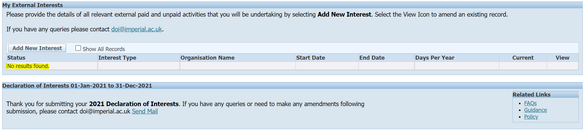

- The Status will show no results found
- A confirmation message will appear, thanking you for your submission

After submitting your Nil Return Declaration, you will be sent a confirmation email. If you have any queries or need to make any amendments following submission, please click on this link to contact the DOI team.

Submitting Information Governance and Security:

To confirm acceptance of the Information Governance and Security by
- Ticking the box
- Press Submit Acceptance

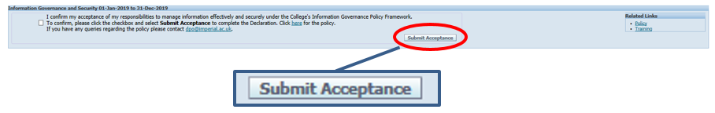

Note: Should you have any queries, please contact doi@imperial.ac.uk. Additionally guidance notes are available on the HR self-service screens.

Submitting Animals Policy Declaration:
- Completing the Policy on the Use of Animals
  - Press either
    - Nothing to Declare
    - Current Interest

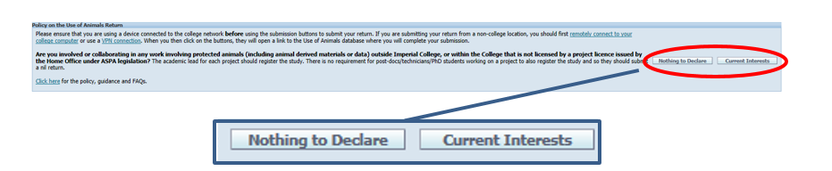

Note: Please ensure that you are using a device connected to the college network before submitting your Use of Animals Declaration return.

If you are submitting your return from a non-college location, you should remotely connect to your college computer or use a VPN connection before clicking on the links to the Use of Animals declaration in ICIS - this will then open a link to the Use of Animals database.

Should you have any queries please contact awerb.admin@imperial.ac.uk.

Category of employees exempt:
Some employees will be exempt from completed the Declaration of External Interests and for details please refer to the Imperial Colleges External Interests webpage.

