How to book unplanned absence

- Click on ‘Log unplanned absence of a colleague’:

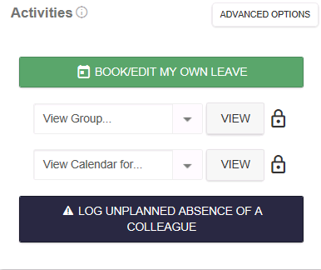

- Select who you are logging the absence for (N.B. you can log sickness for yourself)

- Complete the following questions:

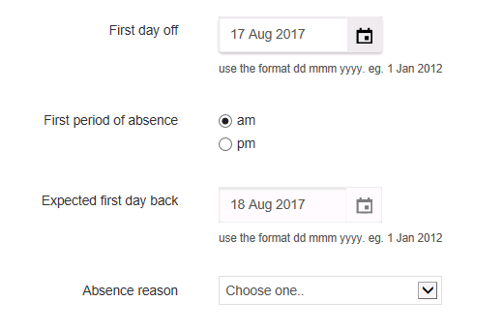

- Click submit
Useful Information
- Information on the form can be edited at a later date
- If the absence reason is unknown, select ‘other’
- The expected return date triggers a return to work form

• Expected day back will generate return to work

- Once submitted, an absence notification is sent to the absent employee and their line manager

- On the ‘expected first day back’, the absent employee will receive an email notification asking them to complete a return to work form:
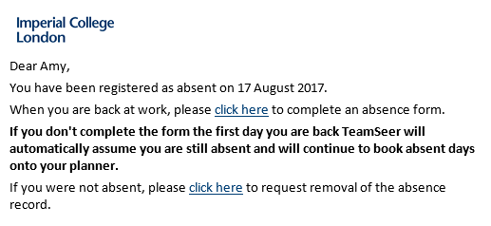

- The employee’s line manager will also receive an email notification:
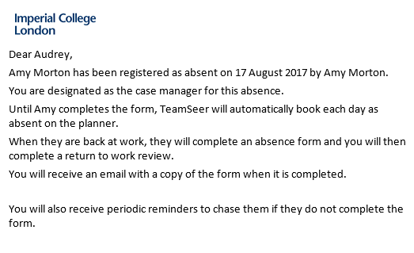

TeamSeer will continue to log the employee absent, until the return to work form is completed. Daily reminders will be sent to both the employee and line manager

- Once the form has been completed, the line manager will receive an email informing them the employee is now back at work, and must perform a back to work interview. Reminders will be visible on the TeamSeer dashboard until completed.
Payroll does not need to be notified via TeamSeer- please keep this box unticked. Sickness will continue to be reported in the standard way

- The unplanned absence is fully completed

