Questioning and listening skills questionnaire

An exercise to strengthen listening skills

The way in which we listen is related to many factors within our personality. This exercise is designed to help you identify your characteristic approach to listening and therefore become more of how that listening can be more accurate effective.

Step 1
- Look at the pairs of words in Table 1 below and ask yourself which word or phrase you identify most strongly.
- Tick column A if you identify strongly with the word on the left, or tick column D if you identify strongly with the word on the right.
- If you do not identify strongly with either word, decide which is more generally characteristic of your behaviour and tick either column B or C.
- Do not spend much time considering your response. Your general impression is what is required. It is important, however, to place a tick against every pair of words or phrases.

Table 1
 | A | B | C | D
Active |  |  |  |  | Reactive
Goes step by step |  |  |  |  | Gets the whole picture
Fast paced |  |  |  |  | Deliberate
Experiments |  |  |  |  | Cautious
Carries out ideas |  |  |  |  | Has ideas
Seeks change |  |  |  |  | Seeks stability
Animated |  |  |  |  | Reserved
Talks to |  |  |  |  | Listens to
Answers |  |  |  |  | Asks
Improvises |  |  |  |  | Plans
Pragmatic |  |  |  |  | Idealistic
Ends |  |  |  |  | Means
TOTALS (no. of ticks)
A | B | C | D

Step 2
This is a repeat of Step 1, but with a different set of words or phrases. As in Step 1, place a tick in the outer columns E or H if you identify strongly with the word closest to the column (Table 2).
Tick an inner column if the identification is weak.

Table 2
 | E | F | G | H
Personal |  |  |  |  | Impersonal
Emotional |  |  |  |  | Intellectual
Opinions |  |  |  |  | Concepts
Discusses |  |  |  |  | Analyses
New Experiences |  |  |  |  | New ideas
Accepting |  |  |  |  | Questioning
Feels |  |  |  |  | Thinks
Intuition |  |  |  |  | Logic
Risks |  |  |  |  | Calculates
Trial & Error |  |  |  |  | Planning & Organising
People |  |  |  |  | Tasks
Supportive |  |  |  |  | Critical

TOTALS (no. of ticks)

E | F | G | H

Step 3

Scoring the exercise

In Tables 1 and 2, add the number of ticks in each column and enter the totals in the box at the foot of the column.

Note the letter of the column in each Table with the highest score (e.g., column B in Table 1 and column H in Table 2).

Now turn to Chart 1 on the next page and shade in the box where your two letters coincide.

If your scores are tied for first place in either table, shade in both boxes (e.g., columns B and C in Table 1 and Column H in Table 2 means shading boxes BH and CH).

The shaded box(es) in Chart 1 gives an indication of your characteristic approach to listening and problem solving on two axes:

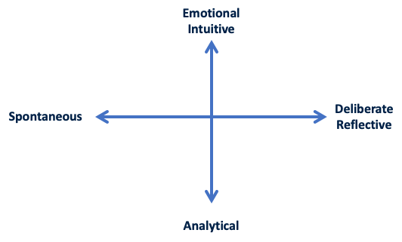

Chart 1 –
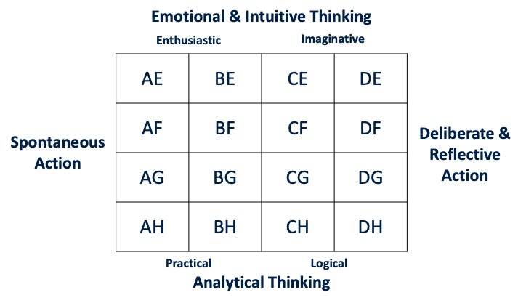

According to the position of your shaded box(es), it will suggest an approach to listening and problem solving which tends towards the:
- Enthusiastic
- Imaginative
- Logical
- Practical

The nearer the centre of the Chart, the more ‘in balance’ your style may be. The closer to each corner of the Chart, the stronger your style of listening on that axis. However, there are NO right or wrong responses; each style has strengths, and each has potential dangers. It is understanding of your own style that you can maximise the positive aspects and minimise the effects of the negatives. Knowing your listening style may enable you to determine those occasions/situations when you must either resist making, say, a snap judgement and listen some more or come to a decision based on a valued interpretation of what you have heard.

The Positives and Negatives of Listening Style Characteristics

Logical

POSITIVE | NEGATIVES
Organised – is prepared to listen, take notes and adjusts to the person’s style | Listens for facts and screens out themes and ideas
Review what has been heard and takes steps to aid recall | Seeks proof and evidence before acting out doubts, argues
Summarises | Processes information serially step-by-step
Considers alternatives | Over cautious
Works well alone | Clings tenaciously to old ideas
Looks for benefits | Lacks self-awareness and fails to recognise when ‘tuning out’

Practical

POSITIVE | NEGATIVES
Sees problems as normal and is not put off by difficult material | Does not discriminate: runs with the ball
Balances facts and ideas and looks for linkages | Impatient: tunes out if subject matter is not seen as relevant
Challenges, looks for options and weighs the evidence | Doesn’t test to understand
Sets personal goals which are realistic | Looks for facts rather than ideas
Reserves judgement and stays with the problem until a personally satisfying resolution can be worked out | Looks for cues for action rather than foundations for ideas

Enthusiastic

POSITIVE | NEGATIVE
Opportunist: ‘What’s in it for me?’ | Does not discriminate: responds to ‘grabbers’ and jumps to conclusions
Actively involves others and is naturally inclined towards listening | Prone to over commitment: to get this person to listen to you, you have to catch them
Listens for new ideas | Easily distracted
Looks for a variety of choice | Demanding: ‘Tell me, tell me!’
Works at listening and is an active listener

Imaginative

POSITIVE | NEGATIVE
Keeps an open mind and actively seeks alternatives | Delays action: easily deflected by ‘grabbers’ and pursues alternatives beyond the point of utility
Remembers what has been said and has recall | Does not discriminate: ignores logical good inconsistencies
Uses what has been heard and places it in perspective | Uncritical
Listens for ideas on which to build | Does not follow up on what has been heard
Self-aware: recognises when ‘tuning out’ | Easily distracted

