Exploring and understanding the pelvic organ symptoms experienced by people with neurological conditions
Participant information sheet

As someone living with a neurological condition who experiences pelvic organ problems, you have been invited to take part in a research study. Pelvic organ problems are symptoms or changes in the way your bladder, bowel or genital/ sexual organs function.

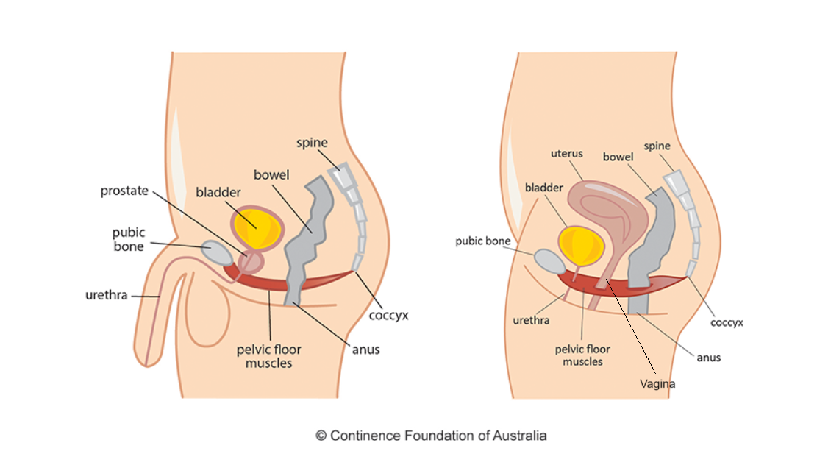
Male pelvic organs Female pelvic organs

Before you decide, it is important for you to understand why the research is being done and what it will involve. Please take time to read the following information carefully and discuss it with others if you wish.

What is the purpose of the study?
Many people living with neurological conditions suffer from pelvic organ problems. It is important healthcare professionals treating these people understand the causes of the symptoms being experienced. This helps healthcare professionals provide people with the best and most specific treatment for their problems. The current questionnaires given to people with neurological conditions and pelvic organ problems are not in depth or thorough enough to allow full understanding of the causes of these symptoms. Through this research, we hope to gain a deeper understanding of the specific symptoms experienced by individuals with various neurological conditions. The results will help to develop a questionnaire, to improve healthcare professionals identification and understanding of what is causing the neurological pelvic organ problems.

Why I have I been chosen?
You have been chosen as a person who has experience of living with a neurological condition and pelvic organ problem/s. We would like to interview about 40 people, who have different neurological conditions to understand the details of their bladder, bowel and genital/sexual symptoms. This will guide the development of an all-inclusive questionnaire.

Do I have to take part?
It is up to you to decide whether or not to take part. If you do decide to take part you will be given this information sheet to keep and be asked to sign a consent form. If you decide to take part you are still free to withdraw at any time and without giving a reason. A decision to withdraw at any time, or a decision not to take part, will not affect the standard of care you receive.

What will happen to me if I take part?
Interview
We will interview you once at either St Mary’s Hospital Paddington; Charing Cross Hospital Hammersmith or Hammersmith Hospital, White City; whichever is easier for you. This should last about 45 minutes to an hour. We would like to do the interviews in person where possible, however if it would be easier for you, we can also complete the interviews online, using Microsoft teams. We can do the interview at a time and date that suits you. Everything we say in the interview will be recorded and then what we’ve said will be typed out onto a computer record. We will spend time looking at these records and summarising the main things that were said. We will also some collect some information about your age, ethnicity and other demographic data, which remains confidential, which we will review regularly to make sure we interview a diverse group of people.

Once you have completed your interview, your involvement in this research will end.

Reimbursement and support
We will reimburse you for any reasonable travel costs for the interview and support for mobility or hearing impairments can also be arranged to help you attend the interview.

What are the possible disadvantages and risks of taking part?
You may find answering questions in the interviews difficult, if you are struggling to cope with these symptoms or if they are impacting your life in a negative way. We can help to signpost you to your GP or the nationwide NHS Talking Therapies Services, to provide you with emotional support, as needed. The website for the NHS Talking Therapies is below should you need it. You are also free to leave the interview or study at any point. If having already been involved, any data already collected with consent would be retained and used in the study. The interview will take place in a private room in the therapies department. We will follow the Imperial College Healthcare NHS Trust policies and Data protection Act 2018, to make sure your information is kept confidential.

What are the possible benefits of taking part?
While there may not be direct and immediate benefits to you, by completing this interview, you will have the opportunity to share your symptoms of living with neurological conditions and pelvic organ problem which is valuable. By sharing your experiences with pelvic organ problems related to your neurological condition, you'll help us develop a questionnaire that will improve healthcare professionals understanding and help us provide better care to others facing similar challenges.

How will we use information about you?
We will need to use information from you and/or from your medical records your for this research project. This information will include your name, contact details and provide a bullet list of identifiers held by site and/or sponsor for the research.
People will use this information to do the research or to check your records to make sure that research is being done properly and the information held is accurate. People who do not need to know who you are will not be able to see your name or contact details. Your data will have a code number instead. We will keep all information about you safe and secure.

Once we have finished the study, we will keep some of the data so we can check the results. We will write our reports in a way that no-one can work out that you took part in the study.

The recording of your interview will contain your anonymised study code. This can only be linked to your name through a consent form, which will be locked in a filing cabinet in a locked office at Imperial College Healthcare NHS Trust. Any electronic data will be stored securely in an Imperial College Healthcare NHS Trust approved, password protected electronic storage.

The recording of your interview will be sent to an approved and trusted external company, Way with Words (who will sign a confidentiality agreement) to be typed up into a written document. We will try not to mention individual names and places in the interview, but in case we do, the company will remove these from the written document. The interview recordings will be kept until the end of the study and will then be deleted.

A summary of the characteristics of the people being interviewed (e.g. age, gender, ethnicity and condition will be included in any research report, but not in a way that you can be identified. Anonymous word-for-word quotes from the interview may be used in any reports of the research. All research data, which has not been deleted will be stored at Imperial College Healthcare NHS Trust for 5 years after the end of the study. It will not be shared with other researchers to support other research projects in the future.

What if something goes wrong?

Imperial College Healthcare NHS Trust holds standard NHS Hospital Indemnity and insurance cover with NHS resolution for NHS Trusts in England, which apply to this study. This does not affect your legal rights to seek compensation.

If you are harmed due to someone’s negligence, then you may have grounds for a legal action. Regardless of this, if you wish to complain, or have any concerns about any aspect of the way you have been treated during the course of this study then you should immediately inform the Investigator

The normal National Health Service complaints mechanisms are also available to you. If you are still not satisfied with the response, you may contact the Imperial AHSC Research Governance and Integrity Team.

In this research study we will use information from you and/or your medical records. We will only use information that we need for the research study. We will let very few people know your name or contact details, and only if they really need it for this study.
Everyone involved in this study will keep your data safe and secure. We will also follow all privacy rules. Everyone involved in this study will keep the data collated as part of this study, including your personal data, safe and secure. We will also follow all privacy laws and legislation that are relevant to the specifics of the study.
At the end of the study we will save some of the data in case we need to check it and/or for future research. We will make sure no-one can work out who you are from the reports we write.

What are your choices about how your information is used?
You can stop being part of the study at any time, without giving a reason, but we will keep information about you that we already have. We need to manage your records in specific ways for the research to be reliable. This means that we won’t be able to let you see or change the data we hold about you
Where can you find out more about how your information is used?
You can find out more about how we use your information
- at www.hra.nhs.uk/information-about-patients
- by asking one of the research team
- by sending an email to pelvichealthresearch@imperial.ac.uk

What will happen to the results of the research study?
We will inform you if the research is to be presented at a conference, to a charity related to these conditions or published in a medical journal, by email. You will not be identified in any report or publication of this research.

Who is organising and funding the research?
The research is organised by Imperial College Healthcare NHS Trust and funded by the Imperial Health Charity and Biomedical Research Centre

Who has reviewed the study?
This study was given a favourable ethical opinion for conduct in the NHS (or private sector) by xxxx REC.

People living with neurological conditions are involved in the management of this research and they have checked this information sheet and the consent form to make sure it is understandable. As NHS patients are participating in this study, it has also been looked at by an independent group of people, called a research ethics committee, to protect your interests.

Contact for further information:
If you are a) a person living with a neurological condition and you experience pelvic organ problems as a result, b) are able to attend an interview in London or using Microsoft teams and are interested in taking part: Please contact Katie Webb, in whichever way suits you best, using the details below so we can discuss it further. Please ask us if there is anything that is not clear or if you would like more information.

Once you have time to consider all the information, if you wish to participate, you will be given a consent form to read and sign. Taking part is voluntary and you are free to withdraw at any time without giving any reason, without your medical care or legal rights being affected

NHS Talking therapies website: www.england.nhs.uk/adults/nhs-talking-therapies/

Thank you for reading this information sheet and considering taking part in this study

This study is being sponsored by Imperial College London.
This study is being organised as part of a pre-doctoral fellowship, by Katie Webb, Pre-Doctoral Fellow.
For further information, please contact me at:
Email: pelvichealthresearch@imperial.ac.uk
Katie Webb is funded by the Imperial Health Charity and Biomedical Research Centre

