Maintain Manager’s & ARC (Folder View)
This option gives you access to enter ARC data and change line manager details in the same folder view.
Log into IC Manager Self Service in one of the following ways:

If you do not use ICIS already: | Existing ICIS users:
1. You should use the link (http://icis.imperial.ac.uk/). Use your College network username and password to login.  - Use Unified Access or the remote desktop connection for access.  - When logging in for the first time, you will be asked to validate the login via MFA.  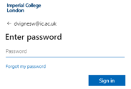  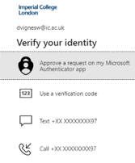  - After successful authentication, you will be redirected to the ICIS sign in page. | - You should use the link (http://icis.imperial.ac.uk/) and your College network username and password to login.  - Use Unified Access or the remote desktop connection for access.  Once logged in navigator to the Delegated Manager Self Service folder:  An example

Expand your delegated authority responsibility. N.B. this will take the format IC HR MM – Delegated MSS. The highlighted digits determine which area of records you have been given access to. For example, MM would give you access to update records for those that sit within the MM Primary HR Organisation.
Expand your delegated authority responsibility and select Maintain Line Managers & ARCs (Folder View)
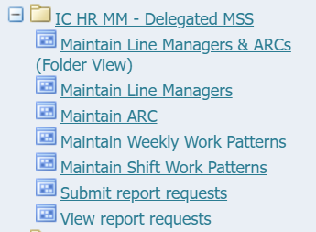
The following search window will be displayed;
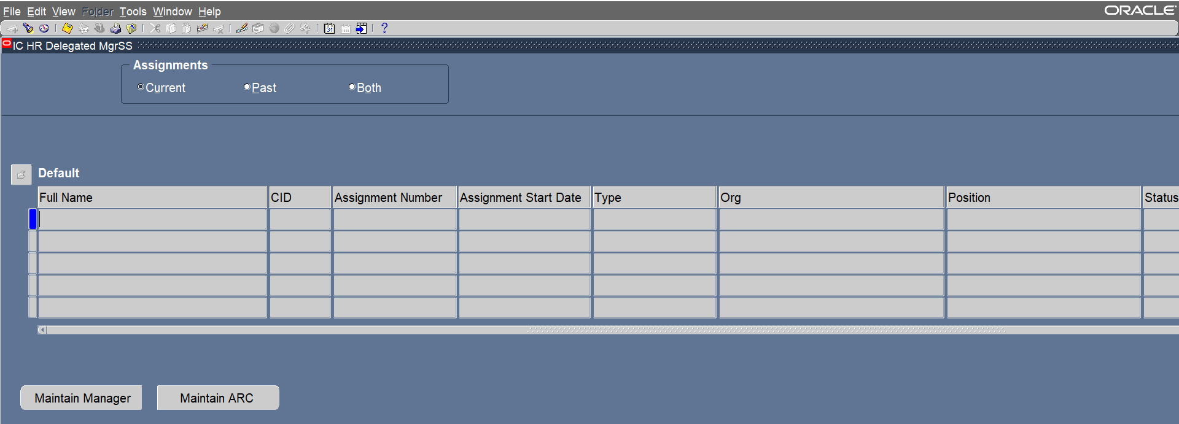
To search for the record you wish to update hit the F11 button on your keyboard. You should see that the first row has now turned light blue. This shows that the row is ready for you to search;
It is recommended to search either by the individual’s name or their CID number. If searching by their name use the format SURNAME% or if by their full name SURNAME%FIRSTNAME, e.g. LONG%LEILA
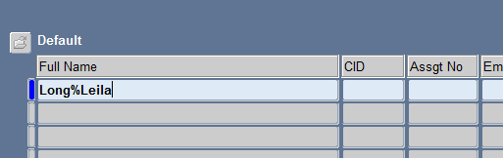

When you’ve entered your search terms, you must press CTRL F11 in order to make the system perform the search.
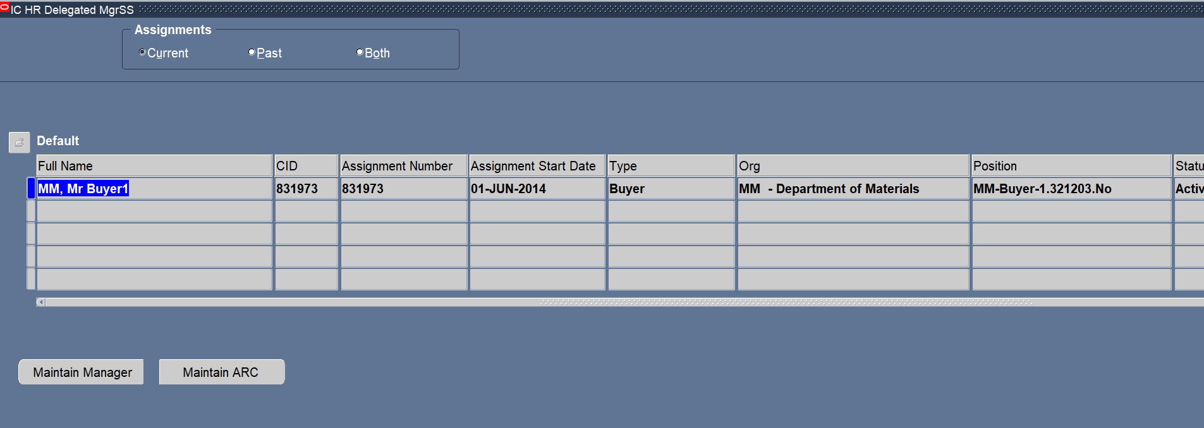

TIP: If searching by their full name, you would also need to include any middle names. Therefore it is always easiest to search just by surname or CID.
Two buttons are displayed at the bottom of the screen - Maintain Manager and Maintain ARC.

Maintain Manager
You should use this button to update the line manager details for an individual. When you hit this button, the current line manager details for the individual you searched for will be displayed;
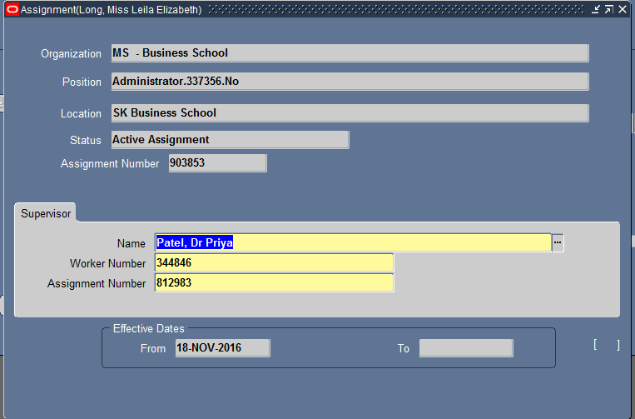

To update this information, click into the Name field on the Supervisor tab and delete out the information currently displayed;
Click on the 3 dots symbol at the end of the Name field and a search box will appear;
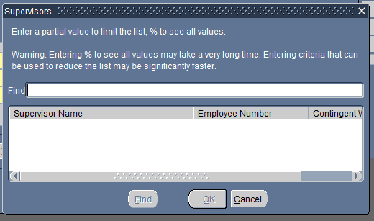
Type in the name of the new Supervisor and hit the Find button;
Select the correct new line manager from the list and hit OK.
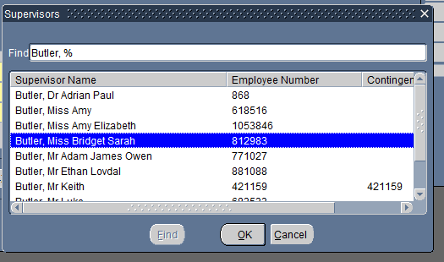

You will be asked whether you want to Update of Correct the information. Always select Update as we want to keep a record of previous line managers;

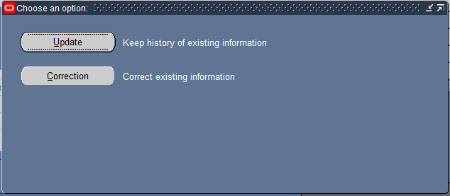

The new line manager’s name and CID will have been entered into the fields;
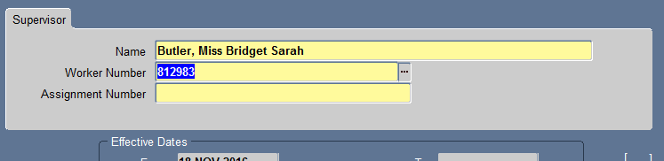
You will also need to enter the line manager’s assignment number – to do this copy and paste the CID number that has defaulted into the Worker Number field.
To save your update, hit the yellow disk icon in the grey tool bar at the top of the window;

Maintain ARC
To update or enter a ARC record for an individual use the Maintain ARC button after you’ve performed the search to bring up the record.
The previous ARC entries for that individual will be displayed, plus a new blank line opened up on today’s date. In the new line, change the Start Date field to reflect when the ARC you’re recording was carried out. Click into the Detail field against the same row.
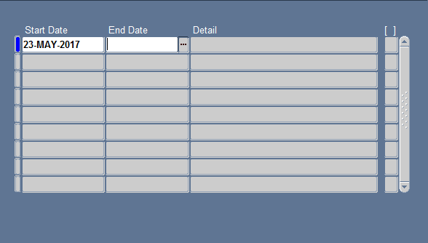
You will have 2 of 3 fields to complete.

Reviewer: Enter the name of the individual who carried out the ARC meeting. Enter this in the format SURNAME%FIRSTNAME. When you hit enter, the system will search for you and provide you with a list of matching options. Select the correct entry.
Next Review Date: This should be the date the next ARC is due. E.G. If you’ve entered 23 May 2017 as the date this current ARC was due, you should enter 31 May 2018 for the next review date.
Reason for Exemption: If for whatever reason a ARC could not be completed, but you don’t want the individual to appear on reports for non-completion you can enter a reason for exemption. To see the pick list of options for exemption, click into the field and select the 3 dots at the end;
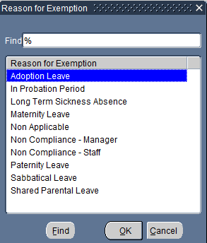
Select the appropriate entry and then hit OK.
You will be returned to the list of ARC records for that individual, and you should be able to see the entry you’ve just made;
Reviewed would have information entered into the 1st two fields and show as
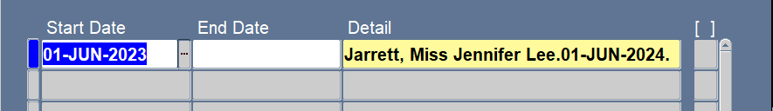
Exemption would have information in the 2nd & 3rd fields and show as
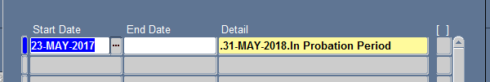

To save your entry, hit the yellow disk icon on the grey tool bar;

