Updating ARC Data

If ARC data has been entered incorrectly, you will be able amend the information through your Manager Self Service responsibility.

Log into IC Manager Self Service in one of the following ways:

If you do not use ICIS already: | Existing ICIS users:
- You should use the link (http://icis.imperial.ac.uk/). Use your College network username and password to login.  - Use Unified Access or the remote desktop connection for access.  - When logging in for the first time, you will be asked to validate the login via MFA.  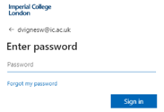  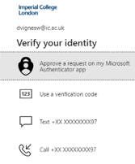  - After successful authentication, you will be redirected to the ICIS sign in page. | - You should use the link (http://icis.imperial.ac.uk/) and your College network username and password to login.  - Use Unified Access or the remote desktop connection for access.  Once logged in navigator to the Manager Self Service folder:

Expand your responsibility “IC Manager Self Service” and select “Maintain ARC details”.

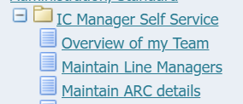

This will take you through to the page entitled “Maintain ARC Details: People in Hierarchy”. Within this list you should see all your direct reports. You will also be able to see indirect reports – i.e. those employees that your own direct reports line manage (if applicable).

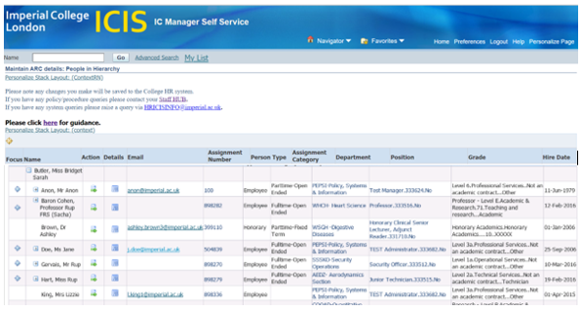

To view the ARC data for your direct reports, click on the action icon in the column labelled Action. This will take you through to a view of all ARC data that already exists for that individual.

Select the line of ARC data that needs to be amended by using the radio button at the start of the line, then click on the “Update” button ;

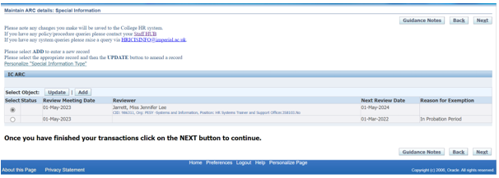

The existing ARC information that is held will be displayed;

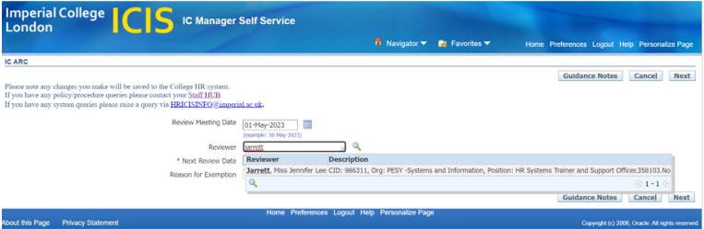

You have access to update the following fields;

- Review Meeting Date (date the ARC took place)
- Reviewer (who carried out the ARC)
- Next Review Date
- Reason for Exemption (if applicable, a list of valid exemption reasons to select from)

Update the existing information as appropriate and select Next;

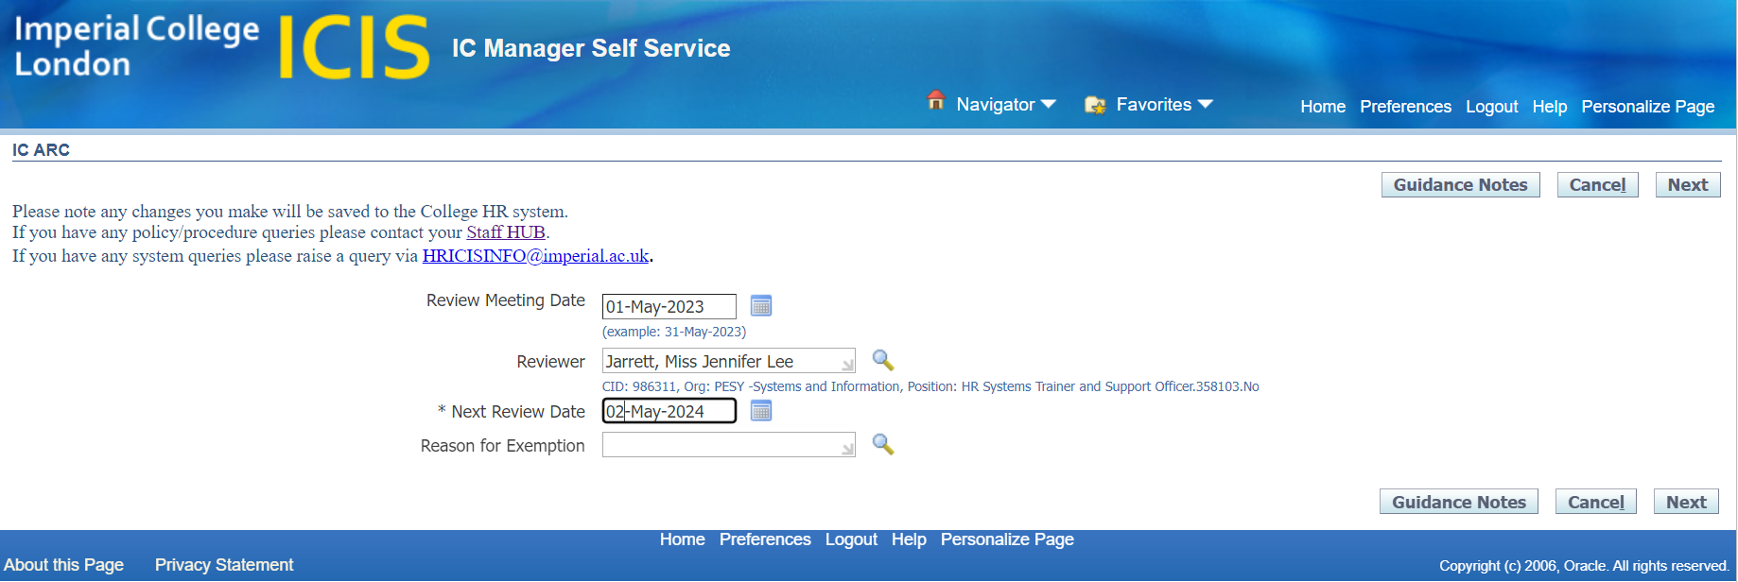

The ARC information that has been updated will show “Updated” in the status column;

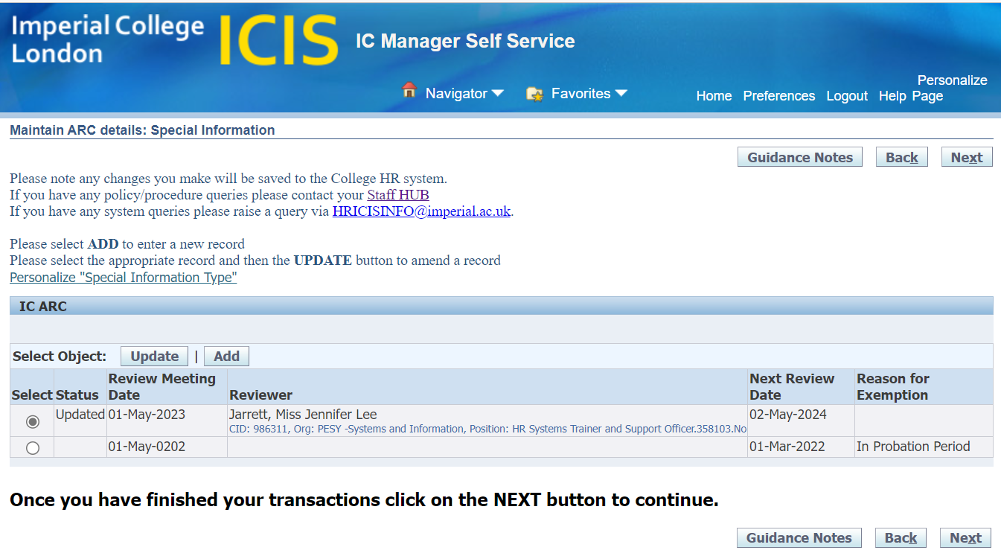

Select Next to continue with your update. A summary of what you are changing will be displayed;

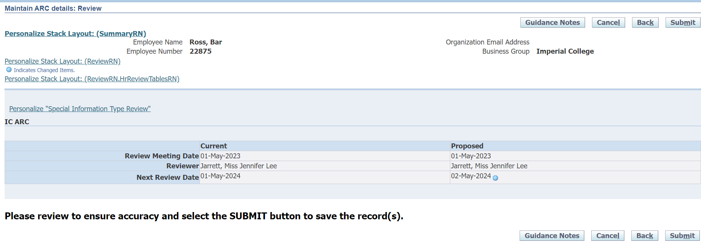

When you are happy with the changes you’ve made select Submit. Confirmation of your submission will be displayed;

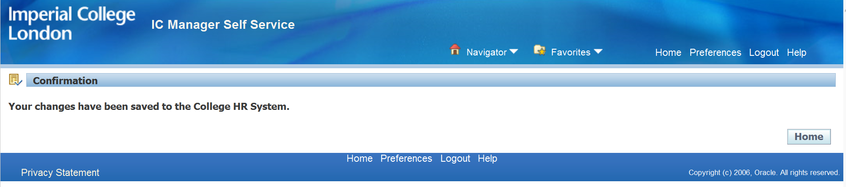

N.B. As with adding new ARC data, there is no approval and the information will go straight through to the College HR System. Therefore please take the time to review the information you’re inputting to ensure accuracy before submitting.

