If you need a salary advance to pay for UK immigration application fees, the College can provide an interest-free loan facility to assist you (as a current or prospective member of staff) and your dependants with payment of:
- UK visa application fees
- Immigration Health Surcharge (IHS) costs
- UK settlement (Indefinite Leave to Remain (ILR)) application fees
- UK citizenship (naturalisation) costs (available to current staff only)
- Associated legal support costs

Action for you: complete this form and send it with relevant supporting evidence to your Department Operating Officer. If you are not sure who this is, send the completed form and evidence to your line manager.

You can find an outline of the full approval process at the end of this document.

A salary advance will only be provided if the conditions are met. You can find full details of the relevant conditions at the end of this document. Please read this information to prevent delays in the process.

Surname/family name:  Full name, including surname/family name (as printed on passport):  Date of birth: (DD/MM/YYYY)  Email:  (We will use this to notify you when we have sent payment to your bank account) | Title:  CID:  Dept/Div/Sch/Inst:  Campus:

Details of Salary Advance
I apply for a salary advance of: |  | £
This loan is for (tick all that apply):  UK visa application  Immigration Health Surcharge  Associated legal support costs |  |  | UK settlement application  UK citizenship application  UK citizenship ceremony
The loan will cover (tick all that apply):
My costs
My dependants’ costs - provide name and relationship of dependants below:
Name: | 1.  2.  3.  4. |  | Relationship:
Prospective employees only
Complete this section if you have not yet started work with the College.
Current staff should proceed to the repayment section below.

Tick either box A or B below:
A I am able to pay the UK immigration application fees up-front but require a salary advance when I start work. This is the College’s preferred method of salary advancement.
B I am unable to pay the UK immigration application fees up-front and require a salary advance now. Please provide your bank details below:
Name of Bank:  Address of Bank: |  |  |  | Name of account holder if not your account:  Swift code:  Account number: ; or  IBAN number:
Repayment
Repayment of the advance will start with the first salary payment after the advance has been made.

I agree to recovery of this advance in equal instalments by either my contract end date (where applicable) or visa end date, whichever is earliest. For UK settlement or citizenship only, I agree to recovery of this advance over 24 months or by my contract end date, whichever is earliest.

You should only complete this section if you wish to repay the advance over a shorter period or if you have exceptionally agreed a longer repayment period with the Staff Compliance Team.
Tick either box A or B and enter the relevant number of months, ensuring this is before your contract or visa end date.
A I wish to repay the debt over a shorter period and request that you take it over months; or
B As exceptionally agreed with the Staff Compliance Team, I wish to repay the debt over a longer period and request you take it over months

If I leave employment before I have fully repaid the salary advance, I understand that the College will deduct the outstanding debt from my final salary, or, if this is insufficient, I undertake to repay the balance immediately.

Name: |  |  |  | Date:

Department/Division/School/Institute
I confirm that the above request meets the conditions for the UK immigration application fees salary advance.

Name:  Departmental Operations Manager or equivalent | Date:

I agree that the department will cover any amount not recovered from the individual from Departmental/Divisional/School/Institute funds.

Name:  Head of Department/Division/School/Institute | Date:

Staff Compliance Team
I confirm that:
- This request meets the conditions for the UK immigration application fees salary advance.
- Where the authorisation is not from the Head of Department, the named individual is authorised to approve this advance.
- The individual’s full name and date of birth appear as printed on the passport.
- Where the individual is a prospective member of staff, their provisional contract start date is:
- The salary advance should be recovered in equal instalments by:
A: Contract/visa end date: ; or
B: Over 24 months - for UK settlement or citizenship only; or
C: Over months - where shorter/longer period agreed.

Name: | Date:

Payroll
Deduction: £ | Start: |  | End:
Please recover debt as set out in Staff Compliance Team box above
Salary advance ref: |  | Current Total of advance/loans outstanding:
Form forwarded to Accounts Payable: Yes No, as receiving loan after work starts

Name: |  | Date:

Information on Salary Advance Process

Conditions of advance

- You must be applying for a UK visa, and/or required to pay the Immigration Health Surcharge (IHS) or be applying for UK settlement (Indefinite Leave to Remain (ILR)) or UK citizenship (naturalisation) or associated legal support costs.
- You must have received and accepted a formal offer of employment (conditional or unconditional) or extension of employment or, in the case of UK settlement or citizenship applications, be a current member of staff.
- The salary advance will only be for the costs outlined at point 1 above.
- Please note: the IHS will be collected upfront and will correspond to the number of years of leave you apply for. Where leave applied for is not for a whole number of years, the IHS fee will increase to reflect the number of additional months. The first additional month will not attract an extra fee, and any more than 6 additional months will attract a full year’s extra fee. Please use the online IHS calculator to calculate your IHS costs.
- If applying for UK citizenship, you may apply for initial costs and then make a second application for ceremony fees if your application is successful.
- The salary advance will be recovered in equal instalments by either your contract end date (where applicable) or visa end date, whichever is earliest. For UK settlement or citizenship only, the salary advance will be recovered over 24 months or by your contract end date, whichever is earliest. The only exceptions will be where you have requested a shorter repayment period, or the Staff Compliance Team has exceptionally agreed a longer repayment period.
- If you leave College employment before you repay the loan the College will deduct the outstanding debt from your final salary or, if this is insufficient, you will be required to repay the balance immediately.
- Your Department/Division/School/Institute will be required to underwrite the loan.
- Please note: where the total of any College loans (including season ticket loans) exceeds £10,000, there will be personal tax implications for you.

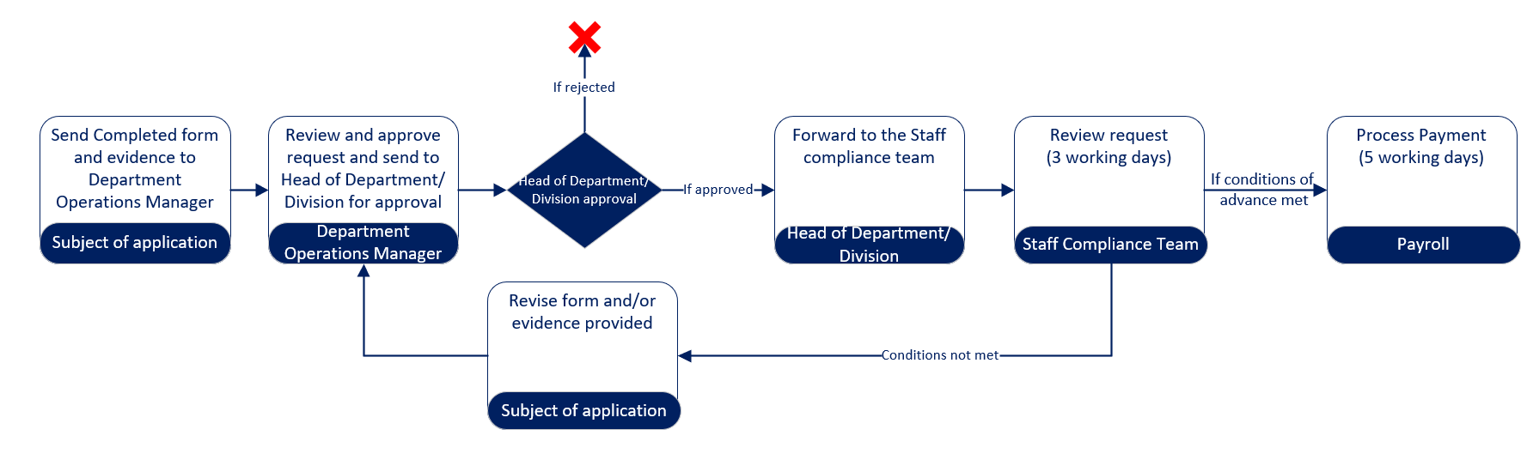
The process

For more information and support on applying for a visa, please visit our immigration webpages.

