Change Line Manager Details

Log into IC Manager Self Service in one of the following ways:

(i) If you are accessing ICIS from a computer with a wired connection on the College network (not halls, wireless or VPN), log in as normal http://icis.imperial.ac.uk/and look for “IC Manager Self Service” in your list of responsibilities. You are particularly urged to adopt this route, rather than following the link which appears in the next paragraph.

(ii) If you are accessing ICIS from home, wirelessly, from halls or via VPN, please click on the following link and follow the instructions:
https://icisremote.ad.ic.ac.uk/dana-na/auth/url_1/welcome.cgi

Expand your responsibility IC Manager Self Service, and select Maintain Line Managers.

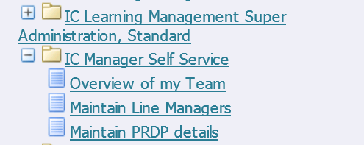

As a Line Manager, you now have the ability to update and change Line Manager information for those people you are responsible for. Please refer to the Business process maps for scenarios in which you would now be expected to make changes to line management information.

To update a line manager using Manager self service, you should take the following steps;

Click on the Action icon in the column labelled “Action” next to the name of the direct report you wish to update.

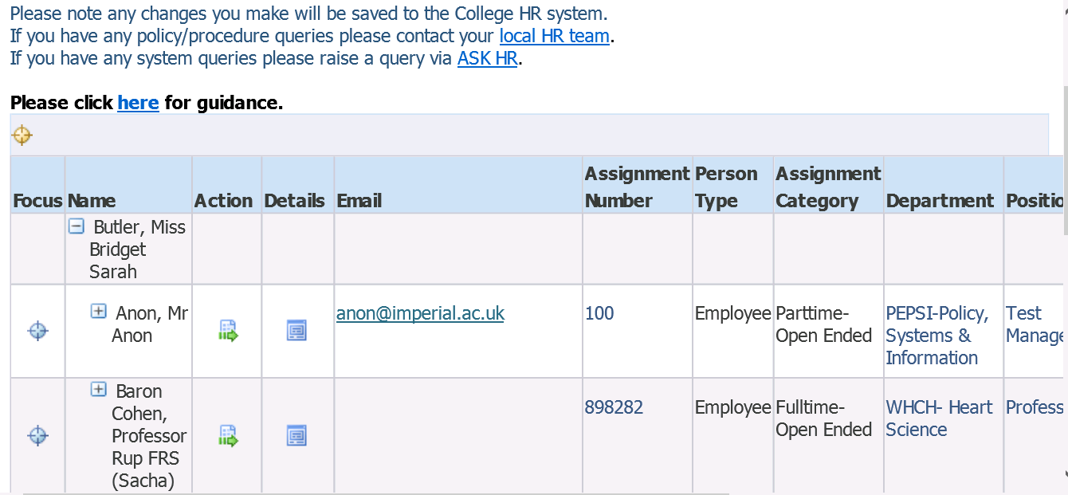

You will be taken through to the Maintain Line Managers: Effective Date Options page;

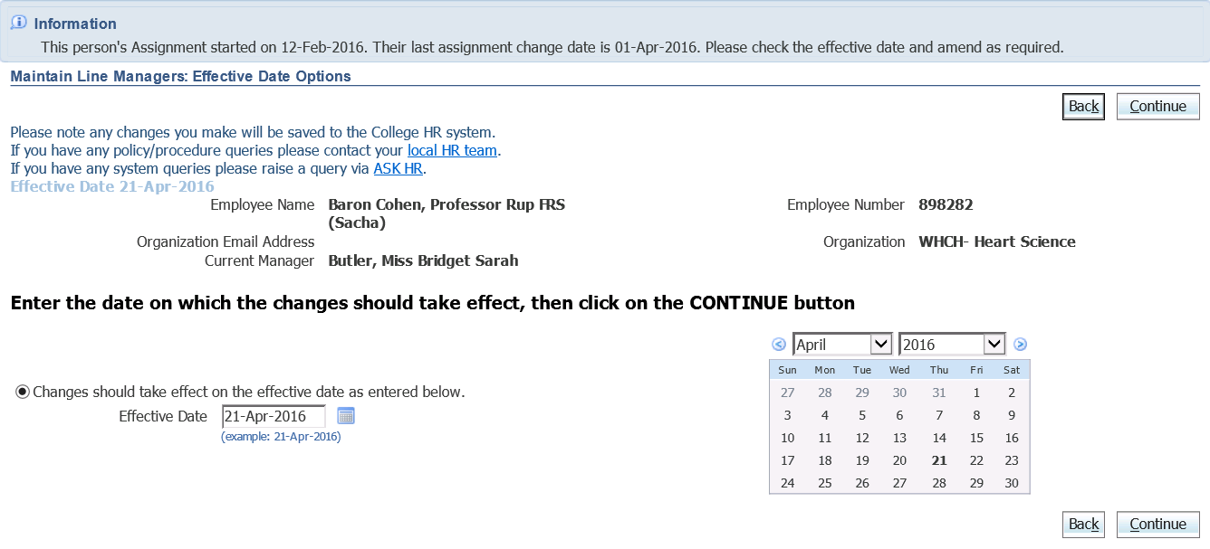

Please see guidance document “Maintain Line Managers: Effective Date Options” page for further details about the options and scenarios for this page.

Once you’ve entered the appropriate date, click on Continue.

The Maintain Line Managers page will be displayed. To update the line manager of this individual you will need to use the first section of this form, labelled “Assign a New Manager”.

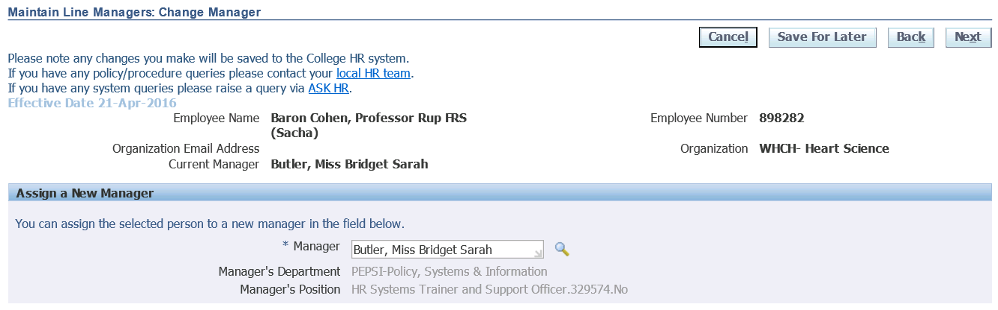

If you are updating this field for one of your direct reports, the field for Manager will already be populated with your own name. If you’re updating this for one of your indirect reports, the field will show the current line manager.

To update, delete out the information that currently exists in the field;

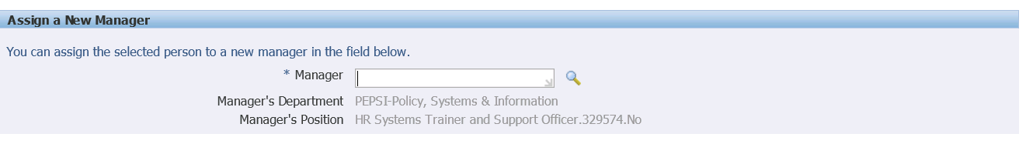

Type in the surname of the person you wish to become the new line manager in the field labelled Manager. A list of results should populate, from which you should select the appropriate entry. Alternatively, use the magnifying glass icon next to the field to search for the individual you wish to assign;

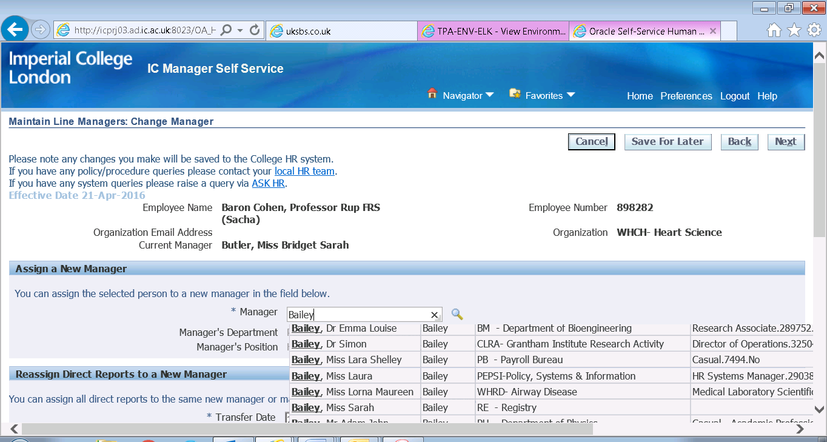

If using the magnifying glass – You would then need to click “Quick Select” or the select radio button to enter this information into the field.

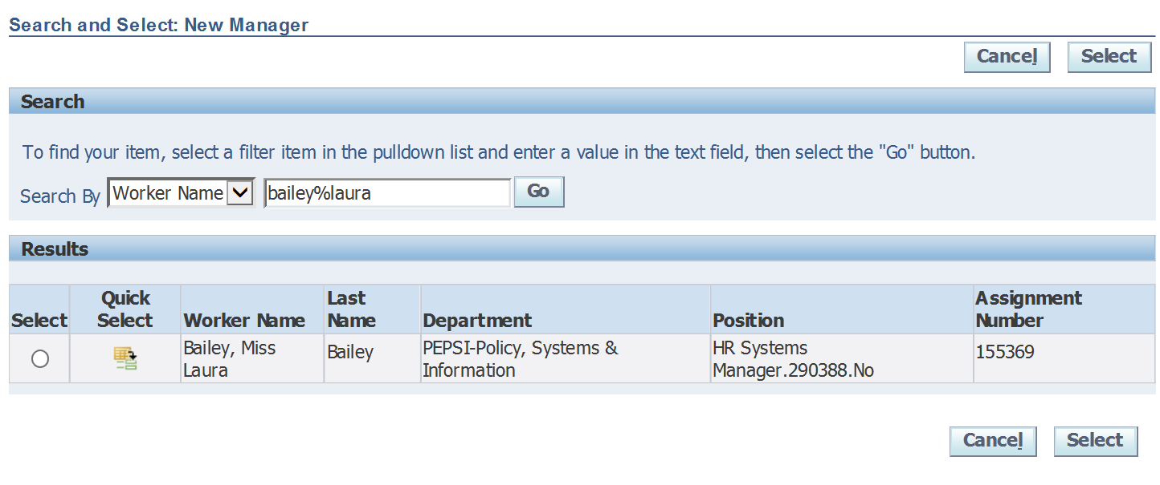

N.B.The position and department fields should also update to show the details of the new line manager;

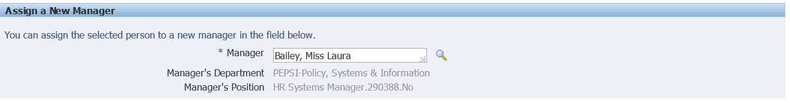

Click on Next when you have entered the details of the new line manager.

An overview of the change you’ve requested will be displayed. The blue circle icon shows against the new information you have entered.

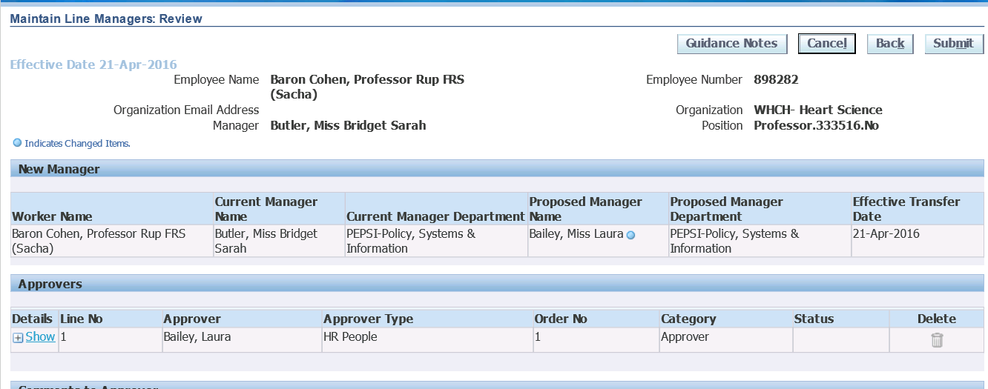

Any change in line management information is automatically routed to your own line manager for approval before it is updated in the system.

This screen also gives you the option to add comments to your request which will be visible to your line manager when they are reviewing the changes. You can enter any information in this box which you think is relevant, and will help your line manager understand why you are requesting this change.

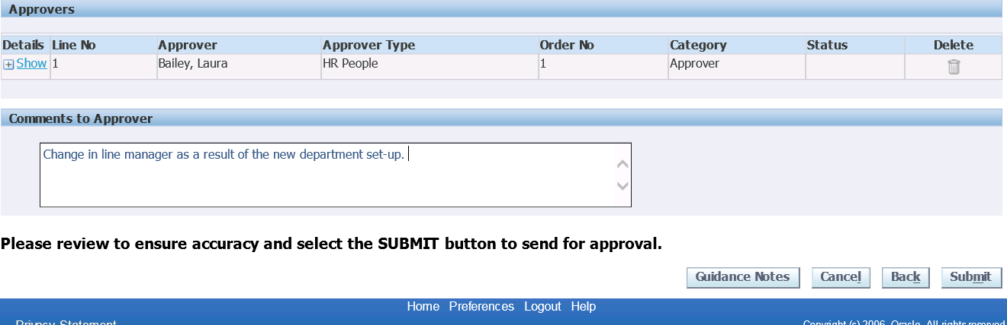

Once you are happy with your change, click on Submit. You will see confirmation that your change has been submitted for approval;

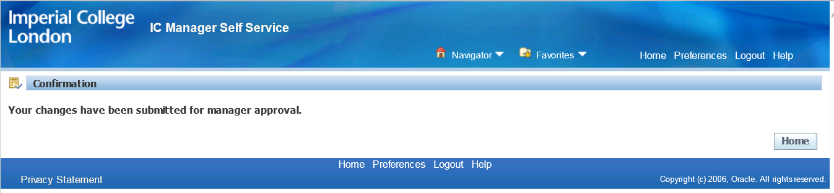

The action is now completed, pending approval from your line manager.

