IMPERIAL COLLEGE

EXTERNAL INTERESTS TO DECLARE

Table of Contents:
Declaration list that can all be completed within ICIS……………………………………3
Submitting External Interests using HR Self Service with ICIS:...……………………...3
Amending and updating your External Interests from your current or previous return:
…………………………………………………………………………………………………9
Submitting External Interest using email………………………………………………...14
Submitting information Governance and Security……………………………………....16
Submitting Animals Policy Declaration…………………………………………………...16
Category of employees exempt from Declaration of External Interests……………...16

Declaration of Interest
The three required declarations have been centralised under the Annual Declarations folder within Imperial College Information System (ICIS):
- My External Interests
- Information Governance and Security
- Policy on the Use of Animals Return

‘If you require further clarification on the process please click here to review the Imperial College’s ‘Register of External Interests and Annual Declaration Policy.’

Submitting External Interests via the Annual Declaration within ICIS Self Service:
The notes below provide instructions on how to declare an external interest(s).

If a previous Interest(s) appear and you need to amend, please see the notes below on ‘Amending and updating your External Interests from your current or previous return’.

- Log into ICIS Self Service by entering your college username and password.

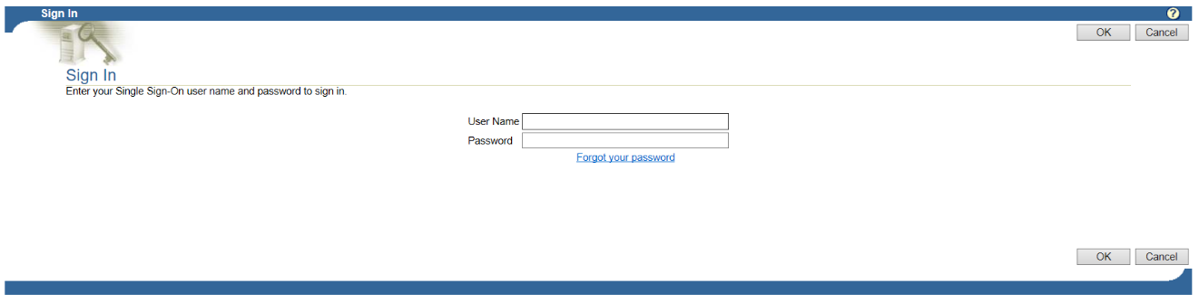

- From the Main Menu by pressing on the Click on Plus box icon to open the My Details folder to open up My Details folder and click on Annual Declarations

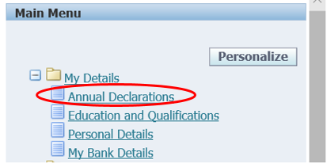

- To update or amend a New Interest, click on the View icon circled below:

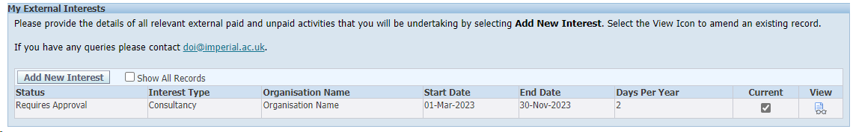
- The system will auto populate the Name, Department and Approver.

However, staff with a secondary role/s will be required to select the relevant Department the Interests is related to.

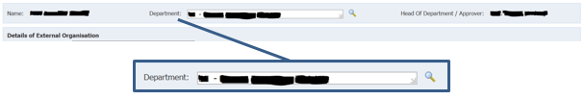

To amend click into the department field and delete. Press the magnifying glass iconto open a search page.

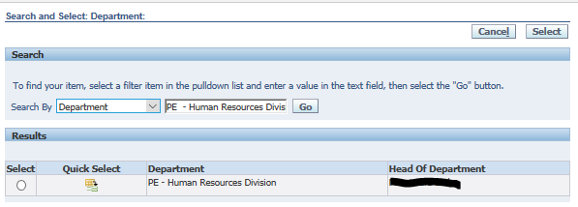

Press the Go button for results to appear and click on action icon in the column labelled Quick Selection to pull through the specific department.

- To Update/Amend the Details of the External Organisation

  - External Interest: Click into the field and select the appropriate Interest Type from the picklist e.g. Directorship.
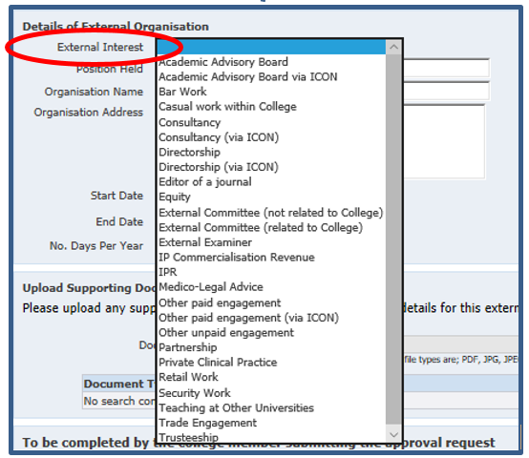
  - Remaining fields click into and type over with the new information

- Complete the remaining fields as shown below:

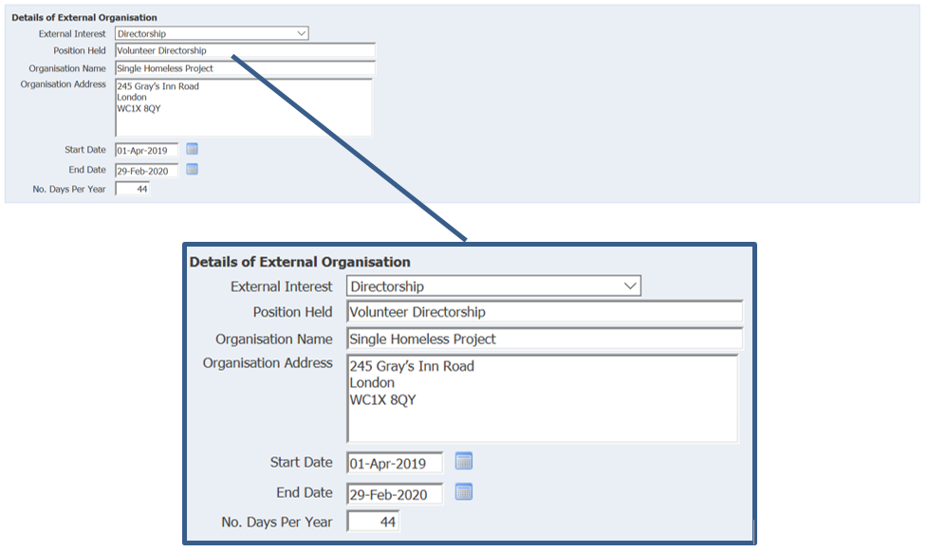
Note: Organisation Address field can only hold a maximum of 150 characters (including spaces).

- Upload Supporting Documents
- Select from the drop down menu the type of document being uploaded
- Select browse to find and attach the corresponding document
- Press upload

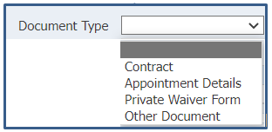

Note: Any number of relevant documents can be uploaded against each document type.

A number of External Interests will require a Private Waiver to be signed and uploaded within the supporting documents.

All External Interests requiring this waiver will have the above sentence highlighted in yellow along with a direct link to the Private Waiver template.

Private Waivers are not required for all positions. To view a full list of positions, policies and guidance online click here.

- Complete the final field

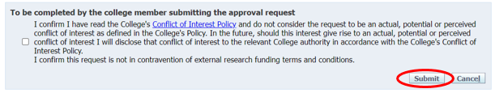
- Click in box for the tick symbol to populate
- Press Submit
Will be sent off for approval

By ticking the box you agree to have read the College's Conflict of Interest Policy and do not consider the request to be an actual, potential or perceived conflict of interest as defined in the College's Policy.

- If you have further interests to declare, click on Add another and repeat steps 3 to 7 from the External Interest to declare – how to submit your return on ICIS guidance

Note: Clicking on Cancel will return you to the homepage and will not save work currently displayed in the Details of External Organisation page.

To submit the newly added declaration or existing declarations of Interest
Follow steps 10 to 12 below

- In order to submit an external interest, the relevant box in the Current Interests column must be ticked

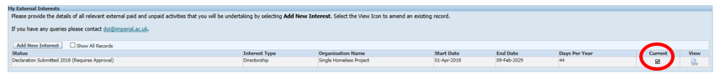

- To submit your declaration of Interest
- Within the Annual Declaration of Interests (nominated calendar year: e.g. 01-Jan-2018 to 31-Dec-2018) press the Submit Declaration button

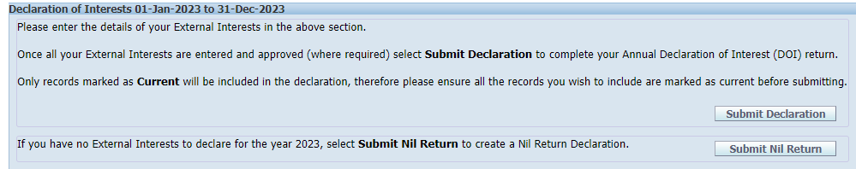

- Final submission check and once submitted no further information can be amended.
- To submit current Declarations of Interest press YES
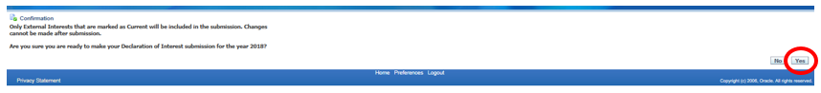

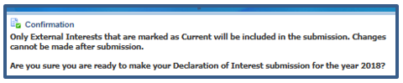

Note: Clicking on NO will return you to the homepage and without submitting the Declarations.

- Once submitted the page will automatically return back to the home screen with confirmation of your submitted 2018 Declaration of Interests

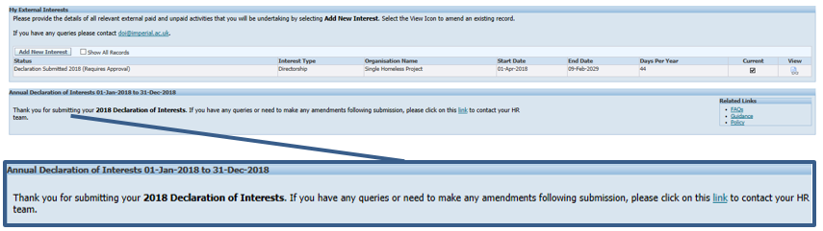

- Under Status there will be a list of all entered Declaration of Interests and once submitted for approval will say (Requires Approval)
- A confirmation message will appear, thanking you for your submission
- The Head of Department / Approver will receive a notification
- On success / rejection you will receive a confirmation email

Note: After submitting your return, you will be sent a confirmation email. If you have any queries or need to make any amendments following submission, please click on this link to contact the DOI team.

- Once submitted this will trigger off an approval request email to your Department Manager/Approver.

- If you wish to logout of ICIS after submitting your return, click on the Logout button in the top right hand corner.

Submitting External Interest using email of Interest:
Email communication will go out across the college to those required to complete the Declaration of External Interests.
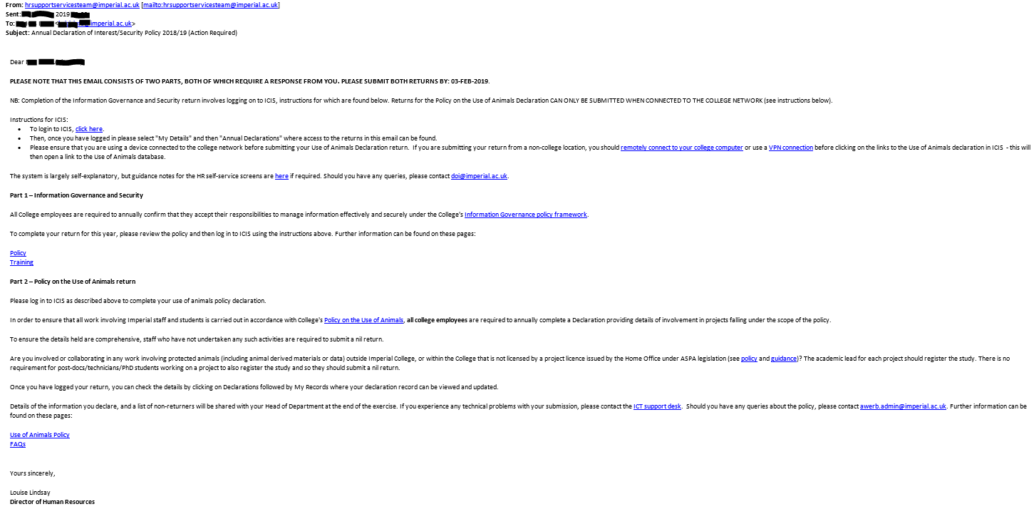

The log in link will direct you to the ICIS page and please follow steps 1 to 14.

Once submitted the page will automatically return back to the home screen with confirmation of your submitted current Declaration of Interests.

- The Status will be a list of all entered of Interests and once submitted for approval will say (Requires Approval)
- A confirmation message will appear, thanking you for your submission
- The Head of Department / Approver will receive a notification
- On success / rejection you will receive a confirmation email

After submitting your return, you will be sent a confirmation email. If you have any queries or need to make any amendments following submission, please email the DOI inbox on doi@imperial.ac.uk.

Submitting Information Governance and Security:
To confirm acceptance of the Information Governance and Security by
- Ticking the box
- Press Submit Acceptance

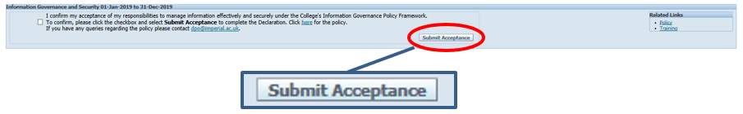

Note: Should you have any queries, please contact doi@imperial.ac.uk. Additionally guidance notes are available on the Declaration of Interests intranet page.

Submitting Animals Policy Declaration:
- Completing the Policy on the Use of Animals
  - Press either
    - Nothing to Declare
    - Current Interest

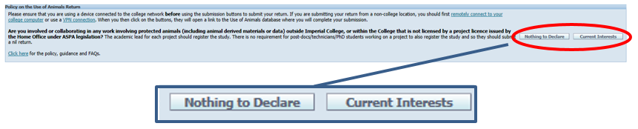

Note: Please ensure that you are using a device connected to the college network before submitting your Use of Animals Declaration return.

If you are submitting your return from a non-college location, you should remotely connect to your college computer or use a VPN connection before clicking on the links to the Use of Animals declaration in ICIS - this will then open a link to the Use of Animals database.

Should you have any queries please contact awerb.admin@imperial.ac.uk.

Category of employees exempt:
Some employees will be exempt from completed the Declaration of External Interests and for details please refer to the Imperial Colleges External Interests webpage.

