Ten Horizon Scanning Questions and a PESTLE Analysis

In our videos on Being Strategic we looked at how you can develop your vision and strategy and explained the importance of ‘scanning the landscape’ to look for potential threats and opportunities that may affect your strategy. Here, we pose some horizon scanning questions for you to think about as well as a worksheet on a horizon scanning tool called a PESTLE analysis.

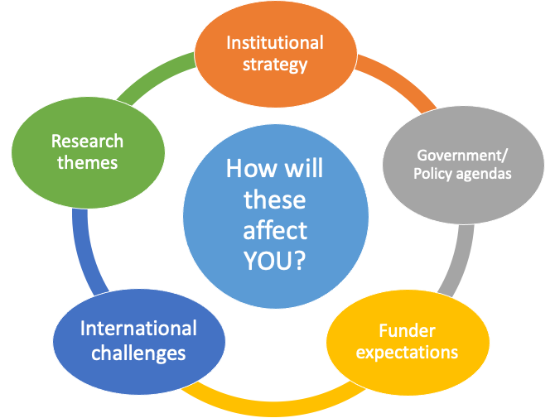

Ten ‘Horizon Scanning’ questions to consider:

- What might affect your career and research strategy in terms of:
- the research themes of your potential funders
- the research themes that the College prioritises in its strategy
- the government’s strategies and policy priorities relating to your research area (and what the public cares about?)
- international challenges that researchers need to address, or may be affected by
- your funders’ expectation of you as a research leader making an impact with their investment and supporting the next generation of researchers

- How, when, or why are these likely to change?

- How can you adapt your reading or conversations to put yourself in a position to hear and understand the likely next research themes, challenges, opportunities, and expectations?

- Who can you engage with e.g., senior members of faculty to learn what they see coming over the horizon?

- What are the big global challenges that could impact (or benefit from) your research?

- How do you use your national and international networks? E.g. to hear about the state of play in other countries in relation to your research field or your research questions

- Could you scale up your current research to address national or international challenges?

- Are you aware of relevant government policy agendas? e.g. industrial strategies, reviews, Select Committee recommendations. What are the concerns of lobbyists or think tanks in relation to your research?

- How does your research strategy align with and support your department’s (or the College’s) research strategy?

- Where can you develop knowledge of, or influence over funders’ strategies and priorities? E.g. Joining funders’ peer review colleges or networking with panel and committee members.

Pestle Analysis

The PESTLE analysis technique is a generic business tool that was developed to facilitate strategic thinking and horizon scanning.

Consider the following categories. What are the possible opportunities and challenges that will influence your success? Make notes in the boxes provided. Better still: generate and discuss ideas with your team.

To really apply PESTLE and scan the horizon, you need to broaden or adapt your reading and conversations. Where or how will you gain these insights?

government influence on the sector, industrial and trade strategy, education policy, government spending, political stability
Political
inflation, exchange & interest rates, economic growth, cost of labour, market growth, demand for raw materials
Economic
demographic factors, population growth rates, cultural change, age distribution, health consciousness, changed expectations, media, modes of work
Social
internet, e-commerce, rate of technological change, infrastructure, logistics, willingness to embrace tech
Technological
including ethics, employment, working time/conditions, or consumer law, discrimination, health and safety law, environmental legislation
Legal
pollution, weather, climate change, geographical position, carbon footprint, waste, social responsibility, raw materials
Environmental

