Worksheet: Reviewing your network
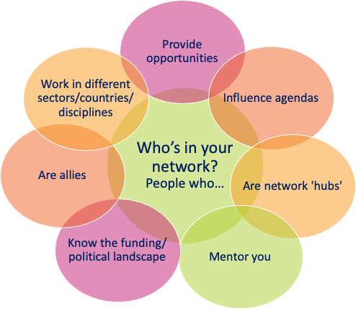
Do you have a healthy and strategic network? Are you making the most of your networks, and are they getting the most from you?
Your networks should change and evolve alongside you and your work. It’s worth doing a quick review occasionally. It might prompt you to re-connect with some great people, notice gaps or expand your networks to include people with whom there may be mutual benefit.

Activity:
- Look below at the descriptions of people or organisations that we suggest should be in a research leader’s network.

- Complete the table on the final page of this worksheet to conduct a review of your current network.

People who:

- Provide opportunities - it’s important to have people in your network who can provide you with opportunities that can develop you or add to your CV. They might be people who are more senior to you, who are looking to delegate opportunities from which they no longer get value or have time for. The opportunities may help you in your career goals – for example, to join a collaboration, be on a review panel or committee, or do some outreach activities.

- Are network hubs – simply, these are people who know lots of other people. They might be members of professional services in the College who can quickly connect you to many other people, or they might be based at funding bodies or learned societies. These people always know someone to connect you with and can help you with any queries or requests you have that are outside your knowledge area.

- Know the funding or political landscape – they might sit on a funding panel, or on a university research committee – these are people who have a broader and perhaps longer-term view of the landscape than you. They can forewarn you of opportunities and challenges on the horizon and help you to be more strategic.

- Offer you a different perspective – this might be because they work in a different sector, country, or discipline area. These people can help you to think of the most impactful research questions, to view yourself and your research from different perspectives and offer you new avenues and ideas. Often the most exciting research comes from the interface of different sectors and disciplines, so working with these people could really increase your motivation levels, as well as your ability to tackle complex challenges.

- Have influence – they might be people in your department who have influence on administrative processes or teaching loads or might be on policy committees or in lobby groups. They can help you with lobbying for change and understanding how to have more influence yourself.

- Can mentor you either formally (with regular meetings) or informally in an ad-hoc way when you have something to discuss. A mentor is someone who can reflect on their experiences and share the insights they have gained. They can act as a sounding board, or help you to process difficult situations, to help you to think more strategically, and connect you to other people to add to your network.

- Are allies –possibly one of the most important groups, your allies are people that feel the same as you and have similar opinions and needs as you. They will truly empathise with your challenges and victories. You can act as a united force together or offer a shoulder to cry on. These are the people you can relax with, let off some steam and know you are not alone.

Your current network: health check

- In the table below, for each role, list names of the people in your network. Preferably specific people that you know, and they know you. Don’t worry if you can’t think of names for every category as this exercise is to identify where there are gaps.

- Once you have listed all your names (there will be duplication with the same names appearing in several categories), assess the strength and effectiveness of the relationship using the tick-box columns:
  - Is it a mutual relationship? Tick the names of the people if the relationship is more than you just knowing who they are. Do they also know you? Have you communicated in a meaningful way?
  - Have you had recent communication? Tick the names of people that you have communication with in the last 3-6 months.
  - Do they know your plans? Tick the names of people that would know (accurately) your current interests as well as your future plans and ambitions i.e. would they know why they would engage with your or which opportunities to send your way? Or is their knowledge likely to be outdated?
  - Do you know their plans? Likewise: Tick the names pf the people whom you know their current interests and future plans.

- Then, answer the reflective questions below the table and consider discussing the outcome with your mentor.
Role.  People who: | Your list of names | Mutual relationship? | Recent comms? | They know your plans | You know their plans
Provide opportunities
Network hubs
Know the funding/ political landscape
Offer different perspectives
Have influence
Will mentor you
Are allies

Reflective questions:

- How would you describe the health of your network?

- Are there any gaps that might affect the success of your future plans?

- What is one thing you could do to fill a gap?

- Which relationships ae out of date, and how might this affect the success of your future plans?

- What do you consider a priority for you to do to strengthen or refresh your relationship?

