**Deciphering the influence of mantle dynamics on Cenozoic records of**

**sea-level change**

**Supervisors:** Dr Fred Richards (f.richards19@imperial.ac.uk); Gareth Roberts

Since the start of the Cenozoic Era (~65 million years ago) our planet has experienced major climatic shifts, including periods of extreme warmth, like the Palaeocene-Eocene Thermal Maximum (~55 million years ago) where global temperatures reached 5–8 °C above their current level, as well as intervals of rapid cooling, such as the Early Pleistocene (~2 million years ago), which coincided with a 4–5°C temperature drop. Accurately determining the amplitudes of ice volume and sea-level variations triggered by these climatic fluctuations is a key priority in climate science, since they hold important clues for understanding the likely response of modern ice sheets to future temperature changes.

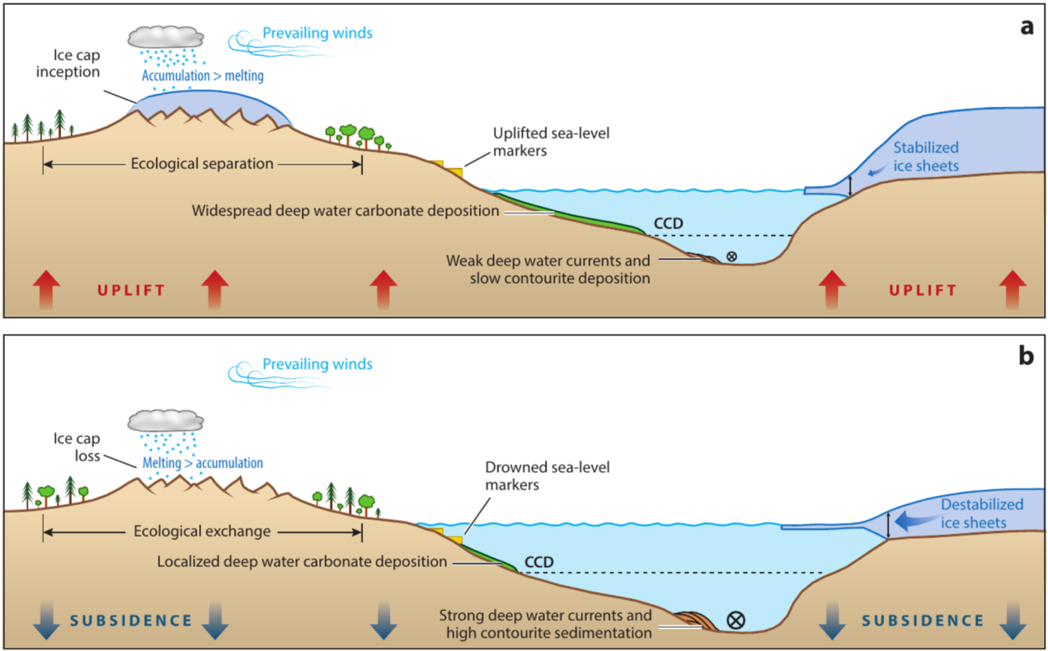

Sea-level marker elevations (e.g., palaeoshoreline deposits and backstripped stratigraphic records) provide useful bounds on the amplitude of past sea-level highstands but have often experienced significant vertical deflection following formation due to dynamic topography (i.e., vertical surface motions driven by mantle convection) and glacial isostatic adjustment (GIA, i.e., sea-level and topography variations caused by ice and ocean mass changes). This project will develop geodynamic models that disentangle these local relative sea-level variations from global signals, yielding new insight into mantle structure and improved reconstructions of Cenozoic GMSL change.

Until recently, it has not been possible to predict geodynamic processes with sufficient accuracy to extract GMSL histories from geomorphic sea-level observations. However, recent advances in seismic tomographic imaging and mineral physics experiments now enable the temperature, density and viscosity of Earth’s interior with reasonable accuracy. New computational techniques have also made robust reconstruction of past dynamic topography and GIA possible. Finally, sea-level indicators are more densely sampled and better dated than before, improving our ability to validate model predictions and to determine the physical state of the mantle.

This project will make use of these recent innovations to tackle major unresolved questions in geoscience, including: i) What was GMSL during past intervals with climatic conditions similar to those expected in the near-future?; ii) Which models of mantle structure best reconcile spatiotemporal variations in the geomorphic record of sea-level change? iii) Can mantle convective processes explain enigmatic “third order” sea-level cycles observed in margin stratigraphy? And iv) How have mantle-flow-driven changes in polar topography and ocean basin volume influenced the amplitude of Cenozoic sea-level variations?

By disentangling geodynamic and climatic contributions to past sea-level variations, this work will shed new light on the sensitivity of Earth’s ice sheets to future climate change. It will suit a geoscientist, applied mathematician or physicist interested in conducting research at the interface between geophysics and palaeoclimate.