**Hot rocks in cold places: Quantifying mantle dynamic impacts on Antarctic Ice Sheet evolution**

**Supervisor:** Dr Fred Richards (f.richards19@imperial.ac.uk)

The Antarctic Ice Sheet (AIS) holds enough ice to raise global sea level by 58 metres and is expected to become the largest contributor to sea-level change later this century. However, the future trajectory of this Antarctic contribution remains the largest source of uncertainty in projections of sea-level rise. For example, the last Intergovernmental Panel on Climate Change (IPCC) report found end-of-century sea level could reach anywhere from 0.3 to 2 m above present, making it difficult for national governments to decide how best to protect their at-risk coastal communities.

Much of this uncertainty results from poorly quantified interactions between the AIS and the underlying mantle (the ~3000 km-thick layer of hot rock sandwiched between Earth’s crust and core). These include: 1) transfer of heat from the mantle into the base of the ice sheet, which controls the speed at which ice slips over bedrock; 2) mantle-driven rebound of Earth’s crust following loss of grounded ice (i.e., ice in contact with bedrock), which may slow or even reverse ice-sheet retreat; 3) mantle-flow-induced uplift and subsidence of bedrock, which modulates the ice storage capacity of the AIS. By integrating geological and geophysical datasets with state-of-the-art computer simulations, this project will transform understanding of these processes and their impact on past, present, and future ice volumes, enabling the development of more actionable sea-level projections.

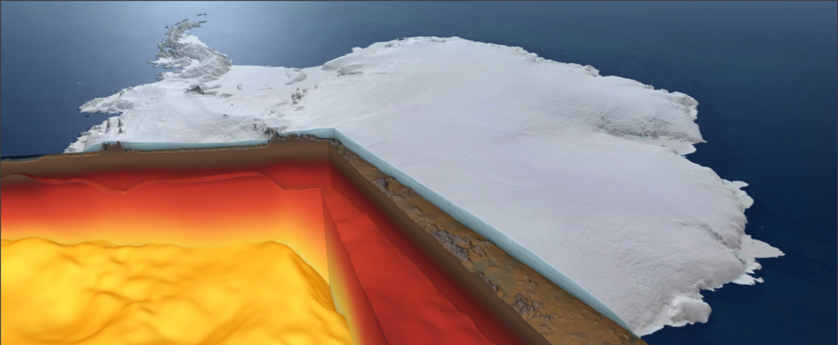

Despite the clear importance of evaluating mantle–ice-sheet interactions, progress has been frustrated by poor knowledge of mantle physical properties, the lack of robust methodologies for reconstructing mantle flow, and the computational expense of simulating the coupled evolution of the mantle and ice-sheet dynamics. Now, recent advances allow us to move forward. First, thermomechanical mantle structure can be determined with unprecedented accuracy thanks to improved seismic imaging and new mineral physics experiments. Secondly, theoretical and computational developments enable the spatiotemporal evolution of mantle flow to be predicted back to around 50 million years before present. Finally, innovative machine learning techniques can be used to construct computationally efficient emulators of complex simulations, significantly accelerating model calculations.

This project will take advantage of these breakthroughs to: i) reconstruct the long-term topographic evolution of Antarctica and its impact on equilibrium ice volumes; ii) quantify the impact of mantle-derived heat on AIS dynamics; iii) determine the impact of spatiotemporal mantle viscosity variations on the ice sheet’s future stability; iv) calibrate new ice-sheet models that are consistent with past and present observations of AIS behaviour.

It will suit a geoscientist, applied mathematician or physicist with computational experience and interest in conducting research at the interface between glaciology, geophysics, and materials science.