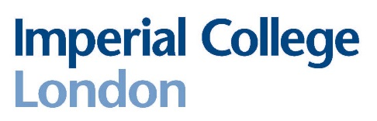**Department of Physics**

**Communicating Physics**

**Application form for 2024/25**

**Please note: Interviews will be taking place in person in Blackett 311.**

|  |  |
| --- | --- |
| **NAME (in capitals):** |  |
| **COURSE CODE (e.g. F303):** |  |
| **CID NUMBER:** |  |
| **Please give below your reasons for wanting to take ‘Communicating Physics’:** | |
| **Please indicate any prior teaching experience:** | |

*All students who are accepted on the course are required to undertake a DBS check. By returning this form it is understood that if you are selected for CP you are committed to the course and cannot withdraw at a later stage. Students who do withdraw will be asked to cover the cost of the DBS check.*

**Please return your completed form to r.bains@imperial.ac.uk by 14:00 pm on Friday 14th June 2024.**

**Interviews for the CP course will take place on Tuesday 25th June 2024.**