What is it Timetabler AutoCalEx?
Timetabler AutoCalEx synchronises Staff and Student timetables to their College Outlook Calendar. This is pushed directly from the timetabling system (CELCAT) into Staff or Student Outlook calendars. Any events associated with your staff/student record in CELCAT will be pushed to your Imperial College Outlook account calendar.

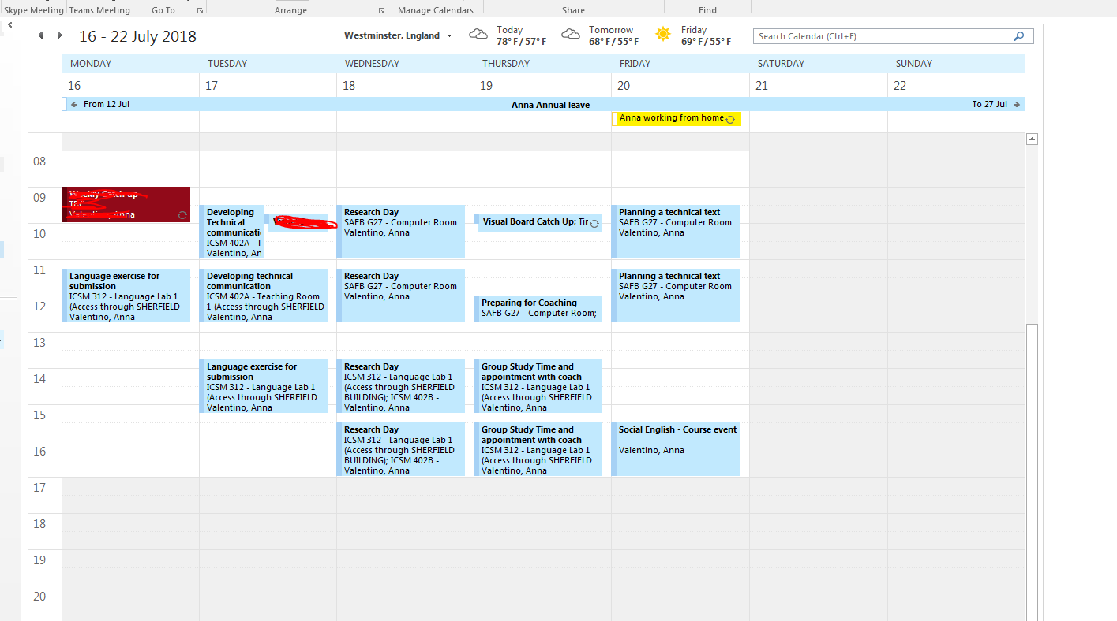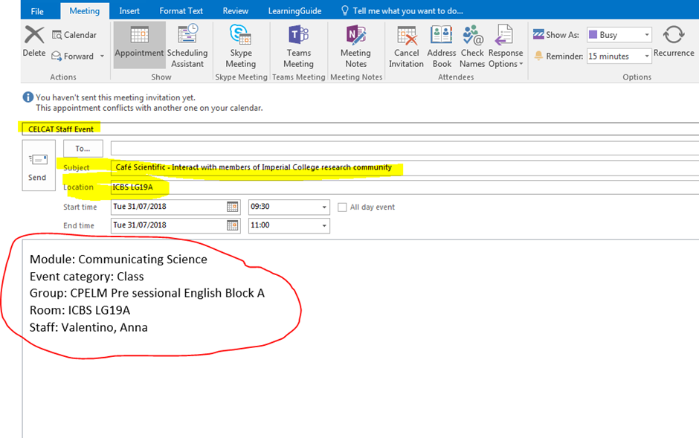

Benefits of Timetabler AutoCalEx
- The sync feed updates timetable changes automatically at regular intervals, refreshing the Outlook calendar every time.
- It is personal to the staff or student, showing any events which are linked to the individual by their student or staff name or their association to a group or team in CELCAT.
- Timetabled events show as busy in the calendar, helping colleagues to schedule meetings.
- If a record has events in CELCAT as both staff and student, you will receive both timetables, and they will be identified in the appointment as CELCAT Staff event and CELCAT Student event respectively.
What happens if……………
- HELP…..I moved the Outlook appointment to a different date/time.
The event will revert to the original date/time at the next update cycle in CELCAT.
- OOPS….I deleted the event.
CELCAT will push the event back into your College Outlook Calendar
- OOPS again…..I changed something on the appointment.
CELCAT will update the event with the original information at the next update cycle.
If you are experiencing issues and you cannot see expected events in your College Outlook Calendar please complete the Timetabling Troubleshooting form at: http://www.imperial.ac.uk/timetabling/support

Viewing your timetable on different devices
https://www.imperial.ac.uk/admin-services/ict/self-service/connect-communicate/email/how-to-guides/setting-up-and-using-email/instructions-for-setting-up-your-email-client/
You may also view your personal calendar here: (log in using your college username (no @ic.ac.uk) and password): https://www.imperial.ac.uk/timetabling/calendar
Central Timetabling Support Office AutoCalEX page https://www.imperial.ac.uk/timetabling/view/autocalex/

