White Paper

AGEing and NuTrient Sensing Network (AGENTS)

Ageing is an inevitable and progressive process characterised by the accumulation of functional deficits across multiple organ systems (1,2). Studies in model organisms have shown that dietary (energy) restriction is one of the most effective interventions for extending lifespan and for maintaining better health during ageing (3). In addition, several genes and pathways have been identified that are associated with greater lifespan (4). While there is compelling evidence from animal models, in humans the situation is more complex and much less understood. Although genotype is an important influence on human ageing, interactions with environmental factors including social structure, culture and lifestyle are pivotal in determining the ageing trajectory (5).

The AGEing and NuTrient Sensing (AGENTS) network is comprised of a multi-disciplinary consortium of leading researchers and early research career scientists, with expertise across ageing, cell biology, nutrition, policy and epidemiology. The AGENTS network was awarded a BBSRC/MRC Ageing Network grant in 2022. The AGENTS network aims to develop a programme of research that will lead to an increase in healthy life years. We believe there are a number of critical unanswered questions relating to ageing and nutrition sensing. The following document represents the consensus opinion of the AGENTS network concerning the key research challenges to address the factors that contribute to the decline in health during ageing and that increase the burden of age-related disability and disease. In addition to this, we aim to provide an overview of the AGENTS Network and how it is building a community to develop new knowledge in the area of ageing and nutrition sensing.

As a construct to work from, the Network have defined nutrition sensing as:
“Systems at multiple scales that detect and respond to nutritional flux.”
In addition, we have adopted the WHO definition of biological ageing:
“The impact of the accumulation of a wide variety of molecular and cellular damage over time. This leads to a gradual decrease in physical and mental capacity, a growing risk of disease and ultimately death. These changes are neither linear nor consistent”.
AGENTS has identified the following areas as challenges to advance understanding of the field of ageing and nutrition sensing:
- Many common non-communicable diseases result from dysregulation of nutrition sensing pathways, which are poorly understood.
- Evidence suggests that nutrition sensing plays an important role in homeostatic mechanisms from the cell to whole body metabolism and food choice.
- There is need to understand how an individual’s environment influences nutrition sensing and vice versa.
- There are well described fundamental biological nutrition sensing pathways that influence lifespan in unicellular organisms and small mammals but there is little understanding about how these influence whole body human physiology.
- There is a lack of biomarkers that can be used to map each of the links between nutrition sensing and human ageing.
To improve understanding in these areas, the AGENTS network has developed (and will support, via pump priming funds) four multidisciplinary projects. These projects will bring together researchers from multiple institutions and disciplines to stimulate new research thinking and innovative research approaches and will generate larger research projects that will bring new understanding to the field. These projects are summarised below:

Project 1: Understanding and influencing the mechanisms of ageing through dietary interventions. Aims to bring a better understanding to the interplay between genetic polymorphisms in nutrition sensing genes and dietary intake. This will help identify potential strategies to improve the ageing trajectory and health span. The project will be conducted in two stages. A modified Delphi technique will first be utilised to gain an expert consensus on the best biomarkers for ageing (current and future). An expert panel will rank possible biomarkers until a consensus of agreement is obtained. The Delphi stage of the study will be funded by the network and will bring new insights into the biomarkers of ageing. The second stage will investigate the effect of food insecurity and time restricted eating on the biomarkers of ageing identified in stage 1. Food insecurity indicates limited or unreliable access to nutritious food and can result in variability between food quality and food intake. Time restricted eating is a dietary pattern that limits food consumption to a certain time period. Both dietary patterns are characterised by periods of fasting but it is hypothesised that these eating patterns will have opposing effects on the ageing trajectory. We hypothesis that experimentally induced food insecurity may accelerate the ageing process by compromising nutrition sensing/metabolic pathways while time restricted eating may reflect a decelerated model of ageing. The study will provide a better understanding of the social and dietary factors impacting the ageing process while unravelling aspects of the mechanism behind it. Funding for this project will be sought from another source but will be strengthened by AGENTs funding and preliminary data collection

Project 2: Gene polymorphisms and mechanistic understanding of impact of nutrition on healthy ageing.
This aims to understand the impact of nutrition and genetic polymorphisms on healthy ageing. Nutrition is an important factor that is known to impact the ageing process and the risk of morbidity. However, the response to nutrition differs greatly between people. We hypothesize that this heterogeneity in response to dietary factors is due to polymorphisms in nutrition sensing genes. This project will have three stages. The first stage will include a short review of the area to identify candidate genes implicated in nutrition sensing pathways. The second stage will use access to big data sets (e.g., UK BioBank) to investigate the relationship between the polymorphisms in the candidate genes identified in stage 1 and ageing related factors available such as BMI, body composition, cognition and muscle strength/frailty. These two stages will be funded and supported by the network. These will bring new insights into the relationship between nutrition sensing, polymorphisms of these pathways and ageing parameters.
The third stage of the study will involve mechanistic investigation of nutrition sensing pathways: cell and animal models, impact of polymorphisms on gastrointestinal and neuronal functions and potentially a human study looking into physiology. Funding for this project will be sought from another source but will be strengthened by AGENTS funding and preliminary data collection.

Project 3: Understanding the Biological Mechanism and Societal Determinants of Anorexia of Ageing
Many older people consume too little food due to anorexia of ageing and this contribute to the development of many age-related problems including sarcopenia. This project aims to focus on understanding the biological mechanism and societal determinants of anorexia of ageing. The project will aim to address the consensus on the definition of anorexia of ageing. Following this, the study will include two stages. The stage 1 will aim to collect preliminary data by using tissues from older adults and testing these on gut on a chip model. Stage 2 will include a review on the social aspects surrounding the anorexia of ageing such as food insecurity. Both stages will be supported by network funding and will bring new understanding regarding the mechanism as well as the social aspects impacting anorexia of ageing.

Project 4: Exploring the impact of protein quality and fibre on gut barrier function, inflammation, and body composition
A decline in gastrointestinal tract (GIT) barrier function is associated with inflammation and inflammation is a major driver that has a negative effect on muscle mass. Decline in GIT barrier function and low-grade inflammation are associated with ageing in animal models but robust data in humans is lacking. Dietary protein and dietary fibre have been demonstrated to have an impact on GIT integrity.
The aims of this project are to explore the impact of protein quality and dietary fibre on gut barrier function, inflammation, body composition and muscle function. The project will have three stages. This project firstly aims to collaborate with industry partners to develop biomarkers of biological age and gut barrier function. Secondly, to engage with the public to develop an understanding of acceptability of changes to protein sources (e.g. legume vs. animal based protein), Thirdly to bring together preliminary data with public and stakeholder engagement to co-create a randomised control trial to test the effect of alternative sustainable protein sources and increased dietary fibre on age-related health outcomes.

Each of these projects embraces interdisciplinary research as highlighted in figure 1 below to build holistic understanding to the research
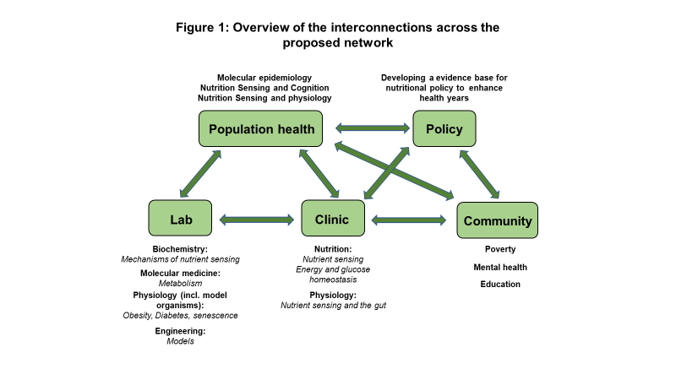

An overarching long term aim of all projects is to bring scientific evidence to influence and inform policy that will improve the health and wellbeing of older people. A major component in all projects is the involvement of ECRs to stimulate the next generation of scientist in the field.
Summary
By building a new multi-disciplinary, multi-institutional research community, the AGENTS network will deliver new biological and social understanding to the field of ageing and nutrition sensing. The AGENTS network believes that to advance understanding of human ageing and health span, it is essential to pursue investigations at many length scales from single cell biology up to population science. It is essential that this embraces interdisciplinary collaboration across biological and social science and includes the role of industry and civil society.

References
1. Lowsky DJ, Olshansky SJ, Bhattacharya J, Goldman DP. Heterogeneity in Healthy Aging. Journals Gerontol Ser A [Internet] Oxford Academic; 2014 [cited 2021 Oct 13];69:640–9. Available from: https://academic.oup.com/biomedgerontology/article/69/6/640/528242
2. López-Otín C, Blasco MA, Partridge L, Serrano M, Kroemer G. The Hallmarks of Aging. Cell [Internet] Europe PMC Funders; 2013 [cited 2021 Oct 13];153:1194. Available from: /pmc/articles/PMC3836174/
3. Fontana L. Excessive adiposity, calorie restriction, and aging. JAMA [Internet] 2006 [cited 2014 Jun 6];295:1577–8. Available from: http://www.ncbi.nlm.nih.gov/pubmed/16595760
4. Rodríguez-Rodero S, Fernández-Morera JL, Menéndez-Torre E, Calvanese V, Fernández AF, Fraga MF. Aging Genetics and Aging. Aging Dis [Internet] JKL International LLC; 2011 [cited 2021 Oct 13];2:186. Available from: /pmc/articles/PMC3295054/
5. Westendorp RG. What is healthy aging in the 21st century? Am J Clin Nutr [Internet] Oxford Academic; 2006 [cited 2021 Oct 13];83:404S-409S. Available from: https://academic.oup.com/ajcn/article/83/2/404S/4650087

