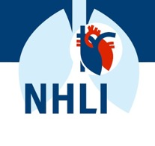
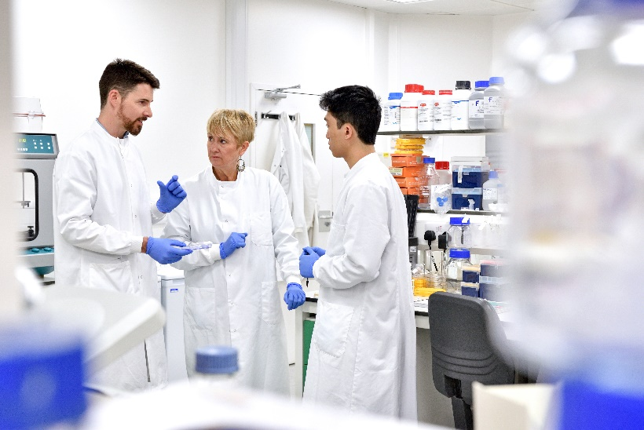


New Scientists Day

Come and join an afternoon of talks from a selection of NHLI’s New Academics and engage in a networking session.

20th November 2023 13:00 to 17:00

Paul Wood Lecture Theatre, Guy Scadding Building, Royal Brompton Campus

NHLI | Paul Wood Lecture Theatre
13:00-13:05 | EDI committee  Welcome, practicalities and NHLI EDI overview?
13:05-13:10 | Clare Lloyd, Head of NHLI  Welcome and Opening Remarks
Cardiac Function
13:10-13:15  13:15-13:25  13:25-13:35 | Professor Ken Macleod  Prashant Srivastava  Michaela Noseda
Genetics and Imaging
13:35-13:40  13:40-13:50 | Professor Dudley Pennell  Brian Halliday
Airways Disease
13:50-13:55  13:55-14:05 | Professor Sebastian Johnson  Freda Yang
Genomic and Environmental Medicine
14:05-14:10  14:10-14:20 | Professor Debbie Jarvis  Andre Amaral
14:20-14:50 | COFFEE AND NETWORKING
14:50-14:55 | EDI committee  Welcome to session two
Inflammation, Repair and Development
14:55-15:00  15:00-15:10 | Professor Adnan Custovic  Sara Fontanella
Vascular Science
15:10-15:15  15:15-15:25 | Professor Beata Wojciak-Stothard  Andrew Cowburn
Cardiovascular Trials and Epidemiology
15:25-15:30  15:30-15:40  15:40-15:50 | Professor Darrel Francis  Matthew Shun-Shin  Rasha Al-Lamee
15:50-16:00 | Clare Lloyd  Close of talks
16:00-17:00 | NETWORKING RECEPTION
17:00 | End of official event

Talks will be 5 minutes long with 5 slides max followed by 5 minutes of questions.

Follow on networking and social gathering at Zetland Arms:
Zetland Arms Pub in Kensington (greeneking.co.uk)

