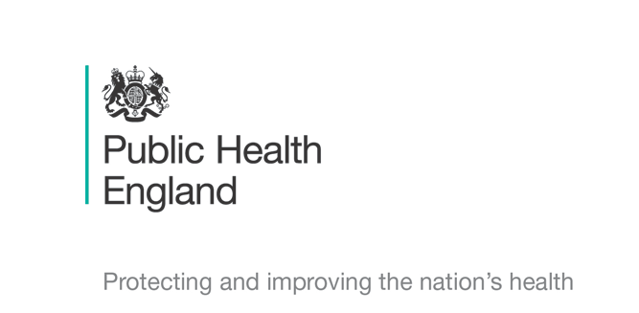


Principal Investigators
Professor Sriskandan, Dr Rebecca Cordery & Dr Miranda Mindlin
Chief Investigator
Prof Shiranee Sriskandan

Schools Transmission Study : COVID-19
Child Contact- Information Leaflet and Assent Form for Children aged Under 8


Today we are finding out about a germ called coronavirus that can make some people sick.

Most germs can live in your throat and nose and on your skin without making you ill.

The doctors and nurses want to know what germs live in your throat and nose and on your hands and have asked your mummy and daddy or guardian if it is OK to find out.
Your parent or guardian will ask you to open your mouth wide like in the picture so they can take a throat swab. It’s a bit ticklish but it is very quick and does not hurt.

They will also take a swab from your nostrils. This is also quick and does not hurt. The nurse can do this for them if it’s easier.

They will ask you to rub a foam swab on your cheek-this is a bit like brushing your teeth.

If your parents or guardian are OK with it, the nurse might come back next week to see you again. Sometimes the nurse might ask you for a spit sample or a hand swab

The nurse will also ask your mummy and daddy or guardian some questions about if you have been well or unwell recently.

Ask your mummy and daddy or your guardian if you have any questions.

Assent Form COVID-19 Study: Child contact aged under 8

Please keep this copy for your own records

Please circle the Thumbs Up/Yes if you agree.
If you don’t agree, please circle the Thumbs Down/No boxes.

- Did you look at the leaflet with your parents or guardian? | Yes   |  | No  
- Do you know what the study is for? | Yes |  | No
- Are you OK take part and have the swabs? | Yes |  | No
If you do want to take part, you or a grown up can write your name below
Your Name ……………………………. Your Age…………….
Date …………………………….

The nurse or doctor running the study needs to sign here too

Research team member name ………………………………….

Signature …………………………………….. Date…………………

Thank you for your time
Assent Form COVID-19 Study: Child contact aged under 8

Please complete this section, tear off, and return to the Study Nurse

Please circle the Thumbs Up/Yes if you agree.
If you don’t agree, please circle the Thumbs Down/No boxes.

- Did you look at the leaflet with your parents or guardian? | Yes |  | No
- Do you know what the study is for? | Yes |  | No
- Are you OK take part and the swabs? | Yes |  | No
If you do want to take part, you or a grown up can write your name below
Your Name ……………………………. Your Age…………….
Date …………………………….

The nurse or doctor running the study needs to sign here too

Research team member name ………………………………….

Signature …………………………………….. Date…………………

This Section to be Returned to the Study Nurse

Thank you

