REACT-LCS
REal-time Assessment of Community Transmission HEALTH AND WELLBEING SURVEY

Jump to section
Your role  Why you have been chosen, what is involved and how it will help others  Our role  Who is carrying out this research, what will happen to the results  Your data  What we will do with your data, how we protect your privacy and what information we share |  |  |  |  | Information for participants  Taking part in the online health and wellbeing survey  You are being invited to take part in a research study. Whether you take part in the study is entirely up to you. Before you decide, it is important for you to understand why the research is being done and what it will involve. Please take your time to read the following information carefully and discuss it with others if you wish.

Your role
How do i take part?
To take part in the study you need to follow the instructions in the study invitation. You will be taken to an online survey that will take around 25-30 minutes to complete. You will be asked questions about any recent symptoms you have experienced, your health status, whether you have had COVID-19, what impacts your health has had on your life since the start of the pandemic.
TAKE PART IN THE SURVEY

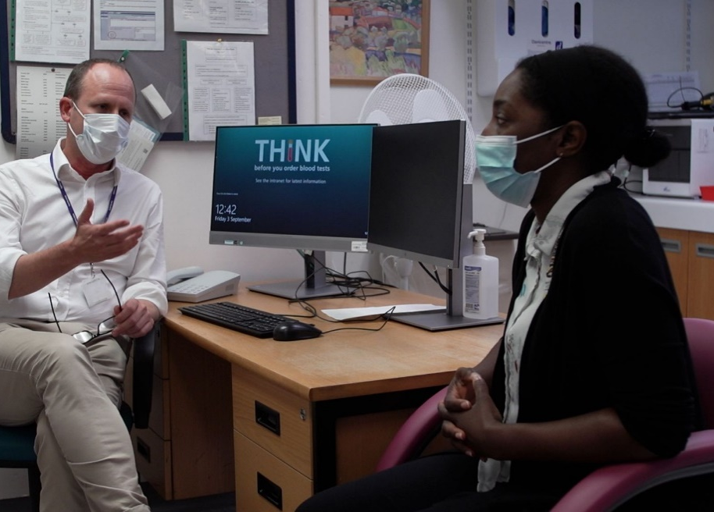

Why have I been invited to take part?
You have been invited to take part in this study because you:
1. Took part in one of the REACT studies carried out by Imperial College London. This would have either been the REACT-1 (nose and throat swab) testing study or the REACT-2 antibody (finger-prick blood) testing study; and
2. Consented to be invited to take part in further research studies.
If you agree to take part in this study, the data you share will be linked to your earlier data collected during the REACT study. This will include the information you answered in response to the original questionnaire.
You do not need to have had COVID-19 or experienced symptoms or ill health related to COVID-19 to take part in this study. Participation from a range of people who have had and have not had COVID-19 is extremely important for helping us understand the impact of the pandemic.
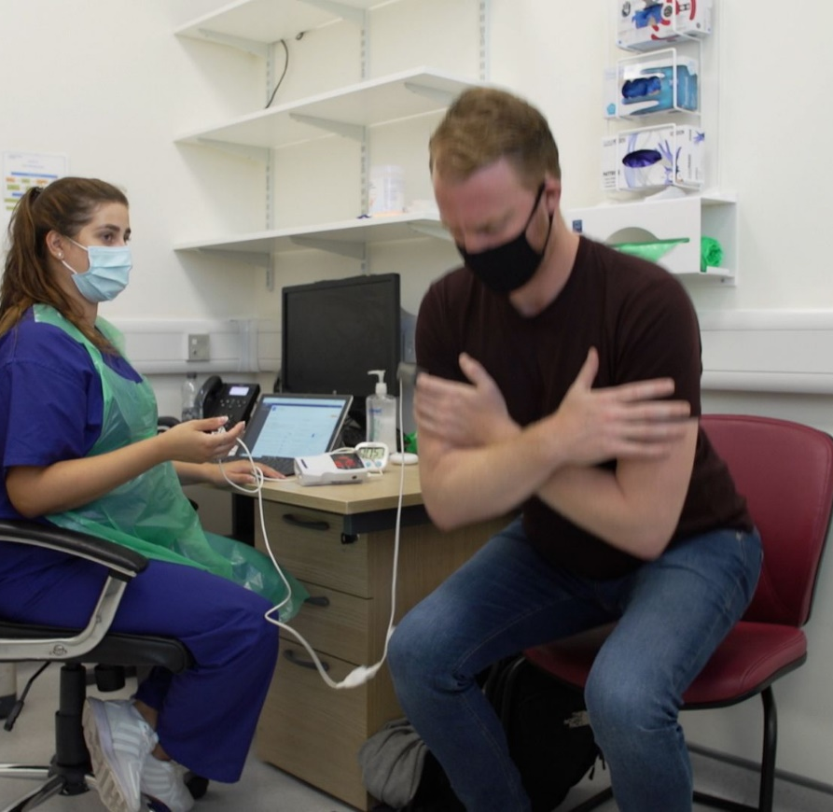  DO I HAVE TO TAKE PART?  No. Whether you take part in the study is entirely up to you. Even if you decide to take part, you can change your mind at any time without giving a reason.  CAN I WITHDRAW FROM THE STUDY?  Yes, you can withdraw from the study at any time without giving reasons. You will have to inform the study team of your wish by phone, email or letter (details in this leaflet). We will then send you a Withdrawal from Study Form which you have to sign and send back to the research team at Imperial College.  You can stop being part of the study at any time, without giving a reason, but we will keep information about you that we already have. We need to manage your records in specific ways for the research to be reliable. This means that we won’t be able to let you see or change the data we hold about you. |  |  |  |  |  |  |  |  | How will this research help others?  The study aims to further our understanding of what differences exist between those who have had COVID-19 and those that haven’t, by exploring what symptoms these groups have experienced since the start of the pandemic.  By identifying the differences we will also be able to see who is most at risk of developing ongoing ill health and how best to treat it and care for those affected.  What does the survey involve?  The survey will contain a mix of multiple-choice and free text questions that will cover:  • Your current health status  • Any recent symptoms, illness and COVID-19 tests  • Impacts of your health and wellbeing on your day to day life  • Underlying health conditions  • You and your sociodemographic background (e.g. age, gender, ethnic group)  • Plus, further questions for people who have had COVID-19 and/or Long COVID exploring any symptoms related to COVID-19 and experiences of any care or support received.  At the end of the survey, you will be invited to do an online assessment to better understand how your cognitive function has been affected by the pandemic. The assessment will take 25-30 minutes to complete. This online test will assess your cognitive ability, including reasoning, working memory, attention, and emotion processing abilities. On completing the assessment, you can choose to view a summary report of your test scores relative to all other people who have undertaken the test.  You may be invited to complete a follow-up survey(s) 12/18 months later, but you can choose to say no.

Our role

Who is carrying out this research?
This research is being run by doctors and researchers from Imperial College London. This research is funded by UK Research and Innovation.

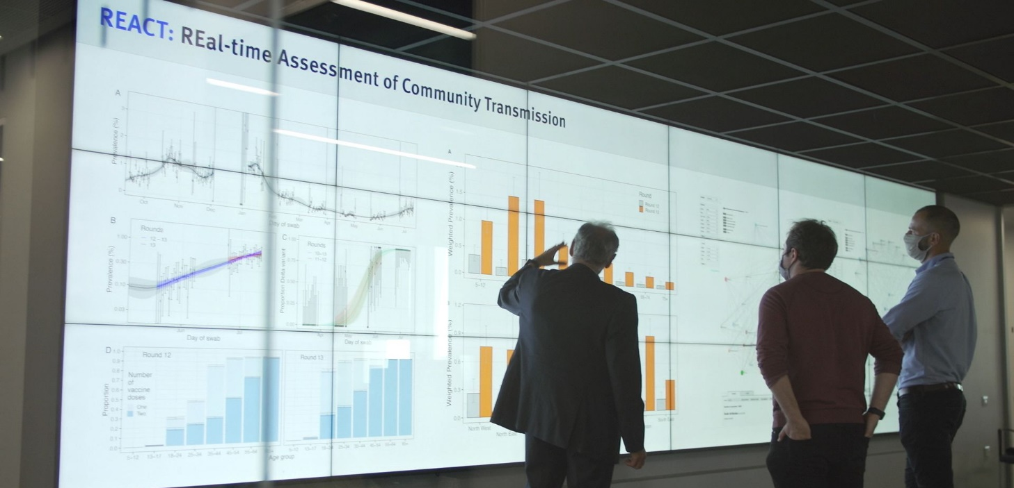

What is the purpose of the study?

REACT Health and Wellbeing survey is part of an extension study to the REal-time Assessment of Community Transmission (REACT) Programme. The main aim of this extension study is to better understand what causes some people to experience ongoing symptoms and ill health after having COVID-19 (commonly described as Long COVID), regardless of how severe the original infection was, whilst others recover quickly.

Through a variety of approaches, this study will explore the role that people’s health, social setting, demographics and environmental exposures (e.g. air pollution) plays in the development and duration of Long COVID. Such insight could improve patient care and support the development of better treatments.
This aspect of the study is focused on exploring the health and wellbeing experiences of the public since the start of the COVID-19 pandemic.

.

Who has reviewed the study?
To protect your interests, all research at Imperial College London is reviewed by an independent group of people called a Research Ethics Committee. This study has been reviewed and granted approval by the South Central Berkshire B Research Ethics Committee.

What will happen to the results of this research study?
The results of this study may be shared in many different ways, such as being published in medical journals, presented at meetings of scientists and reported to both Imperial College, London and the Health Research Authority who oversee and review how research takes place in England. No personally identifiable information about you will be made available outside of the study team.

Contact details
If you have any questions not covered here, you can contact a member of the imperial study team at: XXXX

YOur data

What will you do with my data?
Your survey data (and cognitive assessment data if you take part in this aspect) will be held on secure servers at Imperial College London, linked to your earlier data collected during the REACT study, and given a unique study code so that your identity remains confidential.
If you have consented to health data linkage, Imperial College London will also use information from your medical records held by NHS England and other UK public health bodies for this research project. This information will be linked by your NHS number.
Investigators will use this information to monitor the long term health status of participants from this study. Unless they really need to know who you are, they will not be able to see your name or contact details. Your data will have a code number instead. The number of people who access this information will be kept to a minimum.
We will keep all information about you safe and secure.
Once we have finished the study, we will keep some of the data so we can check the results. We will write our reports in a way that no-one can work out that you took part in the study.
Imperial College and other research institutions both academic and commercial may continue to carry out research using the de-identified data collected during the study. The results of any research that is published, whether by Imperial College or anyone else, will never identify you. See ‘Do you share my information with others’ to learn more. From time to time we may invite you to other research studies that you might be interested in participating in. Even if you receive invitations to future studies, there is no obligation to take part and you can drop out at any time.
The information you share with us as part of this study will only be used for the purpose of health and care research or to contact you about future opportunities to participate in research. It will not be used to make decisions about your healthcare or future services available to you, such as insurance.

How will you protect my privacy?
Your name, address, email will be kept separate from your study data and only linkable by your unique study code. This is in case the Imperial College study team need to contact you about research that your data has been used in. Your contact details will never be passed to another organisation without your permission and will not be visible to the investigators performing the analysis. The results of any research that is published, whether by Imperial College or anyone else, will never identify you. See p6 ‘Do you share my information with others’ to learn more.

What will happen to the information I provide?
Imperial College London is the sponsor for this study and will act as data controller for this study. This means that we are responsible for looking after your information and ensuring that the processing complies with the General Data Protection Regulation (GDPR).
Imperial College London will keep your personal data for 20 years after the study has finished.
Imperial College London has regular internal and external audits of their information security controls and working practices and are accredited to the International Standard for Information Security, ISO 27001.

Do you share my information with others?
So that the maximum information can be obtained from your participation in this study we may make the deidentified data available to other researchers.
It is important that researchers understand as broadly as possible the factors concerning your health now, and in the future to identify as accurately as possible what puts people at greater risk of developing COVID-19, experiencing severe illness or suffering from ongoing ill health. We therefore require your consent for Imperial College London to link data (such as your GP health records) held by NHS England and other UK public health bodies to the REACT study data. This will provide information on the long term health status of the participants. An example of the use of this information would be to enable the monitoring of the longer term effects of COVID-19 on health. You can withdraw this consent at any point.
Researchers in the UK and overseas who wish to access the data from this study and/or to contact participants about future research will have to apply to a Data Access Committee composed of at least three of the study investigators and at least one public representative.

Where can I find out more about how my information is used?
You can find out more about how we use your information
- at www.hra.nhs.uk/information-about-patients/
- by sending an email the research team: XXXXX

Confidentiality
Your personal data will never be available to the general public in any circumstances. The results of this research are likely to be published but will not contain personal information which could identify you such as name, age, gender, ethnicity. Please keep this information sheet for reference.

International transfers
There may be a requirement to transfer information to countries outside the United Kingdom (for example, to a research partner). Where this information contains your personal data, Imperial College London will ensure that it is transferred in accordance with data protection legislation.

Sharing your information with others
For the purposes referred to in this participant information sheet and relying on the bases for processing as set out above, we will share your personal data with certain third parties:
- Other College employees, agents, contractors and service providers (for example, suppliers of printing and mailing services, or suppliers who help us carry out any of the activities described above). Our third party service providers are required to enter into data processing agreements with us. We only permit them to process your personal data for specified purposes and in accordance with our policies and they are required to delete the data when no longer needed to provide the service.

Legal basis
As a university we use personally-identifiable information to conduct research to improve health, care and services. As a publicly-funded organisation, we have to ensure that it is in the public interest when we use personally-identifiable information from people who have agreed to take part in research. This means that when you agree to take part in a research study, we will use your data in the ways needed to carry out analysis conduct research study.
Health and care research should serve the public interest, which means that we have to demonstrate that our research serves the interests of society as a whole. We do this by following the UK Policy Framework for Health and Social Care Research
Our legal basis for using your information under General Data Protection Regulation (GDPR) and the Data Protection Act 2018, is as follows:
- Imperial College London- “performance of a task carried out in the public interest” (Article 6(1)(e) in the GDPR);
- Where special category personal information is involved, Imperial College London rely on “scientific or historical research purposes or statistical purposes (Article 9(2)(j) in accordance with Article 89(1) in the GDPR)”.
Your usual statutory rights to be able to access, change or move your information are limited, because of exceptions applicable to some types of research, and also because we need to manage your information in specific, lawful ways in order for the research to be reliable and accurate.

Can I claim compensation if I am harmed during the study?
If you are harmed by taking part in this research project, there are no special compensation arrangements. If you are harmed due to someone’s negligence, then you may have grounds for a legal action. Regardless of this, if you wish to complain, or have any concerns about any aspect of the way you have been treated during the course of this study then you should immediately inform the Principal Investigator Professor Paul Elliott at XXXX The normal National Health Service complaints mechanisms are also available to you. If you are still not satisfied with the response, you may contact the Imperial College Research Governance and Integrity Team at rgitcoordinator@imperial.ac.uk.

How To Make A Complaint
If you wish to raise a complaint on how we have handled your personal data, please contact:
- The REACT Study Team at XXXXX

- Imperial College London’s Data Protection Officer via email at dpo@imperial.ac.uk, via telephone on 020 7594 3502 and/or via post at Imperial College London, Data Protection Officer, Faculty Building Level 4, London SW7 2AZ.
If you are not satisfied with our response or believe we are processing your personal data in a way that is not lawful you can complain to the Information Commissioner’s Office (ICO). The ICO does recommend that you seek to resolve matters with the data controller (Imperial College London) first before involving the regulator. You can find details about how to contact the Information Commissioner’s Office at https://ico.org.uk/global/contact-us/ or by sending an email to: casework@ico.org.uk

