Investigating links between long-term exposure to air pollution and COVID-19 health outcomes in cohort studies with individual-level data: A systematic review and meta-analysis

By

Abigail B. Schneider

B.A., Wellesley College, 2021

Thesis Submitted in Partial Fulfilment of the
Requirements for the Degree of
Master of Public Health

In the
School of Public Health
Faculty of Medicine
Imperial College London

22 August 2022
CID: 02151164
Word count: 10,988

Table of Contents
List of Tables 6
List of Figures 7
List of Abbreviations in Order of Appearance 8
Abstract 9
1. Introduction 10
1.1 Coronavirus Disease 10
1.2 Air Pollution 11
1.3 Air Pollution and COVID-19 12
1.4 Rationale 13
1.5 Aim 14
1.6 Objectives 14
2. Methods 16
2.1 PECOS 16
2.2 Search Strategy 16
2.3 Screening 17
2.4 Data Extraction 19
2.5 Description of Quality Assessment Scoring 19
2.6 Statistical Analysis 20
3. Results 22
3.1 Study Screening and Selection 22
3.2 Characteristics of Studies Selected for Inclusion 23
3.3 Descriptive Summary of Included Studies 31
3.4 Quality Assessment Scores 32
3.5 Population Overlap Consideration for Meta-Analysis 34
3.6 Studies Excluded from Meta-Analysis 34
3.7 Results from Meta-Analysis 35
3.8 Results from Sensitivity Analyses 44
4. Discussion 47
4.1 Principal Findings and Comparison with Previous Research 47
4.2 Strengths and Limitations 51
4.2.1 Strengths 51
4.2.2 Limitations 51
5. Conclusion and Public Health Recommendations 54
References 56
Appendix 1: Search Strategy by Database 62
Appendix 2: Inclusion/Exclusion Criteria by PECOS 63
Appendix 3: Data Extraction Spreadsheet 64
Appendix 4: Risk of Bias/Quality Assessment Instrument 65
Appendix 5: Pollutant/Outcome Pairs as Examined by Studies in the USA and UK 73
Appendix 6: Results from Random-Effects Models Presented by Pollutant/Outcome Pair 74
Appendix 7: Additional Sensitivity Analyses 76

List of Tables

Table 1: Narrative table summarising the study characteristics of all studies identified as eligible for inclusion in the final systematic review. Table includes study reference; study setting; study design; details about exposure assessment; health outcomes investigated; quality assessment classification; and significant findings reported by a 1µg/m³ increase in exposure to the pollutant of interest.

Table 2: Important confounders associated with COVID-19 and long-term exposure to air pollution. All studies included in the review are listed and if a study has adjusted for a particular confounder in its final model, it is marked with an “x.”

Table 3. Summarised results from the meta-analysis presented by pollutant/outcome pair. Includes pooled RR, associated 95% CI, number of studies included in the random-effects model, and I² value signifying the amount of heterogeneity present between studies identified by the random-effects model.

List of Figures

Figure 1: Depicts the PECOS framework broken down by category as relates to the chosen research question.

Figure 2: PRISMA 2020 flow diagram depicting the searching, retrieval, and screening process of the systematic review.

Figure 3: Forest plot depicting the results from the random-effects model investigating the relationship between PM_{2.5} exposure and COVID-19 hospitalisation.

Figure 4: Forest plot depicting the results from the random-effects model investigating the relationship between PM_{2.5} exposure and COVID-19 mortality.

Figure 5: Forest plot depicting the results from the random-effects model investigating the relationship between PM_{2.5} exposure and COVID-19 ICU admission.

Figure 6: Forest plot depicting the results from the random-effects model investigating the relationship between PM_{2.5} exposure and COVID-19 infection.

Figure 7: Forest plot depicting the results from the random-effects model investigating the relationship between NO₂ exposure and COVID-19 hospitalisation.

Figure 8: Forest plot depicting the results from the random-effects model investigating the relationship between NO₂ exposure and COVID-19 mortality.

Figure 9: Forest plot depicting the results from the random-effects model investigating the relationship between NO₂ exposure and COVID-19 ICU admission.

Figure 10: Forest plot depicting the results from the random-effects model investigating the relationship between NO₂ exposure and COVID-19 infection.

Figure 11: Forest plot depicting the results from the random-effects model investigating the relationship between PM₁₀ exposure and COVID-19 infection.

Figure 12: Forest plot depicting the results from the random-effects model investigating the relationship between NO_{x} exposure and COVID-19 infection.

Figure 13: Forest plot depicting the results from the random-effects model investigating the relationship between O₃ exposure and COVID-19 ICU admission.

Figure 14: Forest plot depicting the results from the sensitivity analysis investigating the relationship between PM_{2.5} exposure and COVID-19 hospitalisation in cohorts from North America.

Figure 15: Forest plot depicting the results from the sensitivity analysis investigating the relationship between PM_{2.5} exposure and COVID-19 hospitalisation in studies classified as “Good” by the quality assessment instrument.

Figure 16: Forest plot depicting the results from the sensitivity analysis investigating the relationship between NO₂ exposure and COVID-19 mortality in cohorts from North America.

Figure 17: Forest plot depicting the results from the sensitivity analysis investigating the relationship between NO₂ exposure and COVID-19 mortality in studies classified as “Good” by the quality assessment instrument.

List of Abbreviations in Order of Appearance

COVID-19 | Coronavirus disease
WHO | World Health Organization
PCC | Post COVID conditions
PM_{2.5} | Particulate matter with a diameter less than 2.5 micrometres
PM₁₀ | Particulate matter with a diameter less than 10 micrometres
CO | Carbon monoxide
O₃ | Ozone
NO_{x} | Nitrogen oxide
NO₂ | Nitrogen dioxide
SO₂ | Sulphur dioxide
PM | Particulate matter
VOC | Volatile organic compounds
ACE2 | Angiotensin converting enzyme 2
ICU | Intensive care unit
LUR | Land use regression model
CI | Confidence interval
IQR | Interquartile range
SD | Standard deviation
OR | Odds ratio
RR | Risk ratio/relative risk
HR | Hazard ratio
ROB | Risk of bias
µg/m³ | Micrograms per metre cubed
ppb | Part per billion
BC | Black carbon
NYC | New York City
CALINE4 | California Line Source Dispersion Model
NRAP | Near roadway air pollution
ELAPSE | Effects of Low-Level Air Pollution: A Study in Europe
NASA | National Aeronautics and Space Administration
ESCAPE | European Study of Cohorts for Air Pollution Effects
AQ | Air quality
FARM | Flexible Air Quality Regional Model
PCR | Polymerase chain reaction
GP | General practitioner
USA | United States of America
UK | United Kingdom
SES | Socioeconomic status
BMJ | British Medical Journal
COMEAP | Committee on the Medical Effects of Air Pollutants
EPA | United States Environmental Protection Agency
UKHSA | United Kingdom Health Security Agency

Abstract

Background: COVID-19 disease swept throughout the world beginning in 2020. As of July 2022, the virus is responsible for more than 6.3 million deaths worldwide. Those infected with COVID-19 disease are at risk of developing long-term side effects, including post-COVID condition, which can interrupt one’s daily life. It has been established that certain individual characteristics can contribute to worsened COVID-19 health outcomes, such being male, Black, and classified as obese. Substantial research has been conducted investigating the relationship between COVID-19 and air pollution, but little evidence has been found to establish a relationship at the individual-level, accounting for the presence of confounding factors such as age, socioeconomic status, and/or comorbidities.

Aims/Objectives: The aim of this study is to investigate the association between a 1µg/m³ increase in exposure to criteria air pollutants (i.e., PM_{2.5}, PM₁₀, NO₂, NO_{x}, and O₃) and the prevalence of COVID-19 health outcomes (i.e., COVID-19 hospitalisation, mortality, ICU admission, and infection) based on individual-level evidence obtained via a systematic review of literature published up through July 2022. Results obtained via the systematic review were pooled by pollutant/outcome pairs in a meta-analysis, calculating the pooled RR and its associated 95% CI.

Methods: A search strategy was developed to obtain the relevant published literature via online database searches of EMBASE, Medline, Scopus, and Web of Science. Search results were screened against the inclusion/exclusion criteria. Relevant data was extracted from the selected studies and quality assessment was conducted to identify sources of error and bias within each study before assigning a relevant score. Studies with effect estimates presented in OR were converted to RR, and data was uploaded to R for meta-analysis using random-effects models.

Results: 16 studies were included in the final systematic review. 14 studies were eligible for meta-analysis. Random-effects models identified statistically significant relationships between a 1µg/m³ increase in exposure to PM_{2.5} and COVID-19 hospitalisation (RR = 1.04; 95% CI: 1.00, 1.15); PM_{2.5} and COVID-19 infection (RR = 1.05; 95% CI: 1.02, 1.07); and NO₂ and COVID-19 hospitalisation (RR = 1.01; 95% CI: 1.00, 1.02). No statistically significant were identified in the remaining random effects models or sensitivity analyses.

Conclusions: Statistically significant relationships were identified between a 1µg/m³ increase in exposure to PM_{2.5} and COVID-19 hospitalisation and COVID-19 infection, as well as between a 1µg/m³ increase in exposure to NO₂ and COVID-19 hospitalisation. Future work is necessary to confirm these relationships and those without statistical significance, due to very few eligible studies available for inclusion in the review at the time when the study was conducted.

1. Introduction

1.1 Coronavirus Disease
As of July 2022, over 6.3 million deaths reported globally can be attributed to Coronavirus disease (COVID-19), defined by the World Health Organization (WHO) as an infectious disease resulting from infection by the SARS-CoV-2 virus.^{1, 2} Since 2020, COVID-19 has been considered a global pandemic by the WHO and is one of the greatest health challenges the modern world has faced, showing no signs of ease as cases continue increasing for the fifth consecutive week since the previous peak in March 2022.² COVID-19 has spread to every country in the world since its elusive outbreak in December 2019 in Wuhan, China but almost three years into the pandemic many countries have lifted protection measures against the virus, despite its continued spread.²⁻⁴

The majority of those who become infected with COVID-19 experience symptoms of respiratory illness that arise between two to fourteen days after infection, but many individuals remain asymptomatic and unknowingly spread the virus to others.² As a result, there have been more than 5.6 hundred million cumulative COVID-19 infections, including reinfections with variants of the disease such as Delta and Omicron, which has raised concerns about the disease’s transmission mechanisms and which populations are most susceptible to infection.⁵ There are several pathways by which COVID-19 can be transmitted, but the primary pathway is via face-to-face interaction through aerosols and respiratory droplets released when coughing, sneezing, talking, or singing.^{6, 7} Asymptomatic individuals account for over 40% of COVID-19 cases and can transmit the virus despite exhibiting no clinical symptoms.^{7, 8}

COVID-19 can induce both short- and long-term health impacts, interrupting one’s daily life and society at large when many people become infected with the virus.⁹ Short-term health impacts of COVID-19 may include but are not limited to a sustained, continuous cough; fever; loss of smell and taste; diarrhoea; and muscle aches and pains.⁹ COVID-19 may also induce long-term health impacts, also known as long COVID or post-COVID conditions (PCC).¹⁰ Little research has been published on PCC due to the relatively short amount of time scientists have had to study the chronic impacts of the virus, but one study published by Lopez-Leon et al. found that 58% of patients with PCC experience prolonged fatigue, 44% endure headaches, and 27% experience long-term dyspnoea, even after the average COVID-19 recovery period of seven to ten days following the onset of symptoms.^{10, 11} The scientific consensus on COVID-19 disease severity has identified male individuals with chronic health conditions such as asthma, lung cancer, and additional comorbidities as having the greatest risk for the most severe COVID-19 outcomes.¹²⁻²⁰

In December 2020 a vaccine against COVID-19 disease was released and has since been circulated worldwide, with 66.9% of all eligible individuals having received at least one dose of the vaccine as of July 2022.²¹ Preliminary findings on the preventative impact of the COVID-19 vaccination suggest that the vaccine has prevented approximately 14.4 million deaths in 185 countries, yet the virus’s mutating genome raises questions on the efficacy.²²⁻²⁶ Therefore, despite the emergence of an effective vaccine, COVID-19 remains a global public health concern as immunity wanes and the virus spreads, facilitated by a reduction in public health measures in many countries at risk for further outbreaks.²⁷⁻³⁰

The magnitude of a response to COVID-19 disease as taken by the global community in 2020 when governments implemented lockdowns and travel restrictions is unlikely to be replicated several years into the pandemic. Regardless of how pervasive the virus remains, due to the desire of world governments to avoid considerable economic consequences of country-wide shutdowns and border closings, governing bodies have adopted individual-level approaches to managing COVID-19 that encourage people to learn to live with the virus rather than risk another global recession that followed the lockdown periods in 2020 and 2021.³¹⁻³⁵ It is important, therefore, that individuals understand their level of personal risk of contracting COVID-19 and how comorbidities are likely to impact the severity of their case, so they make informed decisions regarding personal precautionary measures taken against contracting and spreading the virus.

1.2 Air Pollution
In a 2018 publication, The Lancet Commission on pollution and health identified air pollution as responsible for 16% of global deaths in 2015 alone, establishing it as the universal primary cause of preventable death.^{36, 37} Air pollution, as defined by the WHO, contaminates both indoor and outdoor environments through chemical, physical, and biological means, effectively modifying the chemical composition and intrinsic atmospheric air quality.³⁸ Ambient air pollution refers to outdoor air pollution emissions generated by sectors such as agricultural, energy, power, and transport.³⁹ Deaths due to air pollution are expected to double by the year 2050 if countries continue with business-as-usual emissions, as the window for action to prevent excess deaths due to fossil-fuel emissions rapidly closes while the world approaches the 2030 deadline set by the Intergovernmental Panel on Climate Change to reduce emissions by 45%.^{40, 41} The pollutants identified by the WHO as cause for the greatest public health concern are, in no particular order: particulate matter (PM_{2.5} and PM₁₀), carbon monoxide (CO), ozone (O₃), nitrogen (di)oxide (NO_{x}, NO₂), and sulphur dioxide (SO₂).⁴² The health impacts of these pollutants are not investigated with equal rigour among published scientific literature, and therefore this paper will examine specifically those which have the most robust archives of published research, namely NO_{x}, NO₂, O₃, and PM.

PM is the term for the combination of liquid droplets and solid particles suspended in the air, comprised of a mixture of dirt, dust, smoke, and soot.⁴³ The two types of PM investigated in this study are PM_{2.5} and PM₁₀. PM_{2.5} describes fine particles with a diameter less than 2.5 micrometres, while PM₁₀ refers to the larger particles with a diameter smaller than 10 micrometres.⁴³ When PM are inhaled, their small size allows for easy transport deep into the lungs.⁴³ Inhaled PM pose health risks that affect the heart and lungs, such as an increased risk of developing cardiopulmonary diseases or lung cancer with every 10µg/m³ increase in exposure, as well as a range of mortality and morbidity outcomes.⁴⁴⁻⁴⁶

O₃ is a highly oxidative oxygen gas that can become dangerous to humans when it reacts with NO_{x}, sunlight, and volatile organic compounds (VOC) and is subsequently inhaled at the ground-level.^{47, 48} Long-term O₃ exposure is associated with impaired respiratory functioning and exacerbation of chronic conditions such as asthma, because upon inhalation the gas irritates pulmonary mucous membranes and lung tissues.^{47, 48}

NO_{x} and NO₂ are gases that form as part of the combustion reaction between atmospheric oxygen and nitrogen compounds in fuel or fire.⁴⁹ Emissions typically result from vehicles, power plants, and energy generators.⁴⁹ Long-term exposure to high concentrations of NO_{x} or NO₂ can exert pressure on the respiratory system which may increase one’s susceptibility to respiratory disease and increase the risk of developing asthma.^{46, 49, 50}

1.3 Air Pollution and COVID-19
The current scientific consensus on the interaction between long-term exposure to air pollution and COVID-19 disease is widely debated. Several explanations exist to explain how long-term exposure to criteria pollutants may increase one’s risk of experiencing more severe COVID-19, as well as how the pollutants can impact the biological processes associated with contracting, spreading, or dying from COVID-19. Combined with COVID-19, air pollution may target an individual’s pulmonary immune response and antimicrobial resistance, overwhelming the body’s systems in the lungs and small intestine, the organs mainly responsible for viral load regulation against COVID-19 disease and where viral entry often occurs.^{51, 52} The virus gains entry to host cells by rendering a spike protein to the cell in question while combining with angiotensin converting enzyme 2 (ACE2) receptors to acquire access to the vulnerable cells.^{26, 51, 52} Conditions such as cardiovascular diseases that are associated with poorer COVID-19 health outcomes are also modified by air pollution, the long term effects of which reduce the body’s capacity to fight against the virus and function properly while breathing air with high concentrations of pollutants.⁵²⁻⁵⁴

Since 2020, many studies have been published that suggest an association between long-term exposure to air pollution and COVID-19. However, there is little scientific consensus regarding the validity of these claims because many of the studies in question, despite being highly cited and adjusting for area-level confounding, are ecological in nature (e.g., Wu et al. 2021, Rodriguez-Villamizar et al. 2021) and fall prey to the ecological fallacy.^{55, 56} The ecological fallacy is defined as a scenario where group-level inferences are assumed constant at the individual-level, when in reality the observed association is only valid for the group itself and not for the individuals who compose the group.⁵⁷ Therefore, although the ecological study design is not inherently substandard, attempting to apply it when investigating a potential causal relationship or association between pollutant exposure and a particular health outcome cannot be considered best practice.⁵⁸ To avoid the pitfalls of the ecological analysis, this systematic review only considers manuscripts employing cohort study designs which include individual-level data on either COVID-19 mortality, COVID-19 infection, COVID-19 related hospitalisation, and/or COVID-19 related intensive care unit (ICU) admission. Individual data are data points or responses collected from and associated with one individual, which can then be aggregated for the evaluation and data analysis processes once a potential association has been identified between an individual covariate and the outcome of interest.⁵⁹

If a relationship exists between air pollution and COVID-19, it is vital that public health officials and governments take action to reduce both air pollution levels and COVID-19 cases before one or both unnecessarily take more lives. It is entirely possible for regions and countries to take action to reduce air pollution and COVID-19, making it imperative for public health researchers to conduct well-designed studies investigating this proposed relationship. Even if the relationship between long-term exposure to air pollution and COVID-19 health outcomes is inconclusive or negligible, it remains vital for public health officials to continue pushing for reductions in air pollution, as a relationship has been clearly identified between COVID-19 and impaired respiratory function, which is only exacerbated by the long-term exposure to air pollution.^{44, 54, 60} Additionally, the research must be diversified amongst regions, as most of the literature investigating the relationship between long-term exposure to air pollution and COVID-19 originates in Western countries, leaving a large gap in the knowledge regarding the relationship between long-term exposure to air pollution and COVID-19 health outcomes in African and Asian countries.⁶¹⁻⁶³

1.4 Rationale
Since the beginning of the COVID-19 pandemic, researchers have been undertaking urgently needed studies on the potential relationships between air pollution and COVID-19 health outcomes. Several systematic reviews have been published examining the studies that investigate the relationship between either short- or long-term air pollution, but these reports have not focused specifically on cohort studies with individual data.⁶⁴⁻⁶⁷ Most of the systematic reviews were conducted and subsequently published in 2020, and therefore a plethora of new research has become available in the time between when the original reviews were published and the compiling of the current systematic review.

It is of vital importance from a policy perspective that repeatable, rigorous research is conducted in order to inform public health policy in the upcoming months, when further COVID-19 waves are expected to overwhelm the public and health systems once again.⁶⁸ Because the majority of literature published on the relationship between long-term exposure to air pollution and COVID-19 health outcomes employs ecological study designs, it is critical that a systematic review and meta-analysis analysing the few, good quality studies available utilising individual-level data is available to policy makers and public health officials looking to make recommendations. Additionally, only two of the identified published systematic reviews conduct a meta-analysis.^{64, 69} The first, a review by Zang et al. 2022 conducts a meta-analysis, but does not mention in its title or abstract the term meta-analysis and therefore does not appear in database searches for meta-analyses, and only identifies three cohort studies with individual data, when several others had been published prior to the review’s publication. Additionally, the only health outcomes examined by the study are COVID-19 incidence and COVID-19 mortality. The second, a review from Germany by Pickford et al. 2021, also examines the relationship between ambient air pollution and its impact on viruses.⁶⁹ However, this review looks at a number of viruses, not exclusively COVID-19, does not retrieve papers with exclusively individual-level data, also considers studies of short-term exposure, and the only COVID-19 health outcomes examined are infection and mortality. Therefore, the current review has the potential to provide crucial insights that compare and pool the results of good quality studies with individual data, filling the identified gap in the literature.

1.5 Aim
The aim of this systematic review and meta-analysis is to identify and assess the cohort studies employing individual-level data published between March 2020 and July 2022 that investigate a potential association between long-term exposure to criteria pollutants and COVID-19 disease.

1.6 Objectives
A) Produce a systematic review that employs a robust search strategy updating the report published by Walton et al. in 2021;⁷⁰ identify and select cohort studies detected via database searching that investigate associations between long-term exposure to air pollution and COVID-19 outcomes, specifically: (a) COVID-19 hospitalisation; (b) COVID-19 mortality; (c) COVID-19 ICU admission; and (d) COVID-19 infection.

B) Assess the quality of the studies identified that pass title, abstract, and full-text screening; extract relevant data from the studies selected for inclusion and standardise the effect estimates to relative risk (RR) for every 1µg/m³ increase in exposure to pool them for the meta-analysis process.

C) Conduct a meta-analysis that evaluates and pools the effect estimates presented in the studies selected for inclusion, of the following exposures and outcomes: association between long-term exposure to air pollution and COVID-19 related hospitalisation; association between long-term exposure to air pollution and COVID-19 infection; association between long-term exposure to air pollution and COVID-19 ICU admission; and association between long-term exposure to air pollution and COVID-19 mortality.

D) Evaluate the impact of each study on the results of the meta-analysis through sensitivity analyses that examine subgroups of studies by region and quality assessment score.

E) Apply meta-analysis results to real-world policy issues, making relevant public health recommendations.

2. Methods

2.1 PECOS
This study conducts a systematic review of published literature in line with the PRISMA 2020 statement.⁷¹ Using the PECOS framework, the research question along with inclusion and exclusion criteria were developed for the systematic review and written up into a protocol framework developed by Morgan et al., 2018.⁷²

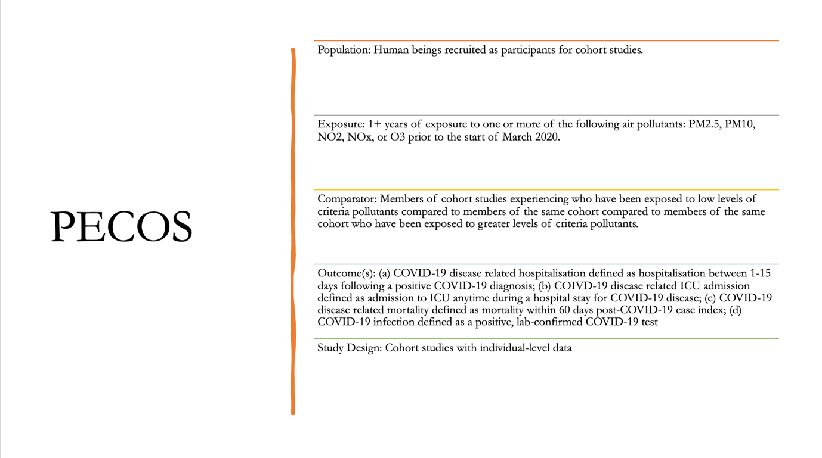
Figure 1. Description of PECOS used to develop the current systematic review. “P” represents population. “E” represents exposure. “C” represents comparator. “O” represents outcome. “S” represents study design.

2.2 Search Strategy
Studies were identified through an online search of the following databases on 1 July 2022: EMBASE, Ovid MEDLINE, Scopus, and Web of Science. Preliminary searches to ensure the proper literature was being identified were conducted on 30 May 2022 and 9 June 2022. The following search string was used to obtain the relevant literature: “air pollution” OR “particulate matter” OR “PM2*” OR “criteria pollutants” OR “NO2” OR “nitrogen dioxide” OR “nitrogen oxide” OR “PM10” OR “O3” OR “ozone” OR “SO2” OR “sulfur dioxide” OR “sulphur dioxide” AND “covid-19” OR “coronavirus” OR “sars-cov-2” OR “covid” AND “cohort stud*” OR “cohort study” OR “prospective stud*” OR “longitudinal stud*” OR “longitudinal study” OR “individual data” AND “long term.” Modified search strategy by database can be found in Appendix 1. Assistance was sought from a medical librarian at Imperial College London to narrow down the search strategy and identify relevant key terms. Search terms were curated to identify keywords in titles and abstracts, and papers in any language except English were excluded. Papers retrieved were timebound by the length of the COVID-19 pandemic, with the start date being March 2020 and the end date being 11 July 2022. Studies were limited to human only outcomes. A total of 502 studies were retrieved via this process. Studies were also retrieved from two additional sources: the Walton et al 2021 report and reference list searching of studies selected for inclusion, from which an additional three studies were selected for inclusion.

2.3 Screening
EndNote20 was used as the reference management software of choice, and all results from each search were uploaded by database.⁷³ Subsequently, references were uploaded to the systematic review management program Covidence to remove duplicates and conduct title, abstract, and full-text screenings.⁷⁴ Before reviewing studies, inclusion and exclusion criteria were specified to ensure that only cohort studies with individual data published between March 2020 through July 2022 examining the association between COVID-19 health outcomes and criteria pollutants were approved for inclusion (Appendix 2). Once uploaded to Covidence, I completed the title and abstract screening process, selecting and excluding studies based on the prespecified inclusion and exclusion criteria.

Following title and abstract screening, I undertook full-text screening to assess a paper’s eligibility for inclusion based on whether it investigated an association between one or more criteria pollutants and one or more of the chosen COVID-19 health outcomes. Finally, study design and use of individual versus aggregate data was considered. All the studies included in this systematic review define long-term exposure to air pollution as exposure from at least one-year prior to the start of the COVID-19 pandemic. Studies were limited to cohort studies with individual data that examine the relationship between long-term exposure to criteria air pollutants and COVID-19 health outcomes that have obtained this information from pre-existing cohorts whom administrators have followed-up regarding COVID-19 outcomes or from hospital records of patients admitted for COVID-19 disease. Authors’ estimates of long-term exposure to air pollution have been gathered from the following sources: previous studies conducted with the cohort in question (e.g., UK Biobank); nearest monitor to hospital admitted for COVID-19 or nearest monitor to patient’s home; modelling, using land use regression (LUR) or satellite data; or a combination of several of the aforementioned methods. A diagram depicting the screening process inspired by the PRISMA flow-diagram can be seen below:

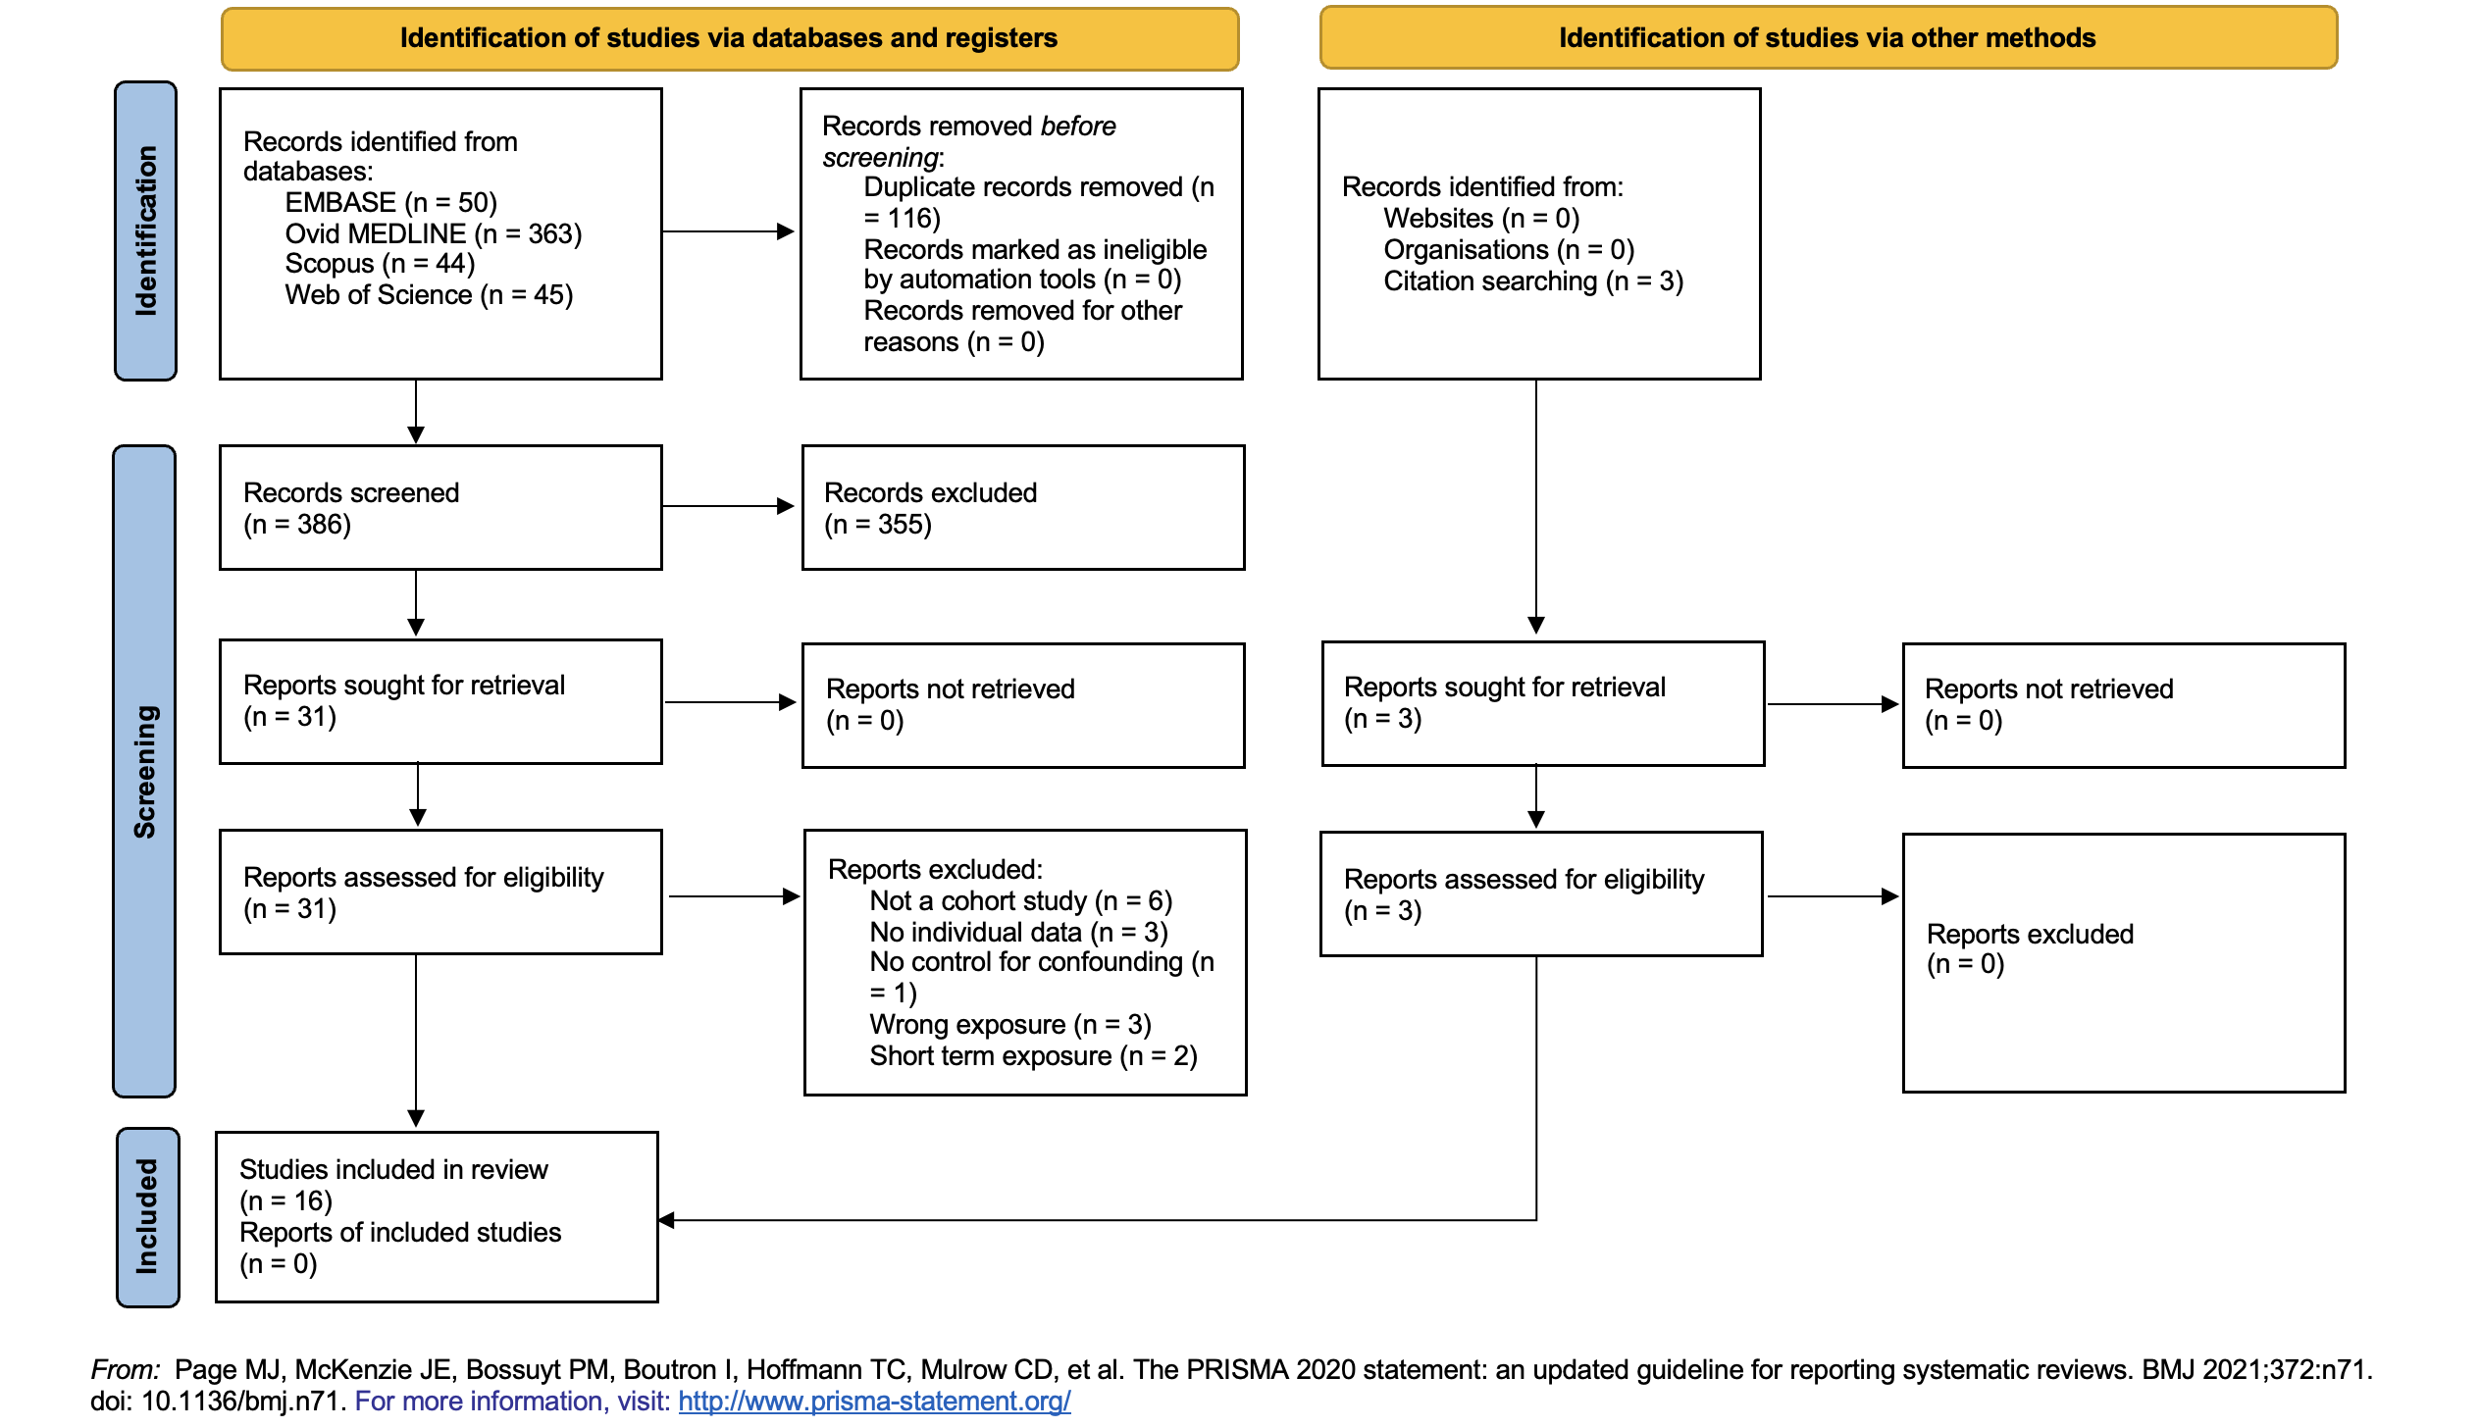
Figure 2. PRISMA 2020 flow diagram for new systematic reviews which included searches of databases and other sources. No registers were searched for this systematic review.

2.4 Data Extraction
Data extraction information was recorded in Microsoft Excel.⁷⁵ A spreadsheet was crafted to guide extraction of all necessary data points from the included papers (Appendix 3). Basic information was extracted first, including study title; date on which extraction took place; study reference; study design; method of analysis; covariates; relevant sensitivity analyses, such as only including patients who had at least one positive COVID-19 test; interaction terms investigated, such as multiplicative interaction between PM_{2.5} exposure and age; aim and objectives; whether study adjusted for any potential confounding factors; and study start and end dates. Study characteristics necessary for the meta-analysis were extracted next, including study’s primary outcome, pollutant exposures, country of residence of study cohort, method of exposure assessment, data sources, number of participants, number of COVID-19 cases, number of COVID-19 hospitalisations, number of COVID-19 deaths, and number of COVID-19 ICU admissions. If a study did not provide the necessary information, the cell was left blank for me to return to later and determine the study’s status for inclusion in the meta-analysis. Numerical data extraction occurred on a separate spreadsheet, with retrieval of effect estimates and associated 95% confidence intervals (CIs); interquartile range (IQR) or standard deviation (SD) values used for reporting effect estimates; and prevalence of the outcome of interest. All effect estimates, whether odds ratios (OR), risk ratios (RR) or hazard ratios (HR) and associated 95% CIs were extracted from a study’s fully adjusted model, meaning the final model produced by the authors that adjusted for all relevant confounders identified, and recorded by outcome and pollutant.

2.5 Description of Quality Assessment Scoring
Following multiple discussions with my supervisors, the decision was made to use the “Risk of Bias Assessment Instrument for Systematic Reviews Informing WHO Global Air Quality Guidelines” as the primary tool for assessing study quality and risk of bias (ROB).⁷⁶ A blank copy of the assessment tool is provided in Appendix 4. Because the ROB tool was published prior to the beginning of the COVID-19 pandemic, small adjustments were made to improve its accuracy for papers that had COVID-19 as the primary outcome, with special attention paid to confounding factors associated with COVID-19 health outcomes. The ROB tool assesses studies on a total of six domains. Each domain included several specific questions, for which a score of one of the following was assigned: “low-risk (1)”, “moderate risk (2),” or “high risk (3).” Papers were ranked as follows: scores less than 1.5 were assigned the rank of “good;” scores greater than 1.5 but less than 2.3 were assigned the rank of “fair;” and scores greater than 2.3 were assigned the rank “poor.” I acted with discretion if a study that scored lower than 2.3 did not adjust for area-level socioeconomic factors or other crucial confounders and assigned it a rank of “poor.”

2.6 Statistical Analysis
Following the data extraction process, reported health effect estimates were reviewed and converted to RR for the meta-analysis. First, the effect estimates and associated 95% CIs were transformed to RR for conversion to 1 microgram per metre cubed (µg/m³) increase in the exposure of interest for pooling and comparison in the meta-analysis. To do so, all values were converted back to their raw beta coefficients calculated during regression by taking the natural log the of the effect estimate. If a study presented its results in parts per billion (ppb), ppb was converted to µg/m³ to ensure that results from all studies could be compared using the same units, by applying the following formula and assuming a constant temperature of 20ºC:⁷⁷

concentration (ppb) = 20.00 x concentration (µg/m³) ÷ pollutant’s molecular weight

Next, beta coefficients were divided by the study’s increase in exposure that RRs were associated with, such as IQR interval or SD, to standardise all effect estimates on a 1µg/m³ scale. Several studies did not include the IQR or SD, nor did they include the value indicating by how much exposure increased, and were therefore excluded from the meta-analysis.^{78, 79} Finally, all beta coefficients were exponentiated, providing effect estimates standardised on a 1µg/m³ scale.

Although most studies presented results in OR, the review team decided that RR was a better metric for reporting results. RRs are easier to interpret, as they represent the ratio of the true risk of the event in each group rather than the ratio of the odds of the event occurring in each group. Therefore, all ORs and associated 95% CIs were converted to RRs using the following formula adapted from Grant 2014:⁸⁰
Relative risk = odds ratio / (1−p₀+(p₀×odds ratio))
(Where p₀ equals the prevalence of the COVID-19 health outcome in the population at risk)
Prevalence was reported directly by the authors, or I calculated the value using the total number of health outcomes that occurred by outcome of interest divided by the total number of study participants. Once ORs were converted to RRs, a meta-analysis was undertaken to calculate pooled effect estimates by outcome and pollutant. Analysis was done in RStudio version 2021.09.0+351 "Ghost Orchid,” using the packages “tidyverse,” “meta,” “metafor,” and “metasens,” as recommended by Harrer et al., 2021.⁸¹ Random effects models were selected as the model of choice due to assumed variability between studies. Potential sources of variation included but were not limited to biological variability (e.g., one population being older than another) and variability in pollutant exposure (e.g., populations were not all exposed to the same concentration of each pollutant). A pollutant/outcome pair was selected for analysis if reported by three or more studies to ensure suitable statistical power. Pooled effect estimates, 95% CIs, and random effect weights were calculated for each study. If two or more studies examined the same pollutant/outcome pair in a single population, the newest study including the most updated data was chosen for inclusion in the meta-analysis. Forest plots depicting pooled effect estimates, 95% CIs, standard errors, and prediction intervals were created to display results from each of the pollutant/outcome random effect models.
Sensitivity analyses were conducted with those pollutant/outcome pairs that retained suitable power once the necessary studies were removed. Two types of sensitivity analysis were conducted: a) by geographical region of study cohort; and b) by quality assessment score, removing any study not classified as “good.” As in the case of the base models, results of sensitivity analyses are presented in forest plots depicting pooled effect estimates, 95% CIs, standard errors, and prediction intervals, by each pollutant/outcome pair that retained enough studies post-removal to warrant a sensitivity analysis.

3. Results

3.1 Study Screening and Selection
502 studies were identified via online database searches. Two additional studies were identified from reviewing reference lists of the studies that passed the screening process (Sheridan et al. 2022; Travaglio et al. 2021), and an additional study was identified via the Walton et al. 2021 report (Zhang et al., 2021), for a total of 505 studies. 116 duplicates were removed, leaving a total of 386 studies to undergo screening. 355 studies were excluded post- title and abstract screening, which left 31 studies for full text screening (Figure 2). Full text screening excluded an additional 18 studies for the following purposes: non-cohort studies (n = 6); studies without individual data (n = 3); studies with no control for confounding (n = 1); studies examining non-criteria pollutants (n = 3); and studies that examined short-term air pollution exposure (n = 2). After full text screening, 16 studies remained for inclusion in the final review.
Full text screening highlighted studies with population overlaps, most frequently the UK Biobank cohort, which was identified as the main cohort under investigation in 31% of the studies included in the review. Therefore, to avoid including multiple analyses of the same cohort, only one study examining UK Biobank outcomes was selected per pollutant/outcome random-effects model. In most cases, this study was Sheridan et al 2022 because it is the most recent UK Biobank publication investigating PM_{2.5}, PM₁₀, and NO₂. In the case of O₃, the only UK Biobank study to investigate this pollutant was Travaglio et al 2021, but the authors chose COVID-19 infection as the primary outcome, a pollutant/outcome pairing only examined by one other study (Kogevinas et al 2021). As a result of only two studies investigating this pollutant/outcome pairing, no random-effects model was run. Travaglio et al 2021 and Chadeau-Hyam et al 2020, both UK Biobank studies that investigated NO_{x} and COVID-19 infection, were included in the analysis for the association between NO_{x} and COVID-19 infection because Chadeau-Hyam et al looked at the full UK Biobank while Travaglio et al looked exclusively at UK Biobank participants in England (Figure 12).
Finally, two additional studies were omitted from the meta-analysis (Lopez-Feldman et al 2021 and Zhang et al. 2021) because authors did not report enough information to convert effect estimates (either raw beta coefficients or OR) from the units of presentation to the 1 µg/m³ scale required to undergo pooling and analysis, leaving a total of 14 studies eligible for meta-analysis.

3.2 Characteristics of Studies Selected for Inclusion
Table 1. Summary table of study characteristics collected during data extraction. Includes a total of 16 studies examining the association between long-term exposure to air pollution and selected COVID-19 health outcomes.
Reference | Setting | Study Design | Exposure Assessment | Health Outcome | Quality Assessment | Significant Findings per 1µg/m³ increase in pollutant exposure
B. Bowe et al., Environ Int. 2021 | United States of America | Prospective cohort study of US Veterans | PM_{2.5}; model of exposure for pollution data from 2018 at 1 km² resolution. Assigned residential address coordinates at an appropriate grid value. | COVID-19 hospitalisation defined as first hospital admission between 7 and 15 days after testing positive. | Good | PM_{2.5}: Association with COVID-19 hospitalisation (RR = 1.05; 95% CI: 1.04, 1.06).
A. Bozack et al., Am J Respir Crit Care Med. 2022 | New York City, United States of America | Retrospective cohort analysis | PM_{2.5}, NO₂, Black Carbon (BC). Combined New York City (NYC) Community Air Survey annual average data merging air pollution samples biweekly from 93 monitoring sites located throughout the five NYC boroughs with LURs to estimate exposure levels. Used data from 2010 census to create 1km radial buffers around the geographic centre of each census block. | (a) COVID-19 mortality defined as death from COVID-19 in hospital as well as "health record–linked post-discharge deaths, such as death after transfer to an inpatient hospice facility;" (b) COVID-19 ICU admission defined as: "patients assigned to the ICU at any point of any hospitalization;" (c) intubation defined as: “patients with an endotracheal tube, nonsurgical airway intubation, or surgical intubation during any encounter.” | Good | NO₂: (a) No association with COVID-19 mortality (RR = 1.00; 95% CI: 0.99, 1.02); (b) or ICU admission (RR = 1.01; 95% CI: 0.99, 1.03).  PM_{2.5}: Association with: (a) COVID-19 related mortality (RR = 1.11 (95% CI: 1.02, 1.21); and (b) COVID-19 ICU admission (RR = 1.13; 95% CI: 1.00, 1.28).
M. Chadeau-Hyam, B. Bodinier et. al, Int J of Epi. 2020 | United Kingdom | Prospective cohort study | NO_{x}, PM₁₀, PM_{2.5} absorbance/m (soot), PM_{2.5}; estimated from 2010 residential address using European-level LUR. | Positive COVID-19 test defined as: "at least one of their test results was positive, and negative otherwise." | Fair | NO_{x}: No association with COVID-19 infection (RR* = 1.00; 95% CI: 0.99, 1.01).  PM_{2.5}: Association with positive COVID-19 test: (RR* = 1.10; 95% CI: 1.00, 1.20).  PM₁₀: No association with COVID-19 infection: (RR* = 0.99; 95% CI: 0.95, 1.02).
C. Chen et al., CMAJ. 2022 | Ontario, Canada | Prospective cohort study | NO₂, O₃, PM_{2.5}; cohort data linked to Ontario’s Registered Persons Database obtaining individuals’ annual residential address from at least 5 years before 2020. Annual exposure data from surfaces of PM_{2.5}, NO2 and O₃ developed previously by van Donkelaar et al. used to calculate patients' "long-term exposures to air pollutants as the average postal code–specific annual concentrations at their residential addresses in the 5 years before the pandemic (2015 to 2019)." | (a) COVID-19 hospitalisation; (b) COVID-19 ICU admission; (c) COVID-19 mortality. No further definitions provided. | Good | NO₂: No association with: (a) COVID-19 hospital admission (RR* = 1.02; 95% CI: 0.99, 1.04); (b) COVID-19 ICU admission (RR* = 1.00; 95% CI: 0.99, 1.01); or (c) COVID-19 mortality (RR* = 1.00; 95% CI: 0.98, 1.03)  O₃: Association with: (a) COVID-19 hospitalisation (RR* = 1.02; 95% CI: 1.00, 1.03); (b) COVID-19 ICU admission (RR* = 1.03; 95% CI: 1.01, 1.04); (c) and COVID-19 mortality (RR* = 1.02; 95% CI: 1.00, 1.03)  PM_{2.5}: Association with: (a) COVID-19 hospitalisation (RR* = 1.03 (95% CI: 1.01, 1.07).  No association with: (a) ICU admission (RR* = 1.05; 95% CI: 0.99, 1.12); or (b) mortality (RR* = 1.00; 95% CI: 0.94, 1.06).
Z. Chen et al., Environ Int. 2021 | California, United States of America | Retrospective cohort study | NO_{x}; California Line Source Dispersion Model (CALINE4) exposure history with detailed residential history, residential address history retrieved from the Geographically Enriched Member Sociodemographic DataMart for KPSC Utility for Care Data Analysis; CALINE4 model (Benson, 1989) applied exposure estimate to near roadway air pollution at the coordinates for motorway and non-motorway roads including traffic emissions (California Air Resources Board, 2017) calculated within a 5-km buffer of residential address, including volume of traffic, “roadway geometry” and weather/meteorological data. | (a) COVID-19 related mortality defined as mortality within 60 days post-case index date; (b) COVID-19 severity (hospitalisation and ICU admission) defined as COVID-19 hospitalisation and/or ICU admission within 30 days after the case index date. | Fair | NO_{x}: No association observed between NO_{x} exposure and COVID-19 hospitalisation (RR* = 0.99; 95% CI: 0.96, 1.02).  Association with non-freeway related near roadway air pollution (NRAP) and: (a) COVID-19 ICU admission (RR* = 1.12; 95% CI: 1.04, 1.19); and (b) COVID-19 mortality (RR* = 1.10; 95% CI: 1.03, 1.18).
Z. Chen et al., Am. J of Respir Crit Care Med. 2022 | California, United States of America | Retrospective cohort study | PM_{2.5}, NO₂, O₃; Estimated daily averages for air pollutant levels at participants’ residential addresses based on accumulated hourly and daily air quality data from ambient monitoring stations reported to EPA Air Quality System and the California Air Resources Board’s Air Quality and Meteorological Information System. California monitoring stations spaced 20-30 km apart in residential areas. Regional air quality assignments using 1x1 km gridded data. | (a) COVID-19 related mortality within 60 days after diagnosis; (b) COVID-19 severity defined as COVID-19-related hospitalisations, and ICU admissions within 30 days after COVID-19 diagnosis. | Good | NO₂: (a) single pollutant models showed an association with COVID-19 hospitalisation (RR* = 1.01, 95% CI: 1.00, 1.02); and (b) ICU admission (RR* = 1.03, 95% CI: 1.01, 1.04).  Multi-pollutant models attenuated the exposure, and NO₂ was not associated with the COVID-19 health outcomes after adjusting for long-term PM_{2.5} exposure. No association with COVID-19 mortality (RR* = 1.01; 95% CI: 0.99, 1.02).  O₃: No association observed: (RR* = 1.00; 95% CI: 0.99, 1.01).  PM_{2.5}: single pollutant models showed an association with: (a) COVID-19 related hospitalisation (RR* = 1.14, 95% CI: 1.09, 1.19); (b) COVID-19 mortality (RR* = 1.07, 95% CI: 1.01, 1.12); and (c) COVID-19 ICU admission (RR* = 1.20, 95% CI: 1.20, 1.10, 1.32).
J. Elliott et al., Euro J of Epi. 2021 | United Kingdom | Prospective cohort study | NO_{x}, PM₁₀, PM_{2.5} (absorbance/m) soot, PM_{2.5}; Environmental exposures modelled levels of NO_{x} and PM₁₀, PM_{2.5} and PM_{2.5} absorbance at residential address in 2010 as seen in de Hoogh K, 2013. | COVID-19 mortality, defined as a death coded as COVID-19 related death in national death registries. | Fair | NO_{x}: No association with mortality (RR* = 1.00; 95% CI: 0.99, 1.02).  PM10: No association with mortality (RR* = 1.04; 95% CI: 0.96, 1.28).  PM_{2.5}: No association with mortality (RR* = 0.94; 95% CI: 0.76, 1.17).
M. Kogevinas et al., Environ Health Perspectives. 2021 | Catalonia, Spain | Prospective cohort study | PM_{2.5}, (BC)¹, NO₂, O₃; estimated exposure from 2018–2019 at participants’ pre-pandemic residential addresses using Effects of Low-Level Air Pollution: A Study in Europe (ELAPSE). Participants assigned an annual average based on 2010 concentration extracted from predicted surfaces (100×100m) taken from the ELAPSE model. | Cases of COVID-19 disease defined as those reporting any of the following: COVID-19 hospital admission; prior, positive diagnostic test for SARS- CoV-2 infection (polymerase chain reaction, antigen test, or serology test, or ≥ four COVID-19 related symptoms combined with being in contact with a diagnosed COVID-19 case correlated with the presence of antibodies. | Good | NO₂: Association with COVID-19 infection (RR = 1.01, 95% CI: 1.00, 1.03).  No association observed with COVID-19 ICU admission (RR = 1.03; 95% CI: 0.99, 1.07).  O₃: No association with: (a) COVID-19 infection (RR = 0.99; 95% CI: 0.97, 1.00); or (b) ICU admission (RR = 0.97; 95% CI: 0.93, 1.02).  PM_{2.5}: Association with: (a) COVID-19 infection (RR = 1.11, 95% CI: 1.02, 1.21); (b) and COVID-19 ICU admission (RR = 1.32, 95% CI: 1.04, 1.70).
Lopez-Feldman et al., The Science of the total environment. 2021 | Mexico City, Mexico | Retrospective cohort study | PM_{2.5}; Data from National Aeronautics and Space Administration (NASA) satellites combined with ground level observations from the WHO; air pollution level measures obtained after averaging 1.1 × 1.1 km² grid-cells (0.01 × 0.01 degrees) within each municipality each year; for accuracy’s sake, authors restricted analyses to those municipalities whose centre was ≤ 7km away from a monitoring station. | COVID-19 related mortality. No additional information provided. | Poor | Authors report evidence of an association between long-term exposure to PM_{2.5} and NO₂ and COVID-19 mortality, but do not report number of COVID-19 cases or number of participants in their study. Therefore, these results are excluded from the meta-analysis and prevalence could not be calculated.
M. Marquès et al., Environ Int. 2022 | Catalonia, Spain | Retrospective cohort study | NO₂, PM₁₀; closest monitor from the Catalan Atmospheric Pollution Monitoring and Forecasting Network allocated to each participating hospital, average long-term exposure estimated from calculating the median concentration of pollutant of interest with data from 1 January 2014 to 13 March 2020. | (a) COVID-19 related mortality; (b) and COVID-19  severity defined as hospitalisation. | Poor | NO₂: No association with COVID-19 mortality (RR* = 0.99; 95% CI: 0.98, 1.00)  PM₁₀: Associated with COVID-19 mortality (RR* = 1.03, 95% CI: 1.02, 1.05).  Additionally, authors were unable to find an association between NO₂ or PM₁₀ and COVID-19 hospitalisation, and therefore did not report the SD or IQR values necessary to standardize the effect estimates, and therefore these results are noncommunicable and have been left out of the analysis.
A. Mendy et al., Resp Med. 2021 | Cincinnati Ohio, United States of America | Retrospective cohort study | PM_{2.5} exposure estimated on a 0.01◦ × 0.01◦ grid using a validated exposure prediction model merging satellite, modelled, and monitored PM_{2.5} data. Aggregated PM_{2.5} exposure estimates at the patients’ zip codes from 2008 to 2017. | COVID-19 related hospitalisation defined  admission related to COVID-19 of ≥24 hours to a hospital or clinic within the University of Cincinnati healthcare system following the diagnosis. Delay between COVID-19 diagnosis and hospitalization no more than a week and the diagnosis reconfirmed upon admission. | Fair | PM_{2.5}: No association with COVID-19 hospitalisation (RR* = 1.00; 95% CI: 0.93, 1.05).
A. Mendy et. al, Respirology 2021 | Cincinnati, Ohio, United States of America | Retrospective cohort study | PM_{2.5}; exposure estimated on a 0.01◦ × 0.01◦ grid using a validated exposure prediction model merging satellite, modelled, and monitored PM_{2.5} data. Aggregated PM_{2.5} exposure estimates at the patients’ zip codes from 2009 to 2018. | COVID-19 hospitalisation defined as  admission to hospital following diagnosis ≥24 consecutive hours. | Fair | PM_{2.5}: Association with COVID-19 hospitalisation (RR* = 1.15, 95% CI: 1.09, 1.22).
C. Sheridan et al., Environ Pollut. 2022 | United Kingdom | Prospective cohort study | PM_{2.5}, PM₁₀, NO₂; European Study of Cohorts for Air Pollution Effects (ESCAPE) project developed LUR models for annual average air pollution. Estimates assigned to participants' residential address as provided at baseline in 2010, as England air pollution levels have shown consistency since 2010. | (a) Covid-19 hospitalisation defined as confirmed COIVD-19 case upon hospitalisation by a positive lab confirmed test; (b) Covid-19 related mortality defined as death among confirmed COVID-19 case defined as positive lab confirmed test. | Good | NO₂: No association with: (a) COVID-19 infection (RR* = 0.99; 95% CI: 0.98, 1.01); (b) COVID-19 hospitalisation (RR* = 1.01; 95% CI: 0.98, 1.04); or (c) COVID-19 mortality (RR* = 0.99; 95% CI: 0.95, 1.04).  PM_{2.5}: Association with COVID-19 infection (RR* = 1.04, 95% CI: 1.02, 1.06).  No association with: (a) COVID-19 hospitalisation (RR* = 1.01; 95% CI: 0.96, 1.07); (b) or COVID-19 mortality (RR* = 1.00; 95% CI: 0.91, 1.09).
M. Travaglio et al., Envrion Pollut. 2021 | England, United Kingdom | Retrospective cohort study | O₃, NO_{x}, NO₂, PM_{2.5}, PM₁₀; European Study of Cohorts for Air Pollution Effects (ESCAPE) LUR for annual average air pollution data. Annual aggregated air quality (AQ) values determined by the European Environmental Agency based on direct observations from multiple monitoring stations located across England. O₃, NO₂, and NO_{x} AQ values represent the annual average of daily measurements for each air pollutant from 2018 to 2019 in each specified region. Pollution Climate Mapping data from UK Air Information Resources with information from air quality stations located throughout England. | (a) COVID-19 related mortality; (b) COVID-19  infectivity. No further information provided. | Fair | NO₂: Association with COVID-19 infection (RR* = 1.03, 95% CI: 1.02, 1.032).  NO_{x}: Association with COVID-19 infection (RR* = 1.01, 95% CI: 1.00, 1.02).  PM₁₀: Association with COVID-19 infection (RR* = 1.04, 95% CI: 1.02, 1.06).  PM_{2.5}: Association with COVID-19 infection (RR* = 1.06, 95% CI: 1.04, 1.09).
G. Veronesi et al., Occ and Environ Med. 2022 | Varese, Italy | Prospective cohort study | O₃, NO_{x}, NO₂, PM_{2.5}, PM₁₀. Estimates of annual and seasonal average ground level pollutants were available for the year 2018 over an area 40km wide at a spatial resolution of 1 km x 1 km. Flexible Air quality Regional Model (FARM) used to model concentrations. Participants' exposure was assigned based on nearest grid centre to residential address on 31 December 2017. | Positive COVID-19 cases defined as a positive  polymerase chain reaction (PCR) test. | Good | NO₂: Association with COVID-19 infection (RR = 1.01, 95% CI: 1.00, 1.03).  NO_{x}: No association with COVID-19 infection (RR = 1.02; 95% CI: 0.99; 1.05).  O₃: No association with COVID-19 infection (RR = 0.98; 95% CI: 0.97, 0.99).  PM₁₀: Association with COVID-19 infection (RR = 1.03, 95% CI: 1.01, 1.05).  PM_{2.5}: Association with COVID-19 infection (RR = 1.04, 95% CI: 1.01, 1.06).
Y. Zhang et. al., Mech Ageing Dev. 2021 | United Kingdom | Retrospective cohort study | PM_{2.5}, PM₁₀, NO₂, and NO_{x}, but because they only observed an association between NO₂ and COVID-19 positivity, authors only reported results for NO₂, introducing reporting bias into the study. Small Area Health Statistics Unit as part of the BioSHaRE-EU Environmental Determinants of Health Project. No information included regarding how exposures were assigned to participants. | Nose and/or throat swabs were taken from hospitalized patients and detection of SARS-CoV-2 can be reported as positive or negative. | Fair | Authors report their results by IQR, but do not report by how much the risk increases when exposure increases, nor do they provide a standard value for effect estimates by which to measure exposure levels against. Reporting bias present as authors do not report the results for pollutants that they did not observe an association.

3.3 Descriptive Summary of Included Studies
Two types of cohort studies were identified in the search process: prospective and retrospective cohort studies. Seven were prospective cohort studies that identified cohorts and followed them through until study end date, collecting information on occurrence of COVID-19 health outcomes and long-term environmental exposures. The 11 remaining studies use a retrospective cohort study design, acquiring COVID-19 health outcome data from administrative sources, hospitals, and general practitioner (GP) records, and environmental exposure data from LURs, satellites, and monitors scattered throughout the region where the study took place.
37.5% of studies were conducted with data from the United States of America (USA), with two coming from California (Z. Chen et al., 2021; Z. Chen et al., 2022);^{82, 83} two from Cincinnati, Ohio (Mendy et al. 2021, as well as another by Mendy et al., 2021); ^{84, 85} one from NYC (Bozack et al., 2021);⁸⁶ and one examining USA military veterans living throughout the country (Bowe et al., 2021).⁸⁷ Studies from the USA examined PM_{2.5}, NO₂, NO_{x}, and O₃ as environmental exposures and investigated all COVID-19 health outcomes except for COVID-19 infection.
The five studies from the United Kingdom (UK) all utilized the UK Biobank cohort, which includes approximately 500,000 subjects. Combined, authors examined the association between all COVID-19 health outcomes and PM_{2.5}, NO₂, NO_{x}, and PM₁₀ as environmental exposures. Among the UK Biobank studies, only two (Elliott et al. 2021; and Sheridan et al. 2022) included the entire cohort. Travaglio et al. examined only participants who were tested for COVID-19 in England. Both Chadeau-Hyam et al. 2020 and Zhang et al. 2021 only included UK Biobank participants who had been tested for COVID-19 at the time of data collection, but Zhang et al.’s cohort is larger (n = 7,362) because their data collection period extended two months past Chadeau-Hyam’s (n = 4,509) when more participants had been given the opportunity to test for COVID-19.
A table depicting the specifics of pollutant/outcome pairs examined by studies conducted in the USA and UK can be found in Appendix 5.
The remaining five studies came from Spain (n = 2), Canada (n = 1), Italy (n = 1), and Mexico (n = 1). In total, North America produced the most studies (n = 8), followed by Europe (n = 5). Only one study was conducted by a research group based in China (Zhang et al. 2021), but this group examined the UK Biobank cohort.
The average study size across all the studies was 111,750 (median = 74,915) participants. Nonetheless, a wide range exists in the number of participants each study included, from 1,128 participants to 473,550 participants, which suggests much variation in cohort size across studies.
Exposure assessment was conducted through several methods. Five studies employed only a LUR for model exposure assessment at residential address for participants. Three studies used nearest monitor data exclusively. The remaining eight studies employed a combination of nearest monitor data, LUR, and satellite data. Fourteen studies examined PM_{2.5}; nine examined NO₂; six examined NO_{x}; seven examined PM₁₀; and five examined O₃. Eleven papers included data on more than one pollutant.
Regarding outcomes examined: half of the studies (n = 8) looked at COVID-19 hospitalisation; half (n = 8) looked at COVID-19 mortality; three looked at COVID-19 ICU admission; five looked at COVID-19 infection; and six studies included multiple COVID-19 health outcomes. Twelve studies used data collected only in 2020. Bowe et al. 2021 and Veronesi et al. 2022 combined data from 2020 and 2021. Only C. Chen et al. 2022 used data collected exclusively in 2021. No studies included data from 2022.

3.4 Quality Assessment Scores
The quality assessment instrument classified seven studies as “Good,” seven studies as “Fair,” and two studies as “Poor” (Table 1). The key factor determining a study’s quality was its success at adjusting for confounding factors associated with air pollution exposure and COVID-19, such as area-level socioeconomic status (SES), race, and presence of comorbidities prior to contracting COVID-19. If a study did not adjust for any confounding factors or did not mention the potential for confounding in its discussion of results, it was ranked as “Poor” as there exists a ROB amongst its results. If a study adjusted for the main relevant confounding factors associated with COVID-19 but was missing several less-essential confounders, it was considered “Fair.” A study was ranked “Good” if it adjusted for all relevant confounders, conducted precise exposure assessment, and explained as necessary any evidence of residual confounding. A table of confounders adjusted for by study can be found below (Table 2).

 |  | Confounder
Study Title |  | Age | Sex | Race | Education | Poverty/Socioeconomic Status | Smoking | Comorbidities
 | Bowe et al. 2021 | x | x |  |  | x | x
 | Bozack et al. 2021 | x | x | x | x | x
 | Chadaeu-Hyam et al. 2020 | x | x | x | x | x | x | x
 | C. Chen et al. 2022 | x | x |  |  | x
 | Z. Chen et al. 2021 | x | x | x | x | x | x | x
 | Z. Chen et al. 2022 | x | x | x | x | x | x | x
 | Elliott et al. 2021 | x | x | x
 | Kogevinas et al. 2021 | x | x |  | x | x | x | x
 | Lopez-Feldman et al. 2021 | x | x |  |  | x | x
 | Marquès et al. 2022 | x | x |  |  |  | x | x
 | Mendy et al. 2021 (1) | x | x | x |  | x | x | x
 | Mendy et al. 2021 (2) | x | x | x |  | x | x | x
 | Sheridan et al. 2022 | x | x | x |  | x | x | x
 | Travaglio et al. 2021 | x | x | x |  | x | x | x
 | Veronesi et al. 2022 | x | x |  |  | x |  | x
 | Zhang et al. 2021 | x | x | x | x | x | x | x
Table 2. Table depicting important confounders associated with COVID-19 health outcomes adjusted for by each study included in the systematic review.

3.5 Population Overlap Consideration for Meta-Analysis
Because many of the studies examined in this review chose the UK Biobank as the primary cohort for analysis, including each of them in the meta-analysis would result in overlap in results from the comparison of correlated RRs. Using results from the same cohort multiple times in one model exaggerates the cohort’s contribution to the pooled effect estimates and can skew the I² value, as there should be little variation amongst the results from studies investigating the same outcomes in one population.^{88, 89} For every pollutant/outcome relationship examined with a random-effects model, only one study examining UK Biobank was included so as little population overlap as possible would occur. Travaglio et al. 2021, only examined UK Biobank participants who were tested for COVID-19 in England, and therefore this study was included in every pollutant/outcome random-effects model for which it contributed an effect estimate, even if there was already another UK Biobank study that also examined the same outcome. This was because there may be an association in the subgroup of UK Biobank participants who live in England that could go unaccounted for if the Travaglio et al. study was excluded, as none of the other UK Biobank studies examined COVID-19 outcomes by country. When two or more UK Biobank studies provided an effect estimate for a given pollutant/outcome random-effects model, Sheridan et al. 2022 was chosen as the study to include because it was published the most recently and includes all the participants identified in the previous studies, in addition to individuals who may have experienced the outcome of interest after the conclusion of the previous studies.

Mendy et al. 2021 published two studies within several months of each other, the earlier study being a sub-cohort of the second, larger study. As in the case of the UK Biobank studies, only the newest version of the Mendy studies was included in the meta-analysis.

3.6 Studies Excluded from Meta-Analysis
Lopez-Feldman et al. 2021, and Zhang et al. 2021, were excluded from the meta-analysis. Lopez-Feldman et al. report the raw beta coefficient derived directly from the results of the regression, rather than in effect estimates like the rest of the studies. By doing so, they leave out the scale on which they measure effect (e.g., IQR or SD), and by how much risk or odds would increase with an increase in exposure. Additionally, I was unable to calculate an effect estimate from the raw values presented because the study did not include the prevalence of the outcome of interest or the number of COVID-19 health events that occurred.

The study by Zhang et al. 2021 was also excluded from the review for similar reasoning. Zhang et al. reported results in OR by IQR, but nowhere in the main manuscript nor supplementary material did they specify by how much the IQR increased per quartile, nor did they specify the scale on which they measured the odds increase per unit. Overall, only 14 studies were able to undergo meta-analysis, with very few studies eligible per pollutant/outcome random-effects model due to much variation in the outcomes chosen by authors for investigation in their respective studies.

3.7 Results from Meta-Analysis
Forest plots for each pollutant/outcome pair with enough studies eligible for analysis are displayed below. Each pollutant/outcome random-effects model required at least three studies to produce results with significant statistical power, so all combinations without at least three studies were excluded from the meta-analysis. Every forest plot has an associated table summarising results (Appendix 6).

PM_{2.5} and COVID-19 Hospitalisation
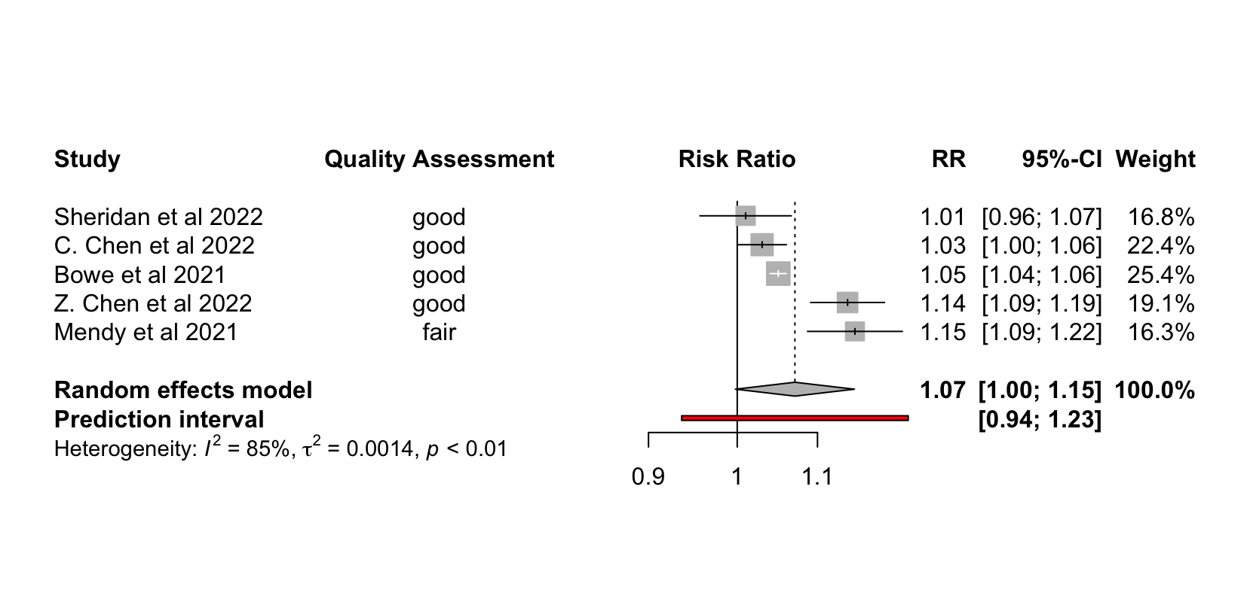
Figure 3. Forest plot displays quality assessment score; effect estimate (RR) per every 1µg/m³ increase in exposure and associated 95% CI; the weight attributed to each study; and results from the random effects model for the association between COVID-19 hospitalisation and PM₂.₅ exposure.

PM_{2.5} and COVID-19 Mortality
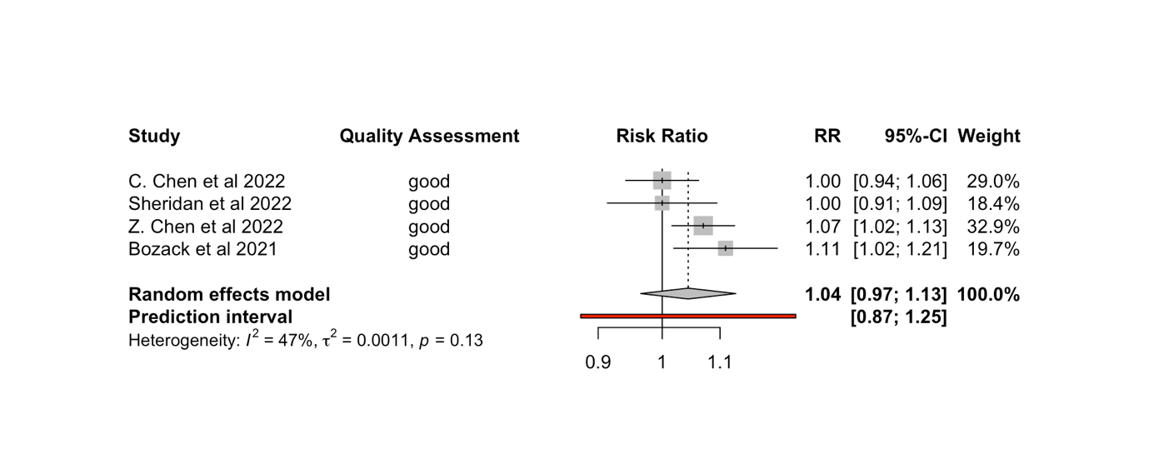
Figure 4. Forest plot displays quality assessment score; effect estimate (RR) per every 1µg/m³ increase in exposure and associated 95% CI; the weight attributed to each study; and results from the random effects model for the association between COVID-19 mortality and PM_{2.5} exposure.

PM_{2.5} and COVID-19 ICU Admission
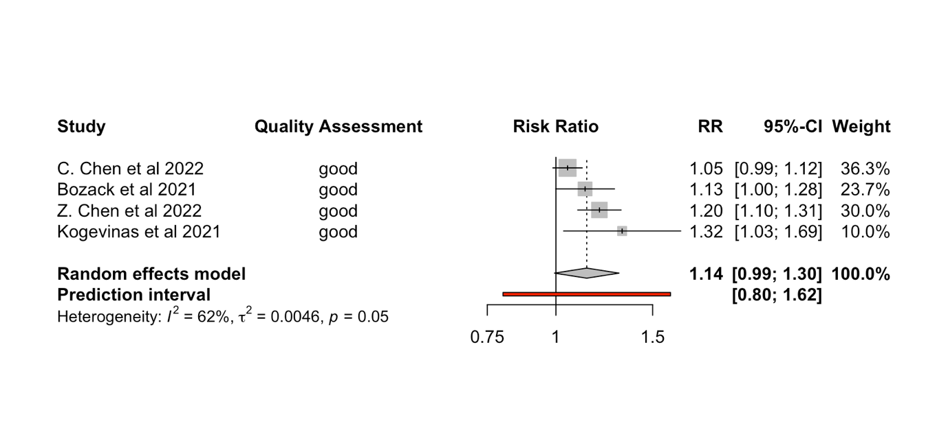
Figure 5. Forest plot displaying the quality assessment score; effect estimate (RR) per every 1µg/m³ increase in exposure and associated 95% CI; the weight attributed to each study; and results from the random effects model for the association between COVID-19 ICU admission and PM_{2.5} exposure.

PM_{2.5} and COVID-19 Infection
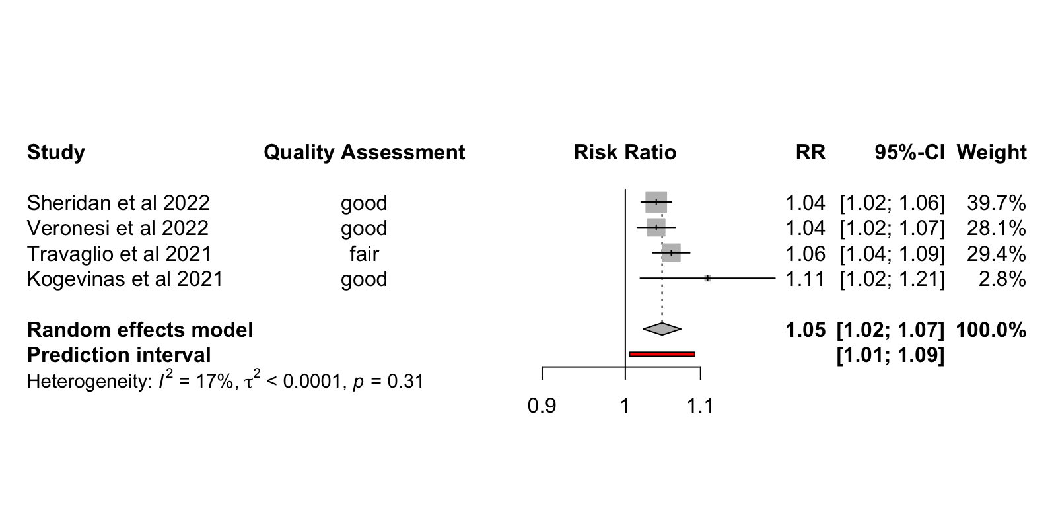
Figure 6. Forest plot displaying the quality assessment score; effect estimate (RR) per every 1µg/m³ increase in exposure and associated 95% CI; the weight attributed to each study; and results from the random effects model for the association between COVID-19 infection and PM_{2.5} exposure.

NO₂ and COVID-19 Hospitalisation
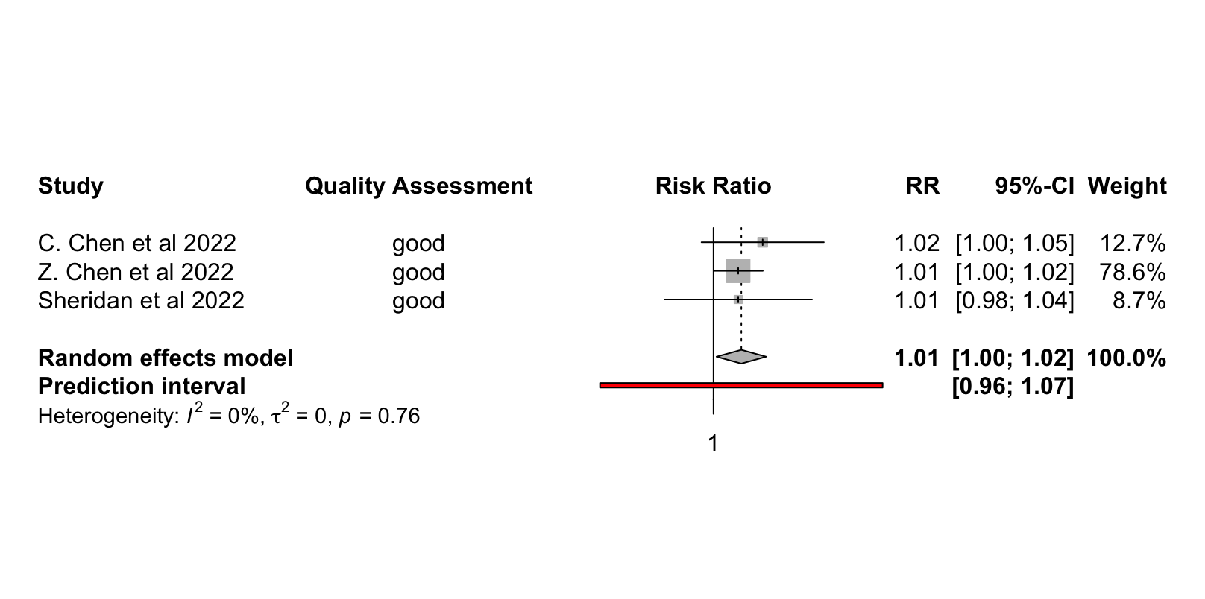
Figure 7. Forest plot displaying the quality assessment score; effect estimate (RR) per every 1µg/m³ increase in exposure and associated 95% CI; the weight attributed to each study; and results from the random effects model for the association between COVID-19 hospitalisation and NO₂ exposure.

NO₂ and COVID-19 Mortality
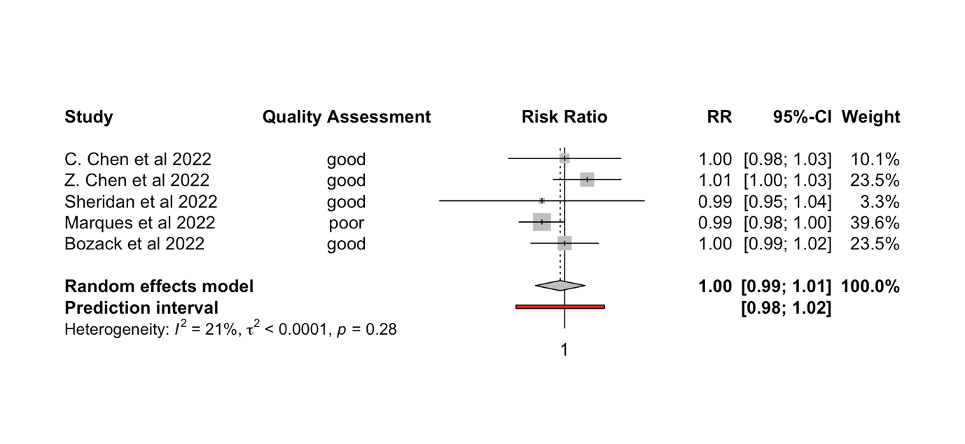
Figure 8. Forest plot displaying quality assessment score; effect estimate (RR) per every 1µg/m³ increase in exposure and associated 95% CI; the weight attributed to each study; and results from the random effects model for the association between COVID-19 mortality and NO₂ exposure.

NO₂ and COVID-19 ICU Admission
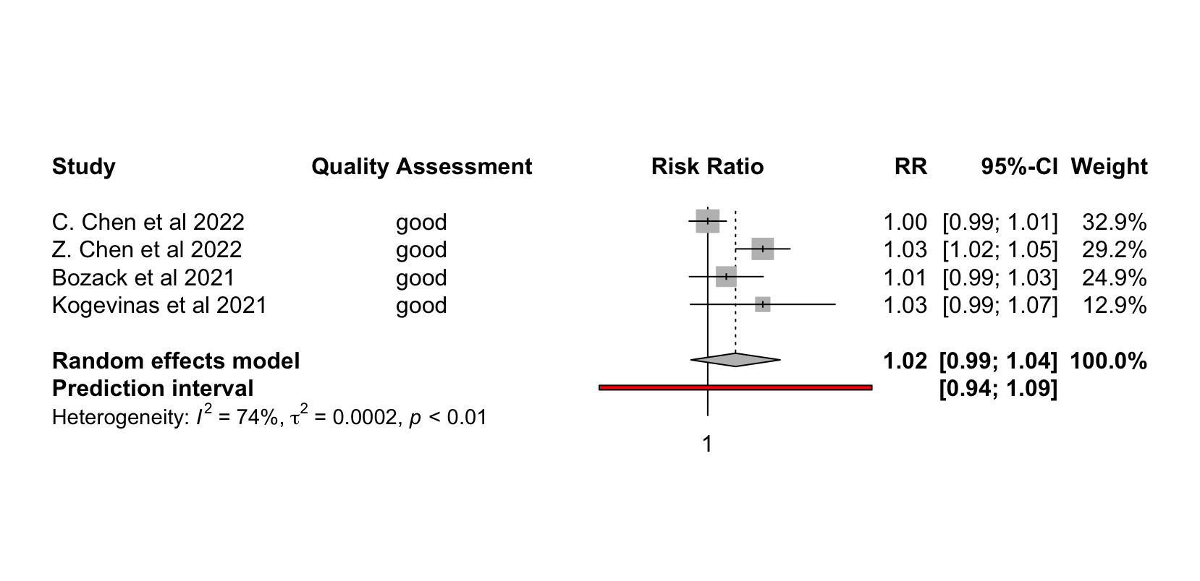
Figure 9. Forest plot displaying the quality assessment score; effect estimate (RR) per every 1µg/m³ increase in exposure and associated 95% CI; the weight attributed to each study; and results from the random effects model for the association between COVID-19 ICU admission and NO₂ exposure.

NO₂ and COVID-19 Infection
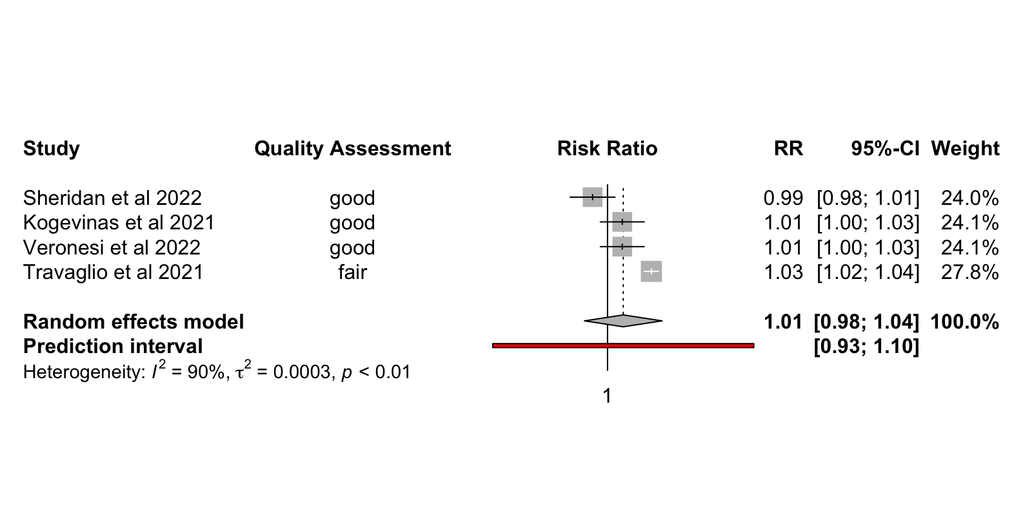
Figure 10. Forest plot displaying the quality assessment score; effect estimate (RR) per every 1µg/m³ increase in exposure and associated 95% CI; the weight attributed to each study; and results from the random effects model for the association between COVID-19 infection and NO₂ exposure.

PM₁₀ and COVID-19 Infection
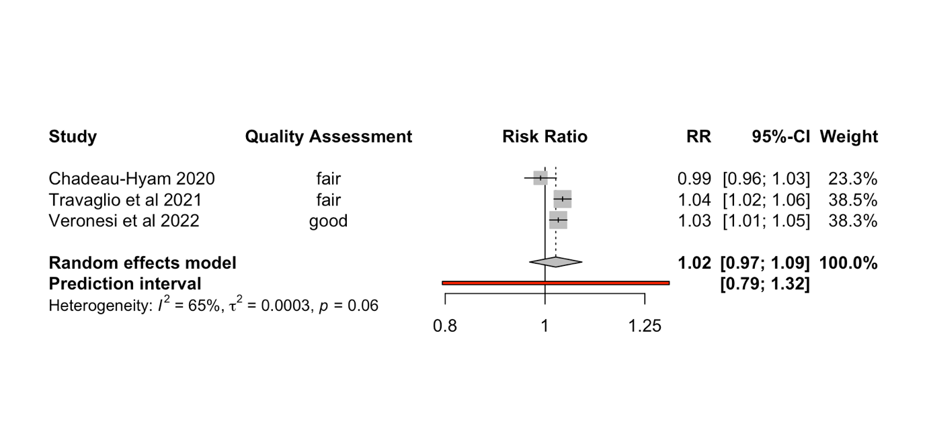
Figure 11. Forest plot displaying the quality assessment score; effect estimate (RR) per every 1µg/m³ increase in exposure and associated 95% CI; the weight attributed to each study; and results from the random effects model for the association between COVID-19 infection and PM₁₀ exposure.

NO_{x} and COVID-19 Infection
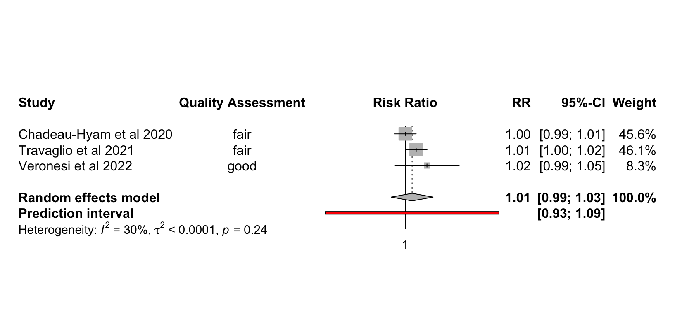
Figure 12. Forest plot displaying the quality assessment score; effect estimate (RR) per every 1µg/m³ increase in exposure and associated 95% CI; the weight attributed to each study; and results from the random effects model for the association between COVID-19 infection and NO_{x} exposure.

O₃ and COVID-19 ICU Admission
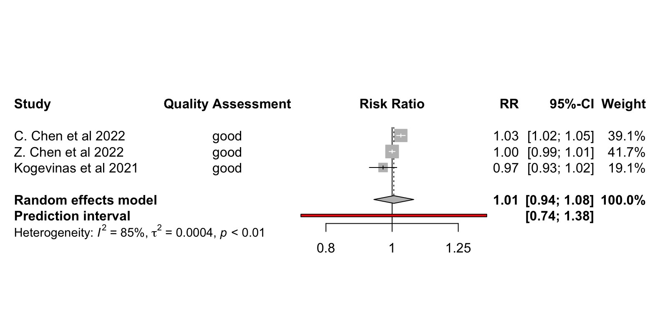
Figure 13. Forest plot displaying the quality assessment score; effect estimate (RR) per every 1µg/m³ increase in exposure and associated 95% CI; the weight attributed to each study; and results from the random effects model for the association between COVID-19 ICU admission and O₃ exposure.

Table 3 presents a summary of all the pooled effect estimates by pollutant/outcome combination.

The forest plot in Figure 3 is based on the results from the meta-analysis that pooled RRs from five different studies investigating the association between PM_{2.5} and COVID-19 hospitalisation. Results depict a positive association between PM_{2.5} exposure and COVID-19 hospitalisation, with a pooled RR of 1.07 (95% CI: 1.00; 1.15). τ² = 0.0014 (p-value < 0.01), indicating the variance in the true effect sizes between studies is slightly greater than zero. Five studies were included in this analysis, four of which observe a statistically significant relationship, but a considerable amount of heterogeneity was identified between studies (I² = 85%). 95% CIs were notably wide for three studies (Sheridan et al. 2022, Mendy et al. 2021, and Z. Chen et al. 2022), and these studies were subsequently assigned the lightest weights. The calculated prediction interval (PI) provides the following range: (0.94; 1.23).

The only other positive association found for PM_{2.5} was between PM_{2.5} exposure and COVID-19 infection (Figure 6). The random-effects model calculated a pooled RR of 1.05 (95% CI: 1.02; 1.07) per every 1 µg/m³ increase in exposure. The I² score equals 17%, indicating a low amount of heterogeneity between studies. The τ² < 0.0001 (p-value = 0.31). Calculated PI was between (1.01; 1.09).

The random-effects models found no statistically significant association between PM_{2.5} exposure and COVID-19 mortality (Figure 4) or between PM_{2.5} exposure and COVID-19 ICU admission (Figure 5), presenting pooled RRs of 1.04 (95% CI: 0.97; 1.13) and 1.14 (95% CI: 0.99; 1.30), respectively. The I² for PM_{2.5} exposure and COVID-19 mortality = 47%, suggesting a moderate level of heterogeneity between studies, with a τ² = 0.0011 (p = 0.13), and a PI of (0.87; 1.25). PM_{2.5} exposure and COVID-19 ICU admission had an I² value of 62%, suggesting moderate heterogeneity between studies, with a τ² = 0.0046 (p-value = 0.05) and a PI of (0.80; 1.62).

COVID-19 hospitalisation was the only outcome with a statistically significant pooled RR associated with NO₂ exposure (RR = 1.01, 95% CI: 1.00; 1.02). This random effects model only included a total of three studies, and produced an I² of 0%, indicating a lack of heterogeneity among the included studies. Similarly, τ² = 0, (p-value = 0.76). The associated PI was between (0.96; 1.07).

NO₂ exposure was not associated with COVID-19 mortality (RR = 1.00, 95% CI: 0.99, 1.01), COVID-19 ICU admission (RR = 1.02, 95% CI: 0.99; 1.04), or COVID-19 infection (RR = 1.01, 95% CI: 0.98; 1.04). The corresponding I² values were 21%, 74%, and 90% respectively, indicating low to significant amounts of heterogeneity present between all included studies. τ² values equalled <0.0001 (p-value = 0.28), 0.0002 (p-value < 0.01), and 0.0003 (p-value < 0.01), respectively. Finally, associated PIs were: COVID-19 mortality (0.98; 1.02); COVID-19 ICU admission (0.94; 1.09); and COVID-19 infection (0.93; 1.10).

Among the results from their cohorts, several studies identified statistically significant associations involving PM₁₀, NO_{x}, or O₃. Travaglio et al. 2021 found a positive association between a 1µg/m³ increase in NO_{x} and COVID-19 infection, while Z. Chen et al. 2021 found a positive association between a 1µg/m³ increase in non-freeway NRAP (NO_{x}) and COVID-19 ICU admission and COVID-19 mortality (Table 1). C. Chen et al. 2022 was the only study to find a positive association between a 1µg/m³ increase in O₃ exposure and any COVID-19 health outcome (Table 1). Travaglio et al. 2021 and Veronesi et al. 2022 both found positive associations between a 1µg/m³ increase in PM₁₀ and COVID-19 infection, while Marquès et al. 2022 found a positive association between a 1µg/m³ increase in PM₁₀ and COVID-19 mortality (Table 1). None of the random-effects models found statistically significant associations between PM₁₀, NO_{x}, or O₃ exposure and any of the COVID-19 health outcomes. Only three pollutant/outcome pairings, one outcome per pollutant, included enough studies to meta-analyse.
Therefore, the only pollutant/outcome pairings that provided enough data to meta-analyse were PM₁₀ and COVID-19 infection; NO_{x} and COVID-19 infection; and O₃ and COVID-19 ICU admission, none of which proved statistically significant. The random-effects model of PM₁₀ exposure and COVID-19 infection produced a pooled RR = 1.02 (95% CI: 0.97, 1.09), with an I² value of 65%, a τ² value of 0.0003 (p-value = 0.06), and a prediction interval of (0.79; 1.32). The random-effects model of NO_{x} and COVID-19 infection produced a pooled RR = 1.01 (95% CI: 0.99, 1.03), with an I² value of 30%, a τ² value < 0.0001 (p-value = 0.24), and a prediction interval of (0.93; 1.09). Finally, O₃ exposure and COVID-19 ICU admission produced a pooled RR = 1.01 (95% CI: 0.94, 1.08), with an I² value of 85%, a τ² value = 0.0004 (p < 0.01), and a prediction interval of (0.74; 1.38).

Table 3. Table displaying the pooled RRs and 95% CIs from the meta-analysis by pollutant/outcome combination per every 1µg/m³ increase in exposure to the pollutant of interest
Analysis | Pooled Relative Risks per 1µg/m³ (95% Confidence Intervals) | No. of Studies Included in Random-Effects Model | Heterogeneity (I²)
PM_{2.5} and COVID-19 Hospitalisation | 1.07 (1.00, 1.15) | 5 | 85%
PM_{2.5} and COVID-19 Mortality | 1.04 (0.97, 1.13) | 4 | 47%
PM_{2.5} and COVID-19 ICU Admission | 1.14 (0.99, 1.30) | 4 | 62%
PM_{2.5} and COVID-19 Infection | 1.05 (1.02, 1.07) | 4 | 17%
NO₂ and COVID-19 Hospitalisation | 1.01 (1.00, 1.02) | 3 | 0%
NO₂ and COVID-19 Mortality | 1.00 (0.99, 1.01) | 5 | 21%
NO₂ and COVID-19 ICU Admission | 1.02 (0.99, 1.04) | 4 | 74%
NO₂ and COVID-19 Infection | 1.01 (0.98, 1.04) | 4 | 90%
PM₁₀ and COVID-19 Infection | 1.02 (0.97, 1.09) | 3 | 65%
NO_{x} and COVID-19 Infection | 1.01 (0.99, 1.03) | 3 | 30%
O₃ and COVID-19 Infection | 1.01 (0.94, 1.08) | 3 | 85%

3.8 Results from Sensitivity Analyses
PM_{2.5} Exposure and COVID-19 Hospitalisation in North America
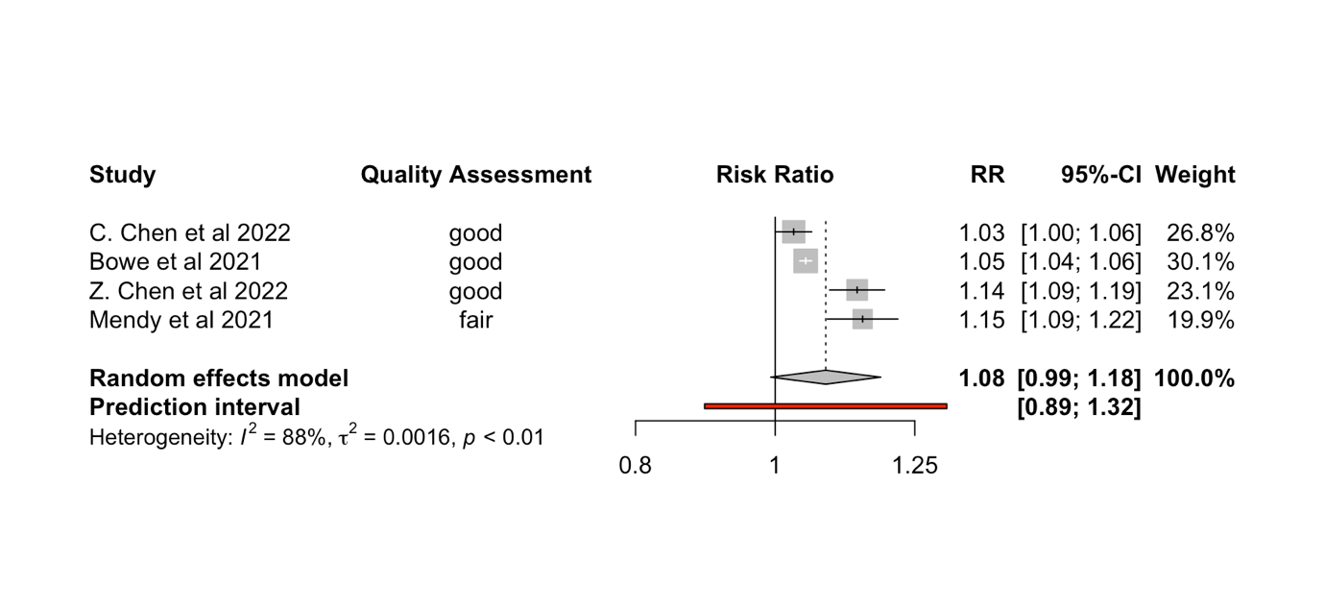
Figure 14. Forest plot displaying the results from the sensitivity analysis examining the relationship between PM_{2.5} exposure and COVID-19 hospitalisation in studies published in North America. Plot includes quality assessment score; effect estimate (RR) per every 1µg/m³ increase in exposure and associated 95% CI; the weight attributed to each study; and results from the random effects model.

PM_{2.5} Exposure and COVID-19 Hospitalisation Excluding Quality Assessment Scores < “Good”
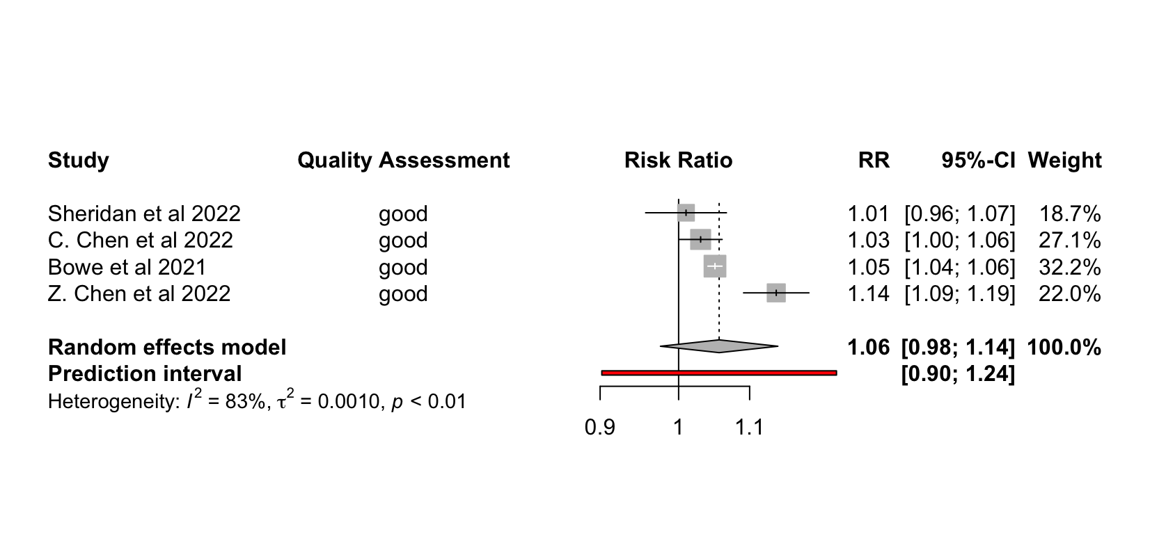
Figure 15. Forest plot displaying the results from the sensitivity analysis examining the relationship between PM_{2.5} exposure and COVID-19 hospitalisation in studies classified as “Good” by the quality assessment instrument. Plot includes quality assessment score; effect estimate (RR) per every 1µg/m³ increase in exposure and associated 95% CI; the weight attributed to each study; and results from the random effects model.

NO₂ Exposure and COVID-19 Mortality in North America
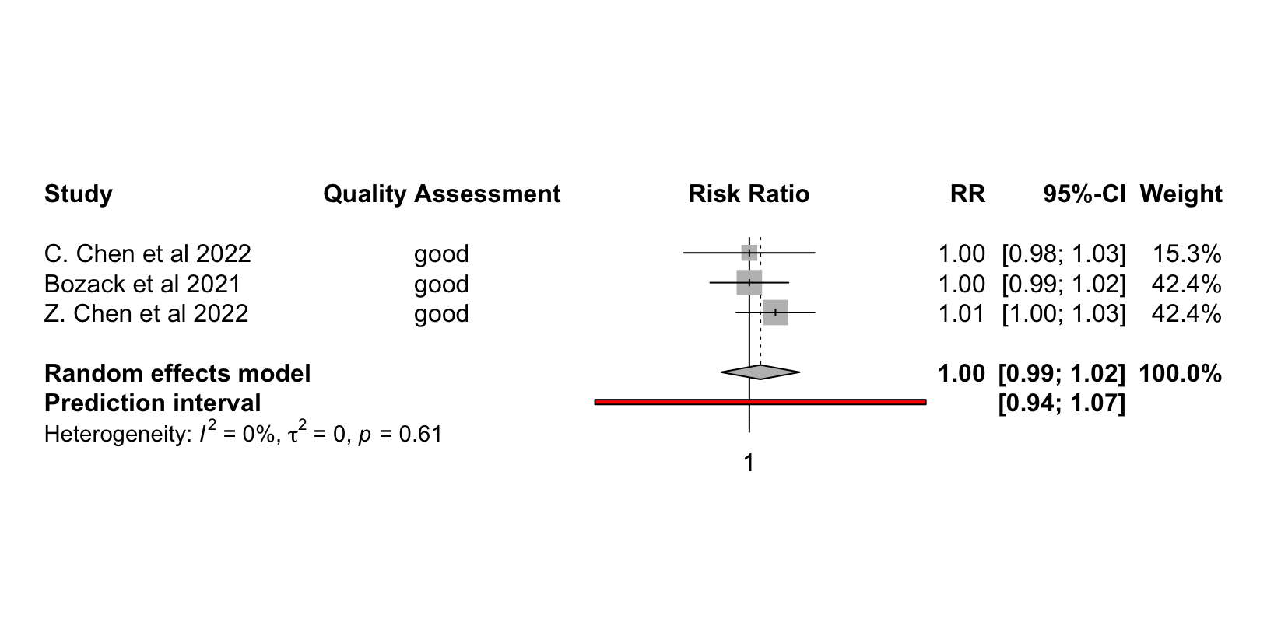
Figure 16. Forest plot displaying the results from the sensitivity analysis examining the relationship between NO₂ exposure and COVID-19 mortality in North America. Plot includes quality assessment score; effect estimate (RR) per every 1µg/m³ increase in exposure and associated 95% CI; the weight attributed to each study; and results from the random effects model.

NO₂ Exposure and COVID-19 Mortality Excluding Quality Assessment Scores < “Good”
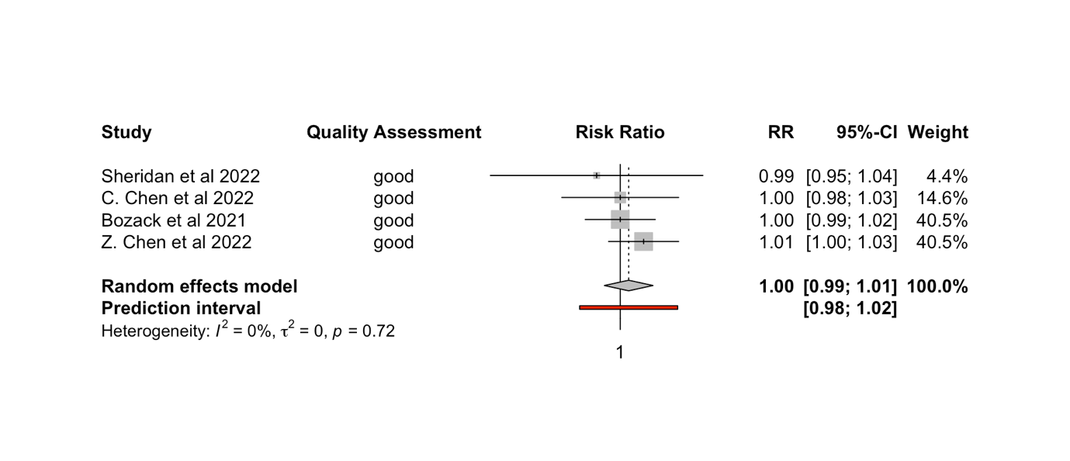
Figure 17. Forest plot displaying the results from the sensitivity analysis examining the relationship between NO₂ exposure and COVID-19 mortality in studies classified as “Good” by the quality assessment instrument. Plot includes quality assessment score; effect estimate (RR) per every 1µg/m³ increase in exposure and associated 95% CI; the weight attributed to each study; and results from the random effects model

Additional sensitivity analyses can be found in Appendix 7.

The forest plot in Figure 14 depicts the results from the random-effects model investigating the association between PM_{2.5} exposure and COVID-19 hospitalisation. In total, five studies included in the full meta-analysis examined the association between PM_{2.5} exposure and COVID-19 hospitalisation, the majority of which examined North American cohorts. Therefore, this sensitivity analysis removed the single study (Sheridan et al., 2022) that did not investigate a North American cohort. In the main meta-analysis, a statistically significant association between PM_{2.5} and COVID-19 hospitalisation was identified (RR = 1.07; 95% CI: 1.00; 1.15). Removing Sheridan et al. attenuated this effect estimate (RR = 1.08 (95% CI: 0.99; 1.18). τ² increased to a value of 0.0016 (p-value < 0.01), and I² increased to a value of 88%, suggesting slightly greater heterogeneity among the North American studies. The prediction interval widened as well to between (0.89; 1.32).

The forest plot in Figure 15 presents the results from the random-effects model investigating the relationship between PM_{2.5} exposure and COVID-19 hospitalisation, only including studies classified as “good” during the quality assessment scoring. Only one study was removed for being classified as “fair” (Mendy et al., 2021). The results of the random-effects model were not statistically significant, with a pooled RR = 1.06 (95% CI: 0.98; 1.14). Heterogeneity slightly decreased overall (τ² = 0.0010 [p-value < 0.01]; I² = 83%). The prediction interval, however, widened slightly to (0.90; 1.24).

The sensitivity analyses for NO₂ exposure and COVID-19 mortality can be seen in Figures 16 and 17. Figure 16 shows a forest plot of the random-effects model investigating the relationship between NO₂ exposure and COVID-19 mortality in North America. The original model included a total of five studies, three from North America and two from Europe. Neither the original model nor the sensitivity analysis exhibit statistically significant results (RR = 1.00; 95% CI: 0.99; 1.02). Heterogeneity decreased a significant amount, with the τ² value = 0 (p-value = 0.61) and the I² value = 0%. The prediction interval widened slightly to (0.94; 1.07). Figure 17 presents the forest plot of the random effects model investigating the relationship between NO₂ exposure and COVID-19 mortality, including only those papers that obtained a quality score of “good.” Only one paper that was included in the original model was excluded from this sensitivity analysis due to a “poor” quality assessment score (Marquès et al. 2022). The pooled RR did not deviate from the original model (RR = 1.00; 95% CI: 0.99; 1.01), and results remained statistically insignificant. As in the case of the sensitivity analysis for COVID-19 mortality by continent, both the τ² value and the I² values decreased significantly to 0 (p-value = 0.72) and 0%, respectively. The prediction interval also remained the same as in the original model (0.98; 1.02).

4. Discussion

4.1 Principal Findings and Comparison with Previous Research
The aim of this study was to investigate the association between long-term exposure to criteria air pollutants and COVID-19 health outcomes in published studies using individual data by undertaking a systematic review and meta-analysis. The systematic review identified 16 studies, 14 of which were eligible for inclusion in the meta-analysis. Several statistically significant associations were identified, but in many cases the sample size of studies eligible for meta-analysis for a given pollutant/outcome pair was too small to discern the true relationship given the available data.

The relationship identified between PM_{2.5} exposure and COVID-19 hospitalisation (RR = 1.07, 95% CI: 1.00, 1.15) indicates that for every 1µg/m³ increase in average long-term exposure to PM_{2.5}, one’s risk of hospitalisation for COVID-19 increases by 7%. The significant amount of heterogeneity identified between studies (I² = 85%) can be explained by the notably large differences in effect estimates found by the included studies, potentially due to different study characteristics. Mendy et al. 2021, and Z. Chen et al. 2022 detected RRs significantly larger than those detected by Sheridan et al. 2022, Bowe et al. 2021, and C. Chen et al. 2022, but all studies were assigned relatively similar weights by the random effects model (Figure 3). Consequently, there is very little overlap between the 95% CIs, suggesting that the associations authors found in their studies varied between cohorts. The pooled RR and associated 95% CI imply the presence of a statistically significant association, but the strength of that association remains uncertain given the large percent of heterogeneity between studies as identified by the model. Heterogeneity in a random-effects model could also be a function of the differences in magnitude between the strength of the associations found in each study’s individual results: Sheridan et al. 2022 had a 95% CI ranging from (0.96, 1.07), while Z. Chen et al. 2022, and Mendy et al. 2021, had 95% CIs ranging from (1.09, 1.19) and (1.09, 1.23), respectively. The PI, which predicts the breadth of statistical significance that may be found by future studies investigating the same relationship, retains the same central estimate as the 95% CI associated with the pooled RR, and therefore the relationship will not necessarily be attenuated by future studies. However, there is uncertainty present in the PI due to the width of the interval extending from 0.86 to 1.23. Despite the presence of some uncertainty around this relationship, a positive relationship was undoubtedly identified between PM_{2.5} exposure and COVID-19 hospitalisation. Other meta-analyses are yet to examine the relationship between COVID-19 hospitalisation and PM_{2.5} in cohort or ecological studies, and therefore this result is significant because it is the first evidence, to my knowledge, of a positive relationship identified between PM_{2.5} exposure and COVID-19 hospitalisation in a meta-analysis using studies with individual-level data.

The findings from the sensitivity analyses of PM_{2.5} and COVID-19 hospitalisation, however, attenuated the significance identified in the main random effects model. When examining a subgroup of studies published in North America, the RR increased but the statistical significance of the association was attenuated (RR = 1.08; 95% CI: 0.99, 1.18). The only study included in the meta-analysis examining the relationship between PM_{2.5} and COVID-19 hospitalisation not published in North America (and therefore excluded from the subgroup analysis) was Sheridan et al. 2022, which was also the only study of the five included in the original random-effects model to find no association between PM_{2.5} exposure and COVID-19 hospitalisation. The change in significance could be explained by the decrease in sample size that occurred when Sheridan et al. 2022, was removed from the random-effects model. Because of how few studies were included in each random-effects model to begin with, due to a general lack of published research available utilising individual-level data, removal of one study from the meta-analysis to form a subgroup for sensitivity analysis reduced the overall statistical power of the model, attenuating the significance of the pooled RRs towards the null. The same is true of the result from the second sensitivity analysis, investigating the association between PM_{2.5} exposure and COVID-19 hospitalisation in only those studies classified as “good” by the quality assessment instrument. In this case, the pooled RR value decreased slightly from the pooled value in original model (RR = 1.06; 95% CI: 0.98, 1.14). This random-effects model reintroduced the Sheridan et al. 2022 study, but excluded the Mendy et al. 2021, as it was classified as “fair” by the quality assessment instrument. Removing Mendy et al. prompted a slight decrease in heterogeneity (I² = 83%). When analysing such a small sample size of studies, any adjustment can influence a consequential fluctuation in the results of the random effects model because each included study has a greater impact on the pooled RR in the base model than it would if the model had more studies from which to pull results. Therefore, although the sensitivity analyses did not contribute statistically significant pooled RRs to the overall results of the meta-analysis, nor were their results particularly informative regarding the trends they were attempting to identify, their presence in the final draft of this thesis proves the importance of a large sample size to ensure sufficient statistical power in results when conducting a meta-analysis.

The relationship between PM_{2.5} and COVID-19 infection was also statistically significant (RR = 1.05, 95% CI: 1.02, 1.07), suggesting that for every 1µg/m³ increase in exposure to PM_{2.5}, one’s risk of becoming infected with COVID-19 increases by 5%. 95% CIs were generally narrow, and the PI indicated that future studies conducted will also most likely find evidence of a relationship between COVID-19 infection and PM_{2.5} exposure (Figure 6). This relationship has also been corroborated by one of the systematic review and meta-analysis studies that examined ecological studies of COVID-19 and long-term exposure to air pollution. Zang et al. 2022, found a positive association between COVID-19 incidence and PM_{2.5} exposure (effect estimate = 1.056; 95% CI: 1.039, 1.042; per every 1µg/m3 increase in PM_{2.5}). Pickford et al. 2021, examined the relationship between COVID-19 incidence and long-term PM_{2.5} exposure in ecological studies, but did not find a statistically significant association (RR = 1.133; 95% CI: 0.979, 1.311; per every 10µg/m³ increase in PM_{2.5} exposure).

The results from the random effects model examining the relationship between PM_{2.5} exposure and COVID-19 ICU admission warrant discussion, despite producing a statistically insignificant pooled RR (RR = 1.14; 95% CI: 0.99, 1.30). The 95% CI is on the cusp of significance, but the results remain insignificant despite all studies but one (C. Chen et al. 2022) identifying statistically significant RRs in their results. C. Chen et al. was assigned the greatest weight by the random effects model (36.3%), as its confidence interval is significantly narrower than those of the other studies included in the model, and it had the largest number of study participants of all the studies eligible for inclusion in this random effects model. Therefore, its contribution to the random effects model’s pooled RR was the greatest of all included studies and is also a potential explanation for the lack of a relationship present between the COVID-19 hospitalisation and PM_{2.5} exposure, despite most studies contributing statistically significant RRs to the model. The broad width of the PI also indicates notable uncertainty in predicted results of future studies based on the results of this random-effects model. No prior systematic review and meta-analysis has examined this relationship, and more primary research with larger cohorts is needed to decrease uncertainty among the present findings.

A 1µg/m³ increase in PM_{2.5} exposure and COVID-19 mortality showed an increase in mortality that did not reach the nominal level of statistical significance (RR = 1.04; 95% CI: 0.97, 1.13). In a random-effects model including only four studies, half providing statistically significant results and the other half statistically non-significant, it is difficult to draw a conclusion in accordance with the true association without a large enough sample size to confirm the lack of association observed. Both Zang et al. 2022, (effect size = 1.047; 95% CI: 1.025, 1.071; per every 1µg/m³ increase in exposure) and Pickford et al. 2021 (RR = 1.65; 95% CI: 1.09, 2.49; for every 10µg/m³ increase in PM_{2.5} exposure) found positive associations between PM_{2.5} exposure and COVID-19 mortality when meta-analysing ecological studies.

NO₂ exposure and COVID-19 hospitalisation were also slightly associated (RR = 1.01, 95% CI: 1.00, 1.02) with one’s risk of hospitalisation for COVID-19, increasing by 1% per every 1µg/m³ increase in NO₂ exposure. Only three studies were included in this random effects model, all with very narrow 95% CIs, and so while there was an association identified and very little heterogeneity present between studies (I² = 0%), the small sample size underscores the need for more research investigating this association. Neither of the systematic review and meta-analysis studies investigated COVID-19 hospitalisation as an outcome. Therefore, this is the first evidence to my knowledge of an association between COVID-19 hospitalisation and NO₂ exposure validated with data from multiple individual-level studies, but more primary research is required to verify the association.

No association was identified between NO₂ exposure and COVID-19 mortality, as was consistent with the results of all but one of the five studies included in the random-effects model (RR = 1.00; 95% CI: 0.99, 1.01). The narrow 95% CI indicates certainty among the results, as does the narrow PI which also predicts no association among the results of future studies. Heterogeneity was low (I² = 21%), consistent with the similar RRs and narrow 95% CIs contributed by all studies included in the model. The sensitivity analysis of a subgroup of studies published in North America confirms this result, as heterogeneity decreased even more significantly (I² = 0%) upon exclusion of Marques et al. 2022 (contributing a quality assessment score of “poor”) and Sheridan et al. 2022, the study with the widest 95% CI. Another sensitivity analysis, this one examining only studies classified as “good” by the quality assessment instrument also had an I² = 0%, further strengthening the evidence that there is no association between COVID-19 mortality and NO₂ per every 1µg/m³ increase in exposure. When examining the results from ecological studies, Zang et al. 2022, (effect estimate = 1.034; 95% CI: 1.006, 1.063; for every 1µg/m³ increase in exposure) and Pickford et al., 2021 (RR = 1.24; 95% CI: 1.15, 1.32; per every 10µg/m³ increase) both find significant associations between COVID-19 mortality and NO₂ exposure, contradicting my results. Based on the results from this meta-analysis, however, effect estimates at the ecological level do not hold true when the association is investigated at the individual-level.

All associations in the three random effects models examining NO_{x}, O₃, and PM₁₀ and COVID-19 infection and COVID-19 ICU admission were statistically insignificant. While it is entirely possible that there is no relationship between these pollutants and any COVID-19 health outcomes, there is another plausible explanation for the lack of significance found by this meta-analysis and the meta-analyses by Zang et al. 2022, and Pickford et al., 2021. Very little primary research has been conducted investigating the health impacts of NO_{x}, O₃, and PM₁₀ on COVID-19, and hardly any research examines these relationships at the individual-level. The research that does exist, however, investigates a diverse array of COVID-19 health outcomes, very few of which overlap. As a result, before conclusions can be drawn regarding the statistical significance of the relationships between NO_{x}, O₃, or PM₁₀ and the associated COVID-19 health outcomes investigated in this paper, it is necessary that these relationships be investigated by more primary research so further analyses have sufficient statistical power.

All the studies adjusted for age and sex in the fully adjusted models that contributed the main effect estimates for the meta-analysis (Table 2). However, there was extensive variability between studies in the confounders adjusted for in their final, fully adjusted models. This between-study variability in adjustment for confounding could be a potential contributor to the high percentage of heterogeneity identified in more than half (n = 6) of the random-effects models. Two of the studies that produced models highly adjusted for relevant confounders (e.g., SES, smoking, and comorbidities) were excluded from the meta-analysis due to their poor communication of results. If they had been eligible for inclusion, the meta-analysis would have contained an additional two studies, increasing the sample size from which to calculate effect estimates and potentially decreasing uncertainty among the results presented in the random effects models.

4.2 Strengths and Limitations

4.2.1 Strengths
The main strength of this review is its status as the first systematic review and meta-analysis of its kind investigating the association between long-term exposure to criteria air pollutants and COVID-19 health outcomes in cohort studies with individual-level data. Prior systematic reviews take a broader approach to their inclusion criteria, not limiting included studies to specifically cohort studies with individual-level data. As a result, previous reviews consist mainly of ecological studies whose results fall prey to the ecological fallacy. If cohort studies with individual-level data are included in the systematic review section of the report, they are typically excluded from the meta-analysis due to the authors not having identified enough studies with individual-level data to meta-analyse, as seen in Zang et al. 2022 and Pickford et al. 2021. While this study encountered that same problem regarding several of the pollutant/outcome pairs, particularly in the cases of NO_{x}, O₃, and PM₁₀, my narrow research question specifying only cohort studies and well-defined inclusion and exclusion criteria made it possible for me to identify all the relevant studies that fit within the scope of my review, and I was able to collect sufficient data to conduct a meta-analysis on almost all the data available from published individual-level studies.

Another strength of my review is its examination and analysis of multiple COVID-19 health outcomes. The Walton et al. 2021 report primarily looked at COVID-19 hospitalisation, while Zang et al. 2022 and Pickford et al. 2021 both chose COVID-19 mortality and COVID-19 incidence as their primary outcomes of interest. My study did not limit its search results to specific COVID-19 health outcomes, and therefore identified a range of COVID-19 health outcomes, including those identified by previous studies but also COVID-19 ICU admission.

4.2.2 Limitations
This review encountered several limitations throughout the length of the research process. The most glaring limitation of this review is the amount of time I had to complete the entire process, leaving me as the sole reviewer of articles for inclusion, which is not best practice for a systematic review because including only one reviewer risks introducing bias. Using data from the PROSPERO registry, an article published in the British Medical Journal (BMJ) reported that the mean estimated time to undertake and complete a systematic review and meta-analysis that has identified at least 27 hits in a database search is approximately 67 weeks (IQR = 42 weeks).⁹⁰ This project was completed in about a quarter of that time, spanning approximately 17 weeks. While the quality of the work completed was not affected by the compressed timeline, the scope of the research was significantly reduced to fit within the allotted timeframe. A meta-analysis can include a range of different statistical tests, from assessment of publication bias with Egger’s tests and funnel plots to meta-regressions that could help expound on between study heterogeneity identified in the random effects models. The condensed timeline allotted for this project did not allow me to learn in-depth how to complete the aforementioned tests, nor did it allow me the time to investigate other relationships identified while reading the selected papers, such as whether an association exists between confounders adjusted for by a study and if the study found a statistically significant RR, which could possibly have helped inform this study’s results.

This study was also limited by the small number of published papers investigating the association between COVID-19 health outcomes and long-term exposure to criteria pollutants. Individual-level data can take a considerable amount of time to collect and analyse, and as a result only 16 papers have been published on my chosen topic since the beginning of the COVID-19 pandemic. The lack of papers using individual-level data, combined with discrepancies in outcomes chosen for investigation by the authors of those papers that did conduct research on cohorts at the individual level, severely limited the results of my meta-analysis. These results must therefore be interpreted with caution, because the statistical significance of the pooled RRs calculated by the random-effects models may result from small sample sizes rather than the presence of a true relationship between the pollutant and outcome of interest. Additionally, the relationships between several of the pollutant/outcome pairs identified by the published studies, (e.g., PM₁₀ and COVID-19 mortality, etc.) went unexamined because not enough studies investigated the same pollutant/outcome pairs in their cohort analyses. Consequently, I could not meta-analyse non-existent results or RRs from pollutant/outcome pairs that were reported on by fewer than three studies.

Another potential limitation is a language bias. A study must have been either written in or translated to English to be included in the review. If there are additional studies that investigate the relationship between long-term exposure to air pollution and the chosen COVID-19 health outcomes at the individual-level not written in or translated to English, then they were unable to be included in the review. Due to how few studies written in English were eligible for inclusion, it is unlikely that there is a plethora of evidence that went unexamined because of language bias.

I cannot be certain that there was no sampling error or ascertainment bias present in the studies’ results. Many of the cohorts under investigation were chosen by the researchers because they were pre-formed for the purposes of other studies (e.g., UK Biobank), and it was easier and cheaper for authors to co-opt existing cohorts for their research rather than to design and recruit their own—especially towards the beginning of the COVID-19 pandemic when institutions were desperate to uncover information about the nature of the coronavirus.

Lastly, as this was the first study to investigate the relationship between air pollution and COVID-19 health outcomes using exclusively cohort studies with individual-level data, there was no past research with which I could compare my results. Many systematic reviews have been published examining the relationship in ecological studies, but those results are incomparable to a study investigating the same relationship at the individual-level because the two types of studies draw conclusions on different levels. Results from ecological studies can provide insight into area-level risks, but these conclusions are not directly relevant when applied to individuals.⁵⁸ In order to determine if one’s risk of experiencing a particular COVID-19 health outcome is associated in any way with the type or amount of air pollution to which they are exposed, adjusting comprehensively for confounding, it is necessary that investigations into this relationship utilize data collected from individual persons, not the population of which that individual is a part. Therefore, attempting to compare the results from my study to those of systematic reviews and meta-analyses of ecological studies is futile and only results in falsely conflated evidence for the sake of comparison itself.

5. Conclusion and Public Health Recommendations
The results of the meta-analysis indicate that there is a 7% increase in one’s risk of hospitalisation for COVID-19 for every 1µg/m³ increase in exposure to PM_{2.5}, and a 1% increase in risk of COVID-19 hospitalisation for every 1µg/m³ increase in exposure to NO₂. PM_{2.5} exposure was also associated with COVID-19 infection, with a 5% increase in one’s risk of infection for every 1µg/m³ increase in exposure. These findings necessitate a reconsideration of how governments manage air pollution levels, particularly in metropolitan areas where PM_{2.5} exposure is highly concentrated. The Committee on Medical Effects of Air Pollutants (COMEAP) have requested access to the results of this meta-analysis, and therefore a real possibility exists for my findings to inform air pollution policy changes in the UK. PM_{2.5} exposure is not only an issue for the UK, however. Many of the world’s most polluted cities are based in countries in Asia, but very few studies have been published from that region investigating the association between long-term exposure to air pollution and COVID-19 health outcomes at the individual-level. This systematic review only identified one (Zhang et al. 2021), but that study examines the UK Biobank cohort; therefore, in this systematic-review and meta-analysis, not a single cohort was included from any country that is designated most at risk from air pollution by the 2021 World Air Quality Report.⁹¹ Therefore, to protect those most at risk worldwide, there must be pressure put on countries that have contributed few to no studies investigating individual-level exposure to PM_{2.5} to fund more well-designed research into how high concentrations of air pollution exposure impact the number of and severity of COVID-19 cases. Without this research, there is little incentive for governing bodies to implement policy change that could potentially impact industry by curtailing the biggest polluters.

In countries that have contributed research to this systematic review and meta-analysis, health organisations such as the WHO and national-level environmental organisations such as the US Environmental Protection Agency (EPA) or the United Kingdom Health Security Agency (UKHSA) must inform and educate policy makers about the risks identified with exposure to PM_{2.5} and NO₂ and their relationship with COVID-19 health outcomes. Most governments are aware of the necessary adjustments in pollution levels that must be implemented to prevent the planet from warming by 1.5ºC by 2025.⁴⁰ However, very few have done enough to meet the targets drawn up in The Paris Agreement in 2015.⁴⁰ While it is unfortunate that not even the threat of global climate disaster can pressure countries to decrease emissions, perhaps the added threat of an increased number of COVID-19 hospitalisations and cases could help persuade governing bodies. Therefore, the evidence of a relationship between long-term exposure to air pollution and COVID-19 health outcomes must be made explicitly clear to those in positions of power in conjunction with the irreversible health consequences of their inaction.

For individuals looking to protect themselves and loved ones from an increased risk of negative COVID-19 health outcomes, it is pertinent that masks are continually worn in crowded spaces, such as on public transportation, museums, and supermarkets. Additionally, when provided the opportunity, one should ensure they have received all the available COVID-19 vaccinations and boosters. Persons exposed to higher concentrations of air pollutants for a longer amount of time can become more sensitive and should take precautions to prevent contracting COVID-19. If the institutions in place to protect us are performing poorly, concerned citizens must put political pressure on elected leaders and take matters into our own hands to protect those most vulnerable in our communities.

References

1. Response WE. Weekly Epidemiological Update on COVID-19 - 13 July 2022. World Health Organization, Updates ES; 2022 13 July 2022.
2. Organization WH. Coronavirus disease (COVID-19) 2022 [cited 2022. Available from: https://www.who.int/health-topics/coronavirus#tab=tab_1.
3. (UKHSA) UKHSA. COVID-19: epidemiology, virology and clinical features: GOV.UK; 2022 [updated 17 May 2022; cited 2022 22 July 2022]. Available from: https://www.gov.uk/government/publications/wuhan-novel-coronavirus-background-information/wuhan-novel-coronavirus-epidemiology-virology-and-clinical-features#:~:text=On%2031%20December%202019%2C%20the,City%2C%20Hubei%20Province%2C%20China.
4. endcoronavirus.org. Some Are Winning - Some Are Not: Which Countries Do Best in Beating COVID-19 Cambrdige, MA, USA: New England Complex Systems Institute Inc.; 2022 [updated 22 July 2022; cited 2022 22 July 2022]. Available from: https://www.endcoronavirus.org/countries.
5. Organization WH. Global Situation [Map]. 2022 [updated 22 July 2022; cited 2022 22 July 2022]. https://covid19.who.int/]. Available from: https://covid19.who.int/.
6. Lotfi M, Hamblin MR, Rezaei N. COVID-19: Transmission, prevention, and potential therapeutic opportunities. Clin Chim Acta. 2020;508:254-66.
7. Asadi S, Bouvier N, Wexler AS, Ristenpart WD. The coronavirus pandemic and aerosols: Does COVID-19 transmit via expiratory particles? Aerosol Sci Technol. 2020;0(0):1-4.
8. Oran DP, Topol EJ. Prevalence of Asymptomatic SARS-CoV-2 Infection : A Narrative Review. Ann Intern Med. 2020;173(5):362-7.
9. Prevention CfDCa. Symptoms of COVID-19: CDC; 2022 [updated 22 March 2022; cited 2022 22 July 2022]. Available from: https://www.cdc.gov/coronavirus/2019-ncov/symptoms-testing/symptoms.html.
10. Lopez-Leon S, Wegman-Ostrosky T, Perelman C, Sepulveda R, Rebolledo PA, Cuapio A, et al. More than 50 long-term effects of COVID-19: a systematic review and meta-analysis. Sci Rep. 2021;11(1):16144.
11. Ziauddeen N, Gurdasani D, O'Hara ME, Hastie C, Roderick P, Yao G, et al. Characteristics and impact of Long Covid: Findings from an online survey. PLoS One. 2022;17(3):e0264331.
12. Wolff D, Nee S, Hickey NS, Marschollek M. Risk factors for Covid-19 severity and fatality: a structured literature review. Infection. 2021;49(1):15-28.
13. Hashim MJ, Alsuwaidi AR, Khan G. Population Risk Factors for COVID-19 Mortality in 93 Countries. J Epidemiol Glob Health. 2020;10(3):204-8.
14. Huang C, Wang Y, Li X, Ren L, Zhao J, Hu Y, et al. Clinical features of patients infected with 2019 novel coronavirus in Wuhan, China. The Lancet. 2020;395(10223):497-506.
15. Shi S, Qin M, Shen B, Cai Y, Liu T, Yang F, et al. Association of Cardiac Injury With Mortality in Hospitalized Patients With COVID-19 in Wuhan, China. JAMA Cardiol. 2020;5(7):802-10.
16. Wang D, Hu B, Hu C, Zhu F, Liu X, Zhang J, et al. Clinical Characteristics of 138 Hospitalized Patients With 2019 Novel Coronavirus-Infected Pneumonia in Wuhan, China. JAMA. 2020;323(11):1061-9.
17. Wu C, Chen X, Cai Y, Xia J, Zhou X, Xu S, et al. Risk Factors Associated With Acute Respiratory Distress Syndrome and Death in Patients With Coronavirus Disease 2019 Pneumonia in Wuhan, China. JAMA Intern Med. 2020;180(7):934-43.
18. Yang J, Zheng Y, Gou X, Pu K, Chen Z, Guo Q, et al. Prevalence of comorbidities and its effects in patients infected with SARS-CoV-2: a systematic review and meta-analysis. Int J Infect Dis. 2020;94:91-5.
19. Zhou F, Yu T, Du R, Fan G, Liu Y, Liu Z, et al. Clinical course and risk factors for mortality of adult inpatients with COVID-19 in Wuhan, China: a retrospective cohort study. The Lancet. 2020;395(10229):1054-62.
20. Davies B, Parkes BL, Bennett J, Fecht D, Blangiardo M, Ezzati M, et al. Community factors and excess mortality in first wave of the COVID-19 pandemic in England. Nat Commun. 2021;12(1):3755.
21. Mathieu E, Ritchie H, Ortiz-Ospina E, Roser M, Hasell J, Appel C, et al. Author Correction: A global database of COVID-19 vaccinations. Nat Hum Behav. 2021;5(7):956-9.
22. Watson OJ, Barnsley G, Toor J, Hogan AB, Winskill P, Ghani AC. Global impact of the first year of COVID-19 vaccination: a mathematical modelling study. The Lancet Infectious Diseases. 2022.
23. Malik JA, Ahmed S, Mir A, Shinde M, Bender O, Alshammari F, et al. The SARS-CoV-2 mutations versus vaccine effectiveness: New opportunities to new challenges. J Infect Public Health. 2022;15(2):228-40.
24. Corral-Gudino L, Del-Amo-Merino MP, Eiros-Bouza JM, Garcia-Cruces-Mendez JF, Dominguez-Gil Gonzalez M. The Omicron wave and the waning of COVID-19 vaccine effectiveness. Influence of vaccine booster and age on confirmed infection incidence. Eur J Intern Med. 2022.
25. Chenchula S, Karunakaran P, Sharma S, Chavan M. Current evidence on efficacy of COVID-19 booster dose vaccination against the Omicron variant: A systematic review. J Med Virol. 2022;94(7):2969-76.
26. Harvey WT, Carabelli AM, Jackson B, Gupta RK, Thomson EC, Harrison EM, et al. SARS-CoV-2 variants, spike mutations and immune escape. Nat Rev Microbiol. 2021;19(7):409-24.
27. Menni C, May A, Polidori L, Louca P, Wolf J, Capdevila J, et al. COVID-19 vaccine waning and effectiveness and side-effects of boosters: a prospective community study from the ZOE COVID Study. The Lancet Infectious Diseases. 2022;22(7):1002-10.
28. Perez-Alos L, Armenteros JJA, Madsen JR, Hansen CB, Jarlhelt I, Hamm SR, et al. Modeling of waning immunity after SARS-CoV-2 vaccination and influencing factors. Nat Commun. 2022;13(1):1614.
29. Talic S, Shah S, Wild H, Gasevic D, Maharaj A, Ademi Z, et al. Effectiveness of public health measures in reducing the incidence of covid-19, SARS-CoV-2 transmission, and covid-19 mortality: systematic review and meta-analysis. BMJ. 2021;375:e068302.
30. Rapidly escalating COVID-19 cases amid reduced virus surveillance forecasts a challenging autumn and winter in the WHO European Region [press release]. Copenhagen: World Health Organization, 19 July 2022 2022.
31. Chowdhury EK, Khan II, Dhar BK. Catastrophic impact of Covid‐19 on the global stock markets and economic activities. Business and Society Review. 2021;127(2):437-60.
32. Bonaccorsi G, Pierri F, Cinelli M, Flori A, Galeazzi A, Porcelli F, et al. Economic and social consequences of human mobility restrictions under COVID-19. Proc Natl Acad Sci U S A. 2020;117(27):15530-5.
33. Guan D, Wang D, Hallegatte S, Davis SJ, Huo J, Li S, et al. Global supply-chain effects of COVID-19 control measures. Nat Hum Behav. 2020;4(6):577-87.
34. Verschuur J, Koks EE, Hall JW. Observed impacts of the COVID-19 pandemic on global trade. Nat Hum Behav. 2021;5(3):305-7.
35. European C, Directorate-General for R, Innovation, Cuhls K, Rosa A, Weber M, et al. After the new normal : scenarios for Europe in the post Covid-19 world: Publications Office of the European Union; 2022.
36. Travaglio M, Yu Y, Popovic R, Selley L, Leal NS, Martins LM. Links between air pollution and COVID-19 in England. Environ Pollut. 2021;268(Pt A):115859.
37. Landrigan PJ, Fuller R, Acosta NJR, Adeyi O, Arnold R, Basu N, et al. The Lancet Commission on pollution and health. The Lancet. 2018;391(10119):462-512.
38. Organization WH. Air pollution 2022 [Available from: https://www.who.int/health-topics/air-pollution#tab=tab_1.
39. Organization WH. Ambient (outdoor) air pollution. Fact sheet. Newsroom 22 September 2021.
40. Shukla JS, R. Slade, A. Al Khourdajie, R. van Diemen, D. McCollum, M. Pathak, S. Some, P. Vyas, R. Fradera, M. Belkacemi, A. Hasija, G. Lisboa, S. Luz, J. Malley. Climate Change 2022: Mitigation of Climate Change. IPCC; 2022.
41. Lelieveld J, Evans JS, Fnais M, Giannadaki D, Pozzer A. The contribution of outdoor air pollution sources to premature mortality on a global scale. Nature. 2015;525(7569):367-71.
42. Organization WH. Air quality 2022 [Available from: https://www.who.int/teams/environment-climate-change-and-health/air-quality-and-health/health-impacts/types-of-pollutants.
43. Agency USEP. Particulate Matter (PM) Basics 2022 [updated 18 July 2022. Available from: https://www.epa.gov/pm-pollution/particulate-matter-pm-basics.
44. Xing YF, Xu YH, Shi MH, Lian YX. The impact of PM2.5 on the human respiratory system. J Thorac Dis. 2016;8(1):E69-74.
45. Pope CA, 3rd, Burnett RT, Thun MJ, Calle EE, Krewski D, Ito K, et al. Lung cancer, cardiopulmonary mortality, and long-term exposure to fine particulate air pollution. JAMA. 2002;287(9):1132-41.
46. Hoek G, Krishnan RM, Beelen R, Peters A, Ostro B, Brunekreef B, et al. Long-term air pollution exposure and cardio- respiratory mortality: a review. Environ Health. 2013;12(1):43.
47. Ebi KL, McGregor G. Climate change, tropospheric ozone and particulate matter, and health impacts. Environ Health Perspect. 2008;116(11):1449-55.
48. (EPA) USEPA. Ground-level Ozone Basics: EPA; 2022 [updated 14 June 2022. Available from: https://www.epa.gov/ground-level-ozone-pollution/ground-level-ozone-basics.
49. (EPA) USEPA. Basic Information about NO2 [updated 7 June 2021. Available from: https://www.epa.gov/no2-pollution/basic-information-about-no2.
50. Sunyer J, Basagana X, Belmonte J, Anto JM. Effect of nitrogen dioxide and ozone on the risk of dying in patients with severe asthma. Thorax. 2002;57(8):687-93.
51. Dogra P, Ruiz-Ramirez J, Sinha K, Butner JD, Pelaez MJ, Rawat M, et al. Innate Immunity Plays a Key Role in Controlling Viral Load in COVID-19: Mechanistic Insights from a Whole-Body Infection Dynamics Model. ACS Pharmacol Transl Sci. 2021;4(1):248-65.
52. Chen C, Wang J, Kwong J, Kim J, van Donkelaar A, Martin RV, et al. Association between long-term exposure to ambient air pollution and COVID-19 severity: a prospective cohort study. CMAJ : Canadian Medical Association journal = journal de l'Association medicale canadienne. 2022;194(20):E693-E700.
53. Frontera A, Cianfanelli L, Vlachos K, Landoni G, Cremona G. Severe air pollution links to higher mortality in COVID-19 patients: The "double-hit" hypothesis. J Infect. 2020;81(2):255-9.
54. Bourdrel T, Annesi-Maesano I, Alahmad B, Maesano CN, Bind MA. The impact of outdoor air pollution on COVID-19: a review of evidence from in vitro, animal, and human studies. Eur Respir Rev. 2021;30(159).
55. Wu X, Nethery RC, Sabath MB, Braun D, Dominici F. Air pollution and COVID-19 mortality in the United States: Strengths and limitations of an ecological regression analysis. Science advances. 2020;6(45).
56. Rodriguez-Villamizar LA, Belalcazar-Ceron LC, Fernandez-Nino JA, Marin-Pineda DM, Rojas-Sanchez OA, Acuna-Merchan LA, et al. Air pollution, sociodemographic and health conditions effects on COVID-19 mortality in Colombia: An ecological study. Sci Total Environ. 2021;756:144020.
57. Piantadosi S, Byar DP, Green SB. The ecological fallacy. Am J Epidemiol. 1988;127(5):893-904.
58. Villeneuve PJ, Goldberg MS. Ecological studies of COVID-19 and air pollution: How useful are they? Environ Epidemiol. 2022;6(1):e195.
59. London IC. Definition Individual data. statista: Imperial College London.
60. Aveyard P, Gao M, Lindson N, Hartmann-Boyce J, Watkinson P, Young D, et al. Association between pre-existing respiratory disease and its treatment, and severe COVID-19: a population cohort study. The Lancet Respiratory Medicine. 2021;9(8):909-23.
61. Edem B, Williams V, Onwuchekwa C, Umesi A, Calnan M. COVID-19-related research in Africa: a cross-sectional review of the International Clinical Trial Registration Platform (ICTRP). Trials. 2021;22(1):682.
62. Guleid FH, Oyando R, Kabia E, Mumbi A, Akech S, Barasa E. A bibliometric analysis of COVID-19 research in Africa. BMJ Glob Health. 2021;6(5).
63. Kaewkungwal J, Adams P, Sattabongkot J, Lie RK, Wendler D. Issues and Challenges Associated with Data-Sharing in LMICs: Perspectives of Researchers in Thailand. Am J Trop Med Hyg. 2020;103(1):528-36.
64. Zang ST, Luan J, Li L, Yu HX, Wu QJ, Chang Q, et al. Ambient air pollution and COVID-19 risk: Evidence from 35 observational studies. Environ Res. 2022;204(Pt B):112065.
65. Copat C, Cristaldi A, Fiore M, Grasso A, Zuccarello P, Signorelli SS, et al. The role of air pollution (PM and NO2) in COVID-19 spread and lethality: A systematic review. Environ Res. 2020;191:110129.
66. Katoto PDMC, Brand AS, Bakan B, Obadia PM, Kuhangana C, Kayembe-Kitenge T, et al. Acute and chronic exposure to air pollution in relation with incidence, prevalence, severity and mortality of COVID-19: a rapid systematic review. Environmental health : a global access science source. 2021;20(1):41.
67. Jeevananthan C, Muhamad NA, Jaafar MH, Hod R, Ab Ghani RM, Md Isa Z, et al. Effects of temperature, humidity, air quality and anthropic activities on the transmission of SARS-CoV-2: a systematic review protocol. BMJ open. 2020;10(11):e039623.
68. Wise J. Covid-19: Sharp rise in infections seen across the UK. BMJ. 2022;378:o1638.
69. Pickford R, Woeckel M, Schneider A, Peters A. Impact of air pollutants on viruses/virus infections – a systematic literature review and meta-analysis. Munich, Germany: The Institute of Epidemiology; 2021.
70. Walton H, Evangelopoulos D, Kasdagli M, Selley L, Dajnak D, Katsouyanni K. Investigating links between air pollution, COVID-19 and lower respiratory infectious diseases. Imperial College London, Environmental Research Group; 2021 6 September 2021.
71. Page MJ, McKenzie JE, Bossuyt PM, Boutron I, Hoffmann TC, Mulrow CD, et al. The PRISMA 2020 statement: an updated guideline for reporting systematic reviews. BMJ. 2021;372:n71.
72. Morgan RL, Whaley P, Thayer KA, Schunemann HJ. Identifying the PECO: A framework for formulating good questions to explore the association of environmental and other exposures with health outcomes. Environ Int. 2018;121(Pt 1):1027-31.
73. Team TE. EndNote. EndNote 20 ed. Philadelphia, PA: Clarivate; 2013.
74. Covidence. Covidence systematic review software. Melbourne, Australia: Veritas Health Innovation; 2022.
75. Corporation M. Microsoft Excel. 2018.
76. Assessment WGAQGWGoRoB. Risk of Bias Assessment Instrument for Systematic Reviews Informing WHO Global Air Quality Guidelines. In: Europe WROf, editor. Copenhagen, Denmark: World Health Organization. Regional Office for Europe; 2020.
77. Boguski TK. Understanding Units of Measurement Manhattan, KS: Center for Hazardous Substance Research, Kansas State Univeristy; 2006 [2:[Available from: https://cfpub.epa.gov/ncer_abstracts/index.cfm/fuseaction/display.files/fileid/14285.
78. Lopez-Feldman A, Heres D, Marquez-Padilla F. Air pollution exposure and COVID-19: A look at mortality in Mexico City using individual-level data. The Science of the total environment. 2021;756:143929.
79. Zhang Y, Yang H, Li S, Li WD, Wang J, Wang Y. Association analysis framework of genetic and exposure risks for COVID-19 in middle-aged and elderly adults. Mech Ageing Dev. 2021;194:111433.
80. Grant RL. Converting an odds ratio to a range of plausible relative risks for better communication of research findings. BMJ. 2014;348:f7450.
81. Harrer M, Cuijpers P, Furukawa TA, Ebert DD. Doing Meta-Analysis With R: A Hands-On Guide. 1st ed. Boca Raton, FL and London: Chapman & Hall/CRC Press; 2021 2021.
82. Chen Z, Huang BZ, Sidell MA, Chow T, Eckel SP, Pavlovic N, et al. Near-roadway air pollution associated with COVID-19 severity and mortality - Multiethnic cohort study in Southern California. Environment international. 2021;157:106862.
83. Chen Z, Sidell MA, Huang BZ, Chow T, Eckel SP, Martinez MP, et al. Ambient Air Pollutant Exposures and COVID-19 Severity and Mortality in a Cohort of COVID-19 Patients in Southern California. American journal of respiratory and critical care medicine. 2022.
84. Mendy A, Wu X, Keller JL, Fassler CS, Apewokin S, Mersha TB, et al. Air pollution and the pandemic: Long-term PM2.5 exposure and disease severity in COVID-19 patients. Respirology (Carlton, Vic). 2021;26(12):1181-7.
85. Mendy A, Wu X, Keller JL, Fassler CS, Apewokin S, Mersha TB, et al. Long-term exposure to fine particulate matter and hospitalization in COVID-19 patients. Respiratory medicine. 2021;178:106313.
86. Bozack A, Pierre S, DeFelice N, Colicino E, Jack D, Chillrud SN, et al. Long-Term Air Pollution Exposure and COVID-19 Mortality A Patient-Level Analysis from New York City. AMERICAN JOURNAL OF RESPIRATORY AND CRITICAL CARE MEDICINE. 2022;205(6):651-62.
87. Bowe B, Xie Y, Gibson AK, Cai M, van Donkelaar A, Martin RV, et al. Ambient fine particulate matter air pollution and the risk of hospitalization among COVID-19 positive individuals: Cohort study. Environment international. 2021;154:106564.
88. Borenstein ML, Hedges LV, Higgins JPT, Rothstein HR. Introduction to Meta-Analysis: John Wiley & Sons; 2009.
89. Lunny C, Pieper D, Thabet P, Kanji S. Managing overlap of primary study results across systematic reviews: practical considerations for authors of overviews of reviews. BMC Med Res Methodol. 2021;21(1):140.
90. Borah R, Brown AW, Capers PL, Kaiser KA. Analysis of the time and workers needed to conduct systematic reviews of medical interventions using data from the PROSPERO registry. BMJ Open. 2017;7(2):e012545.
91. Tiseo I. Average PM2.5 levels in the most polluted cities worldwide 2021. Statista Imperial College London; 2022.

Appendix 1: Search Strategy by Database

Database | Search String | Total No. of Papers Identified
EMBASE | "air pollution" OR "particulate matter" OR PM2* OR "criteria pollutants" OR NO2 OR "nitrogen dioxide" OR "nitrogen oxide" OR PM10 OR O3 OR ozone OR SO2 OR "sulfur dioxide" OR "sulphur dioxide" AND covid-19 OR coronavirus OR sars-cov-2 OR covid AND "cohort stud*" OR "cohort study" OR "prospective stud*" OR "longitudinal stud*" OR "longitudinal study" OR "individual data" AND "long term" | 50
Ovid Medline | "air pollution" OR "particulate matter" OR PM2* OR "criteria pollutants" OR NO2 OR "nitrogen dioxide" OR "nitrogen oxide" OR PM10 OR O3 OR ozone OR SO2 OR "sulfur dioxide" OR "sulphur dioxide" AND covid-19 OR coronavirus OR sars-cov-2 OR covid AND "cohort stud*" OR "cohort study" OR "prospective stud*" OR "longitudinal stud*" OR "longitudinal study" OR "individual data" AND "long term" | 363
Scopus | "air pollution" OR "particulate matter" OR PM2* OR "criteria pollutants" OR NO2 OR "nitrogen dioxide" OR "nitrogen oxide" OR PM10 OR O3 OR ozone OR SO2 OR "sulfur dioxide" OR "sulphur dioxide" AND covid-19 OR coronavirus OR sars-cov-2 OR covid AND "cohort stud*" OR "cohort study" OR "prospective stud*" OR "longitudinal stud*" OR "longitudinal study" OR "individual data" AND "long term" | 44
Web of Science | "air pollution" OR "particulate matter" OR PM2* OR "criteria pollutants" OR NO2 OR "nitrogen dioxide" OR "nitrogen oxide" OR PM10 OR O3 OR ozone OR SO2 OR "sulfur dioxide" OR "sulphur dioxide" AND covid-19 OR coronavirus OR sars-cov-2 OR covid AND "cohort stud*" OR "cohort study" OR "prospective stud*" OR "longitudinal stud*" OR "longitudinal study" OR "individual data" AND "long term" | 44

Appendix 2: Inclusion/Exclusion Criteria by PECOS

Inclusion Criteria | Population: Human beings  Exposure: Long-term exposure to criteria air pollutants defined as exposure of greater than one year prior to March 2020  Comparator: Members of a cohort study who have been exposed to low concentrations of criteria air pollutants compared to those who have been exposed to higher concentrations of criteria air pollutants  Outcomes: COVID-19 related hospitalisation; COVID-19 related infection; COVID-19 related mortality; COVID-19 related ICU admission  Study Design: Either prospective cohort studies with individual data or retrospective cohort studies with individual data
Exclusion Criteria | Population: Non-humans  Exposure: short term exposure to criteria pollutants; exposure to non-criteria pollutants; studies investigating the relationship between indoor air pollution and COVID-19; studies investigating the change in levels of air pollution since the beginning of the COVID-19 pandemic; Black carbon  Outcomes: Non-COVID-19 related health outcomes; COVID-19 intubation; COVID-19 respirator usage; COVID-19 outcomes not identified in the inclusion criteria  Study Design: Any study without a cohort study design; studies without individual level data.

Appendix 3: Data Extraction Spreadsheet

Study ID:
Study Title:
Form Completion Date:
Reference:
Outcomes:
Pollutants:
Setting:
Exposure Assessment:
Data Source:
Aim:
Objectives:
Study Design:
Study Start Date:
Study End Date:
Participation Dates:
No. of Participants:
Analysis Method:
Covariates:
Sensitivity Analyses:
Interaction Terms:
Confounders Adjusted for in Final Model:

Appendix 4: Risk of Bias/Quality Assessment Instrument

Source: WHO Global Air Quality Guidelines Working Group on Risk of Bias Assessment

Risk of bias instrument | Topic: |  |  | Reviewer ID:
 |  | Study ID:
 |  | Date:
For each PECOS |  | Long-term studies | Short-term studies |  |  | Notes
Critical potential
confounders
Other potential
confounders
Domain | Subdomain | Low-risk (ideal study) criteria | Moderate-risk criteria | High-risk criteria | Overall judgement for a domain: Low/ Moderate/ High | Rationale/ Notes (quotes from the study to justify the judgement)
1.  Confounding | Were all confounders considered adjusted for in the analysis? | All critical and other/additional potential confounders adjusted for or with support (e.g. exploratory analysis) of minimal risk due to residual confounding (i.e. there is  evidence that this confounder might not lead to severe confounding). | All critical potential confounders but not all other/ additional potential confounders adjusted for without support (e.g. exploratory analysis) of minimal risk due to residual confounding (i.e. there is evidence  that this confounder might not lead to severe confounding). | Not all critical potential confounders adjusted for without support (e.g. exploratory analysis) of minimal risk due to residual confounding.
 | Validity of measuring of confounding factors | Confounders measured with documented valid methods. | Not all critical potential confounders were measured with documented valid methods; however, there is evidence that this does not lead to severe confounding. | Any critical or other/additional potential confounder not validly assessed and evidence  of residual confounding.
 | Control in analysis (Did the authors use an appropriate analysis method or study design that controlled for confounding domains?) | Authors used appropriate analysis methods or study designs that controlled for confounding domains. | Authors used inappropriate methods or designs when adjusting for critical potential confounders; however, there is evidence that this does not lead to severe confounding. | Authors used inappropriate methods or study designs when adjusting for critical and other/additional potential confounders.
 | Overall

Domain | Subdomain | Low-risk (ideal study) criteria | Moderate-risk criteria | High-risk criteria | Overall judgement for a domain: Low/ Moderate/ High | Rationale/ Notes (quotes from the study to justify the judgement)
2.  Selection bias | Selection of participants into the study (includes non- response) | Participants in all exposure levels and with  all outcomes had equal opportunity to be in the study. | Participants in all Participants in exposure levels all exposure did not have equal levels did not opportunity to be in have equal  the study, but not opportunity to to the extent that be in the study,  effect estimates were to the extent that seriously biased effect estimates (rationale required). were seriously  biased.
 | Overall
3.  Exposure assessment | Methods used for exposure assessment | Exposure levels assessed with appropriate methods. | Exposure levels Exposure levels assessed with less not assessed than appropriate with appropriate methods but not methods to the to the extent that extent that effect effect estimates were estimates were seriously biased. seriously biased.
 | Exposure measurement methods comparable across the range of exposure | Measurement methods used are comparable  across the range of exposure. | Measurement Measurement  methods vary methods vary across the range of across the range exposure; however, of exposure and there is evidence differences are supporting that not accounted for. the exposure  measurement is sufficiently similar that effect estimates are not seriously biased.
 | Change in exposure status (for long-term studies only) | Spatial exposure contrasts did not change throughout the study or time  varying exposure was used to account for changes. | Spatial exposure Spatial exposure contrasts did change contrasts throughout the did change study and were not throughout the accounted for but study and were effect estimates were not accounted not seriously biased. for, and effect  estimates were seriously  biased and were different in cases and non-cases.
 | Exposure contrast | Exposure contrast was large compared to the precision of exposure assessment (between-subject variance larger than within- subject variance). | Exposure contrast Exposure contrast was small relative was so small  to the within- relative to the subject variance but within-subject not to the extent variance that that the study is the study is  uninformative. uninformative.
 | Overall

Domain | Subdomain | Low-risk (ideal study) criteria | Moderate-risk criteria | High-risk criteria | Overall judgement for a domain: Low/ Moderate/ High | Rationale/ Notes (quotes from the study to justify the judgement)
4.  Outcome measurement | Blinding of outcome measurement | Outcome measurements were not influenced by knowledge of the exposure. | Outcome measures were influenced by knowledge of the exposure; however, evidence supports that effect estimates were unlikely biased. | Outcome detection was related to exposure  status and effect estimates are likely biased.
 | Validity of outcome measurements | No systematic errors in the measurement of the outcome or systematic errors were unrelated to the exposure. | Minimum systematic errors suspected in the measurement were related to the exposure received. | Critical systematic errors in the measurement were related to the exposure received.
 | Outcome measurement | Methods of outcome assessment were comparable across exposure groups. | Methods of outcome assessment were not comparable across exposure groups; however, evidence supports that outcome detection would not have varied. | Methods of outcome assessment were not comparable across exposure groups.
 | Overall
5.  Missing data | Missing data of outcome measures | No missing outcome data or missing data  infrequent (<10%) or missing data related to outcome or exposure data imputed using appropriate methods. | Missing data on outcomes not infrequent (≥10%) and rationale for attrition explained in the study; methods have possibly been used to properly account for it. | Evidence of substantial missing outcome data (≥10%), rationale for attrition not explained in  ethe study and methods unlikely to properly account for it.
 | Missing data of exposures | No missing exposure data or missing data  infrequent (<10%) or missing data related to exposure or outcome data imputed using appropriate methods. | Missing data on exposure not infrequent (≥10%) and rationale for attrition explained in the study; methods have possibly been used to properly account for it. | Evidence of substantial missing exposure data (≥10%), rationale for missing data  not explained in the study, and/ or the portion of participants and reasons for missing data are dissimilar across exposures/  exposure groups.
 | Overall

Domain | Subdomain | Low-risk (ideal study) criteria | Moderate-risk criteria | High-risk criteria | Overall judgement for a domain: Low/ Moderate/ High | Rationale/ Notes (quotes from the study to justify the judgement)
6.  Selective reporting | Authors reported a priori primary and secondary study aims | Effect estimates presented for all hypotheses tested as per aims; reference to published or  unpublished study protocol. | Effect estimates presented for some (not all) hypotheses tested as per aims, but evidence suggests that effect estimates unlikely to be seriously biased. | Effect estimates selectively presented for some (not all) hypotheses tested as per aims and effect estimates likely to be seriously biased.
 | Overall

Appendix 5: Pollutant/Outcome Pairs as Examined by Studies in the USA and UK

USA | PM2.5 |  | NO2 |  | NOx |  | O3 |  | PM10
 | Infection | n = 0 | Infection | n = 0 | Infection | n = 0 | Infection | n = 0 | NA
 | Hospitalisation | n = 4 | Hospitalisation | n = 1 | Hospitalisation | n = 1 | Hospitalisation | n = 1
 | ICU admission | n = 2 | ICU admission | n = 2 | ICU admission | n = 1 | ICU Admission | n = 1
 | Mortality | n = 2 | Mortality | n = 2 | Mortality | n = 1 | Mortality | n = 1
UK | Infection | n = 3 | Infection | n = 2 | Infection | n = 2 | NA |  | Infection | n = 3
 | Hospitalisation | n = 1 | Hospitalisation | n =1 | Hospitalisation | n = 0 |  |  | Hospitalisation | n = 0
 | ICU Admission | n = 0 | ICU Admission | n = 0 | ICU Admission | n = 0 |  |  | ICU Admission | n = 0
 | Mortality | n = 2 | Mortality | n = 1 | Mortality | n = 1 |  |  | Mortality | n = 1

Appendix 6: Results from Random-Effects Models Presented by Pollutant/Outcome Pair

PM_{2.5} Exposure and COVID-19 Hospitalisation:

Study | RR | 95% CI | Weights (%)
Bowe 2021 | 1.0500 | (1.0400, 1.0600) | 25.4
C. Chen 2022 | 1.0300 | (1.0007, 1.0602) | 22.4
Z. Chen 2022 | 1.1400 | (1.0911, 1.1911) | 19.1
Mendy 2021 | 1.1500 | (1.0870, 1.2166) | 16.3
Sheridan 2022 | 1.0100 | (0.9567, 1.0663) | 16.8

PM_{2.5} Exposure and COVID-19 Mortality

Study | RR | 95% CI | Weights (%)
Bozack 2021 | 1.1100 | (1.0191, 1.2090) | 19.7
C. Chen 2022 | 1.0000 | (0.9417, 1.0619) | 29.0
Z. Chen 2022 | 1.0700 | (1.0161, 1.1268) | 32.9
Sheridan 2022 | 1.0000 | (0.9137, 1.0944) | 18.4

PM_{2.5} Exposure and COVID-19 ICU Admission

Study | RR | 95% CI | Weights (%)
Bozack 2021 | 1.1300 | (0.9988, 1.2784) | 23.7
C. Chen 2022 | 1.0500 | (0.9872, 1.1168) | 36.3
Kogevinas 2021 | 1.3200 | (0.9988, 1.2784) | 23.7
Z. Chen 2022 | 1.2000 | (1.0954, 1.3145) | 30.0

PM_{2.5} Exposure and COVID-19 Infection

Study | RR | 95% CI | Weights (%)
Kogevinas 2021 | 1.1100 | (1.0191, 1.2090) | 2.8
Sheridan 2022 | 1.0400 | (1.0202, 1.0602) | 39.7
Travaglio 2021 | 1.0600 | (1.0354, 1.0852) | 29.4
Veronesi 2022 | 1.0400 | (1.0152, 1.0654) | 28.1

NO₂ Exposure and COVID-19 Hospitalisation

Study | RR | 95% CI | Weight (%)
C. Chen 2022 | 1.0200 | (0.9952, 1.0454) | 12.7
Z. Chen 2022 | 1.0100 | (1.0000, 1.0200) | 78.6
Sheridan 2022 | 1.0100 | (0.9804, 1.0405) | 8.7

NO₂ Exposure and COVID-19 Mortality

Study | RR | 95% CI | Weights (%)
Bozack 2021 | 1.0000 | (0.9852, 1.0150) | 23.5
C. Chen 2022 | 1.0000 | (0.9754, 1.0252) | 10.1
Z. Chen 2022 | 1.0100 | (0.9950, 1.0252) | 23.5
Marques 2022 | 0.9900 | (0.9801, 1.0001) | 39.6
Sheridan 2022 | 0.9900 | (0.9462, 1.0358) | 3.3

NO₂ Exposure and COVID-19 ICU Admission

Study | RR | 95% CI | Weights (%)
Bozack 2021 | 1.0100 | (0.9902, 1.0302) | 24.9
C. Chen 2022 | 1.0000 | (0.9900, 1.0101) | 32.9
Z. Chen 2022 | 1.0300 | (1.0150, 1.0452) | 29.2
Kogevinas 2021 | 1.0300 | (0.9907, 1.0708) | 12.9

NO₂ Exposure and COVID-19 Infection

Study | RR | 95% CI | Weights (%)
Kogevinas 2021 | 1.0100 | (0.9952, 1.0250) | 24.1
Sheridan 2022 | 0.9900 | (0.9752, 1.0050) | 24.0
Travaglio 2021 | 1.0300 | (1.0250, 1.0350) | 27.8
Veronesi 2022 | 1.0100 | (0.9952, 1.0250) | 24.1

NO_{x} Exposure and COVID-19 Infection

Study | RR | 95% CI | Weights (%)
Chadeau-Hyam 2020 | 1.0000 | (0.9900, 1.0101) | 45.6%
Travaglio 2021 | 1.0100 | (1.0000, 1.0200) | 46.1
Veronesi 2022 | 1.0200 | (0.9904, 1.0505) | 8.3

PM₁₀ Exposure and COVID-19 Infection

Study | RR | 95% CI | Weights (%)
Chadeau-Hyam 2020 | 0.9900 | (0.9554, 1.0258) | 23.3
Travaglio 2021 | 1.0400 | (1.0202, 1.0602) | 38.5
Veronesi 2022 | 1.0300 | (1.0102, 1.0502) | 38.3

O₃ Exposure and COVID-19 ICU Admission

Study | RR | 95% CI | Weights (%)
C. Chen 2022 | 1.0300 | (1.0150, 1.0452) | 39.1
Z. Chen 2022 | 1.0000 | (0.9900, 1.0101) | 41.7
Kogevinas 2021 | 0.9700 | (0.9262, 1.0159) | 19.1

Appendix 7: Additional Sensitivity Analyses

Sensitivity Analysis: PM_{2.5} Exposure and COVID-19 Mortality in North America

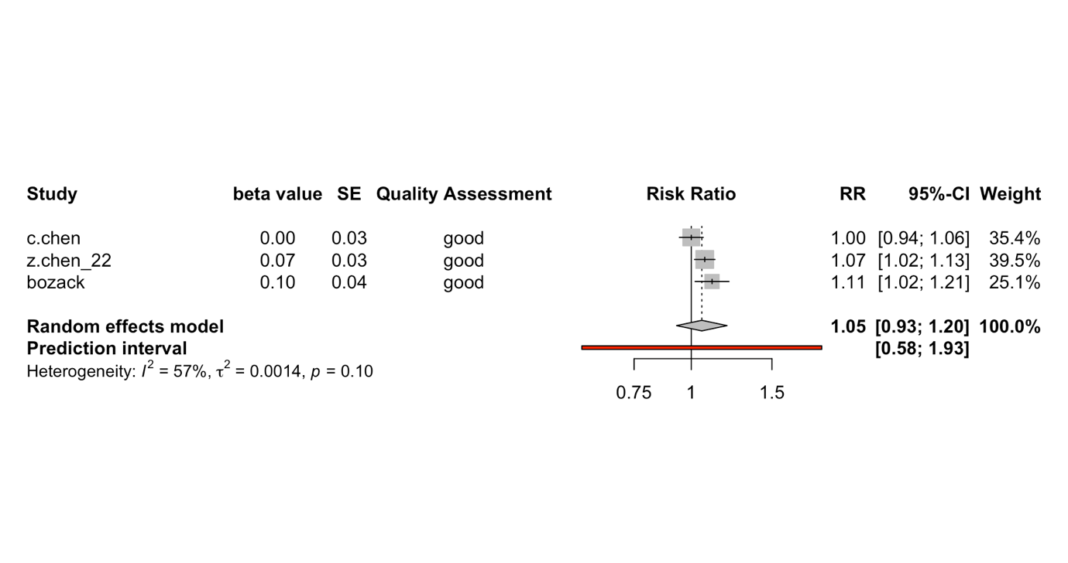

Study | RR | 95% CI | Weights (%)
Bozack 2021 | 1.1100 | (1.0191, 1.2090) | 25.1
C. Chen 2022 | 1.0000 | (0.9417, 1.0619) | 35.4
Z. Chen 2022 | 1.0700 | (1.0161, 1.1268) | 39.5

Sensitivity Analysis: PM_{2.5} Exposure and ICU Admission in North America

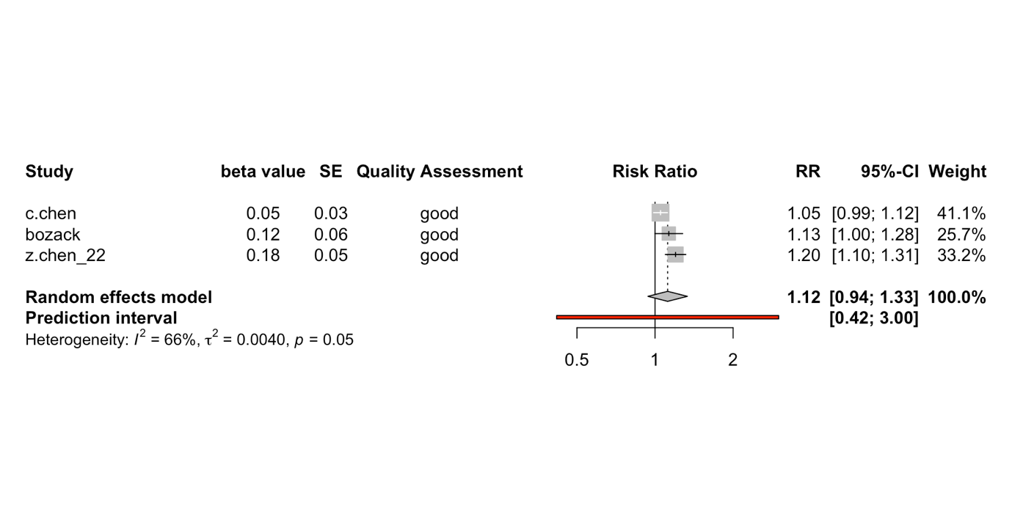

Study | RR | 95% CI | Weights (%)
Bozack 2021 | 1.1300 | (0.9988, 1.2784) | 25.7
C. Chen 2022 | 1.0500 | (0.9972, 1.1168) | 41.1
Z. Chen 2022 | 1.2000 | (1.0954, 1.3145) | 33.2

Sensitivity Analysis: NO₂ Exposure and ICU Admission in North America

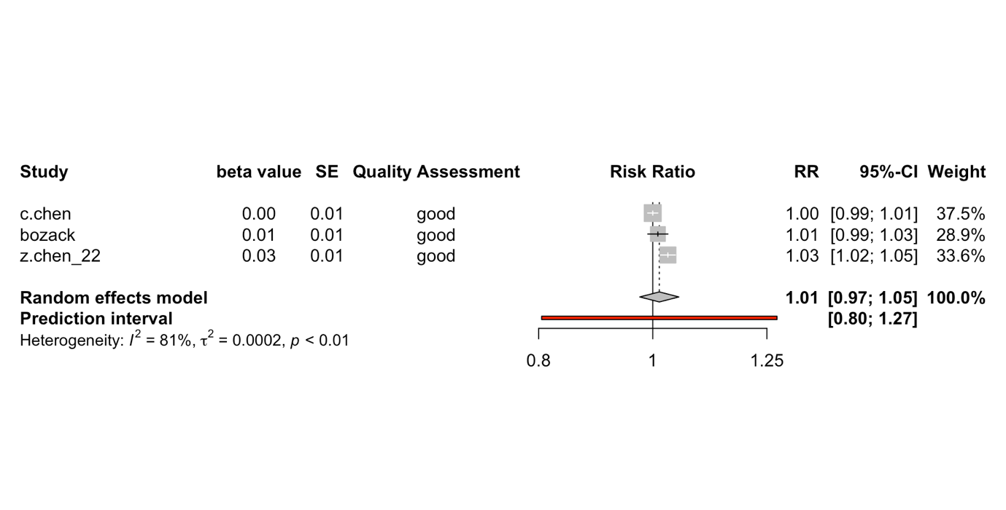

Study | RR | 95% CI | Weights (%)
Bozack 2021 | 1.0100 | (0.9902, 1.0302) | 28.9
C. Chen 2022 | 1.0000 | (0.9900, 1.0101) | 37.5
Z. Chen 2022 | 1.0300 | (1.0150, 1.0452) | 33.6

Black carbon was excluded from this review as it was only examined by two of the studies included and is not considered a criteria pollutant.
* Originally reported as an OR and was converted into a RR
Paper does not report the type of effect estimate that it uses to summarise its results [e.g., RR, OR, etc.]
Paper does not report the type of effect estimate that it uses to summarise its results [e.g., RR, OR, etc.]
Paper does not report the type of effect estimate that it uses to summarise its results [e.g., RR, OR, etc.]

