COVID-19 REACT Long COVID
QUESTIONNAIRE
Version 11b

Contents
Chronic disease/medical history 2
Multiple COVID 4
Exercise 5
Sleep 8
Fatigue 9
Anxiety/Depression 11
Diet 14
Alcohol 18
Smoking 20
Drugs 23
Women’s health 26
Demographics 30

Chronic disease/medical history

The following questions will help us understand more about your health and if you suffer from any health conditions.

ASK ALL
HEALTH (from Census 2011)
How is your health in general? Is it…

- Very Good
- Good
- Fair
- Bad
- Very bad
- Prefer not to say

ASK ALL
CONDHIST1
Do you have any of the following?

Please select all that apply

1. Organ transplant recipient
2. Diabetes (type I or II)
3. Heart disease or heart problems such as heart failure
4. Hypertension (high blood pressure)
5. Stroke
6. Kidney failure (kidneys do not work well)
7. Liver disease
8. Anaemia
9. Allergy (eczema, hay fever, rhinitis)
10. None of these
11. Prefer not to say

ASK ALL
CONDHIST2
How about these? Do you have any of the following?

Please select all that apply

1. Asthma
2. Other condition affecting lungs (such as chronic obstructive lung disease (COPD), bronchitis or emphysema)
3. Cancer
4. Fibromyalgia
5. Epilepsy
6. Other condition affecting the brain and nerves (e.g. Dementia, Parkinson’s, Multiple Sclerosis, Myasthenia Gravis)
7. Osteoarthritis
8. A weakened immune system/reduced ability to deal with infections (as a result of a disease or treatment)
9. Hepatitis, tuberculosis or other chronic infection.
10. None of these
11. Prefer not to say

ASK ALL
CONDHIST3
How about these? Do you have any of the following?

Please select all that apply

1. Dementia
2. Anxiety
3. Rheumatoid arthritis
4. Hypothyroidism (underactive thyroid gland)
5. Hyperthyroidism (overactive thyroid gland)
6. Addison’s or Cushing’s disease (poor functioning of the adrenal glands)
7. Depression
8. Any other psychiatric condition e.g. bipolar disorder, schizophrenia, anorexia or bulimia
9. Sleep apnoea/ narcolepsy
10. Any other serious illness
Please specify which illness: _______________________________
11. None of these
12. Prefer not to say

Do you think you have had COVID-19?

1 Yes
2 No
3 Not sure

If Yes ASK THE FOLLOWING

When Did you have COVID-19 ( Date)

COVRECOV (from PHOSP-COVID)

Do you feel fully recovered from COVID-19?

1 Yes
2 No
3 Not sure

ASK IF COVRECOV=2 OR 3
SYMPTTIME (from PHOSP-COVID)

We would like to understand more about your symptoms. For each symptom below please rate them before you had COVID-19, in general since you had COVID-19 and the worst you have felt in the past 24 hours. Please rate them on a scale 0-10 where:

0 Neutral
1
2 Slight sensation
3
4
5 Annoying
6
7 Distressing
8
9
10 Unbearable

For each symptom below please rate them before you had COVID-19, in general since you had COVID-19 and the worst you have felt in the past 24 hours. If you did not experience this symptom leave the box blank.

USE A GRID. DISPLAY LIST OF SYMPTOMS ON THE SIDE OF THE GRID
- Breathlessness
- Cough
- Fatigue
- Sleep quality
- Pain

DISPLAY ANSWERS BOXES ACROSS TOP OF THE GRID
Before you had COVID-19 [ALLOW NUMERIC VALUE 0-10]
Since you had COVID-19 [ALLOW NUMERIC VALUE 0-10]
Worst in the last 24 hours [ALLOW NUMERIC VALUE 0-10]

ASK IF COVRECOV=2 OR 3
SYMPTTRAJEC (from PHOSP-COVID)

Please also try to indicate if the symptom is staying the same, getting better or getting worse
USE A GRID. DISPLAY LIST OF SYMPTOMS ON THE SIDE OF THE GRID
- Breathlessness
- Cough
- Fatigue
- Sleep quality
- Pain

Ask about TRAJECTORY
- Same
- Better
- Worse
- Not applicable

MULTIPLE COVID
ASK ALL
REACT1STUDY
Did you take part in the REACT-1 antigen study using an antigen /*PCR swab test?
An antigen/PCR test is done by a nasal, throat or saliva swab and tests for current COVID-19 infection. *PCR = Polymerase Chain Reaction
Please do not include any tests that show if you have had COVID-19 in the past (antibody tests on blood or fingerprick).

1 Yes
2 No
3 Not sure

IF REACT1STUDY=1
ANTIGENTEST1RESULT
What was the result of this antigen test?
1 Positive
2 Negative
3 Not sure or inconclusive

IF REACT1STUDY=1
ANTIGENTEST1DATE
To the best of your recollection, when did this you have the antigen (swab) test?
WRITE IN DATE
DAY/MONTH/YEAR

IF ANTIGENTEST1RESULT=1
ANTIGENCOVIDRECENT1
Since you tested positive for COVID have you recovered and subsequently had an illness you believe may have been COVID19 for second time?

1 Yes
2 No
3 Not sure

IF ANTIGENCOVIDRECENT=1
ANTIGENCOVIDRECENTDATE
To the best of your recollection, when did this second illness start?
WRITE IN DATE
DAY/MONTH/YEAR

IF ANTIGENCOVIDRECENT1=1
ANTIGENCOVIDRECENT1CONFIRMED
Was this second illness confirmed by an antigen /*PCR swab test?
An antigen/PCR test is done by a nasal, throat or saliva swab and tests for current COVID-19 infection. *PCR = Polymerase Chain Reaction
Please do not include any tests that show if you have had COVID-19 in the past (antibody tests on blood or fingerprick).

1. Yes
2. No
3. Not sure

ASK ALL
REACT2STUDY
Did you take part in the REACT-2 antibody study (with home fingerprick testing)

1 Yes
2 No
3 Not sure

IF REACT2STUDY=1
COVIDRECENT1
Since you took part in the REACT-2 antibody study (with home fingerprick testing) have you had an illness that you believe may be COVID19?

1 Yes
2 No
3 Not sure

IF COVIDRECENT1=1
COVIDRECENT2
To the best of your recollection, when did this illness start?
WRITE IN DATE
DAY/MONTH/YEAR

IF COVIDRECENT1=2
PCRPREV1A
Since you took in the REACT study (with home fingerprick testing) have you taken an antigen /*PCR swab test? An antigen/PCR test is done by a nasal, throat or saliva swab and tests for current COVID-19 infection.
*PCR = Polymerase Chain Reaction
Please do not include any tests that show if you have had COVID-19 in the past (antibody tests on blood or fingerprick).

1 Yes
2 No
3 Not sure

IF PCRPREV1A=1
PCRPREV2
Have any of the antigen/PCR swab tests you have taken since participating in the REACT-2 study (with home fingerprick testing) tested positive?

1 Yes
2 No
3. Not sure

IF PCRPREV2=1
PCRPREV3
As best as you can recall, when was your last positive antigen/PCR test (do not include blood or fingerprick tests)?
WRITE IN DATE
DAY/MONTH/YEAR

IF PCRPREV2=1
PCRPREV4
If you have had more than one positive antigen/PCR test, when was your first positive test (note, this may be before you took part in REACT study)
WRITE IN DATE
DAY/MONTH/YEAR

Vaccination

ASK ALL
VACCINE1 (from REACT1)
Have you received a coronavirus vaccine?
- Yes, as part of a trial
- Yes, from my healthcare provider
- No

IF VACCINE1 =1
VACCINE2 (from REACT1)
Which vaccine did you receive as part of a trial ?
      - Pfizer/Biotech
      - AstraZeneca/Oxford
      - Janssen
      - Moderna
      - Imperial Vaccine
      - Novavax
      - Other (specify)
IF VACCINE1 =1
VACCINE 3
What was the date of your first vaccine in the trial?
WRITE IN DATE
DAY/MONTH/YEAR

IF VACCINE1 =1
VACCINE 4
What was the date of your last vaccine in the trial?
WRITE IN DATE
DAY/MONTH/YEAR

IF VACCINE1=2
VACCINE 5
Which vaccine did you receive from your healthcare provider ?
1.Pfizer/Biotech
2.AstraZeneca/Oxford
3.Janssen
4.Moderna
5.Imperial Vaccine
6.Novavax
7.Other (specify)
IF VACCINE1 =2
VACCINE 6
What was the date of your first vaccine from your healthcare provider?
WRITE IN DATE
DAY/MONTH/YEAR

IF VACCINE1 =2
VACCINE 7
What was the date of your last vaccine from your healthcare provider?
WRITE IN DATE
DAY/MONTH/YEAR

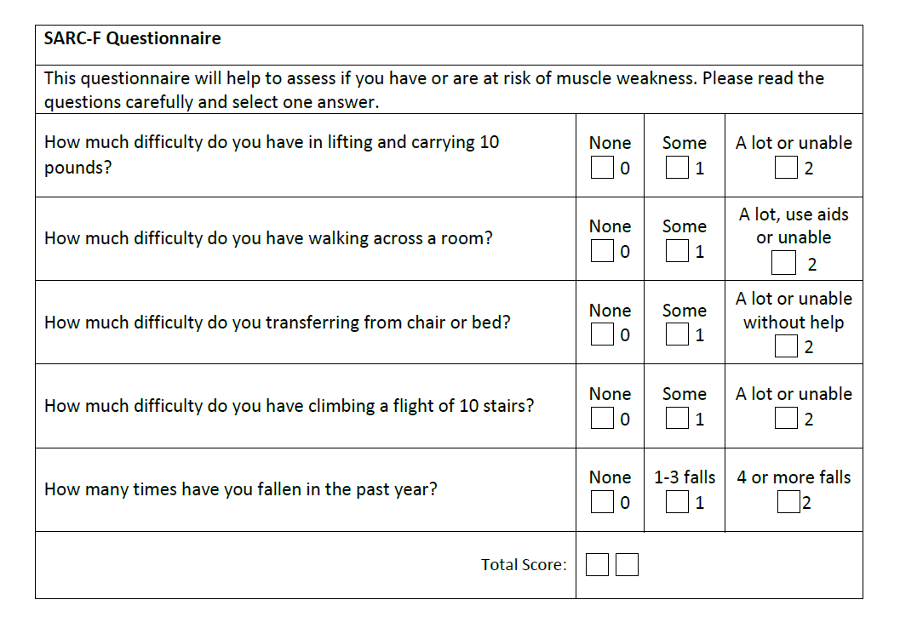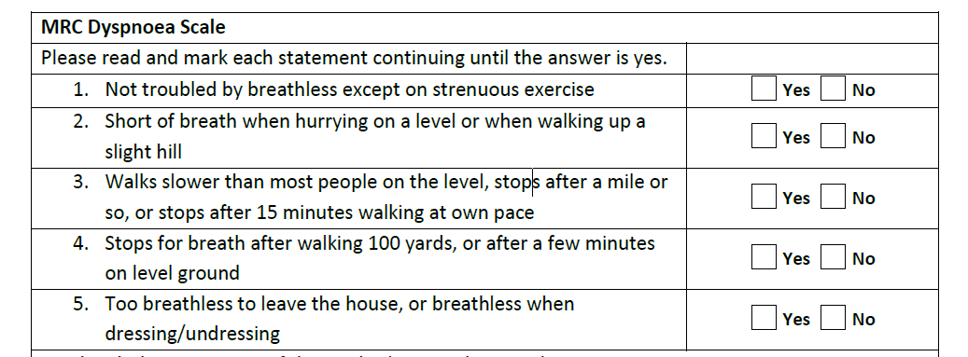Exercise

ASK ALL
EXSIXMONTH
Would you say that the amount of physical activity and exercise you have done has increased, decreased, or stayed the same over the last 6 months?

1. Increased a lot
2. Increased a little
3. Stayed about the same
4. Decreased a little
5. Decreased a lot
6. Don’t know

IF EXSIXMONTH = 4 OR 5
EXSIXMONTHWHY (adapted from Taking Part, Year 11)
You said that the amount of physical activity and exercise you have done has decreased over the last 6 months. Here is a list of reasons why people might do less physical activity and exercise. Why are you doing less?

- I was worried about the risk of infection/catching COVID-19
- I had less free time
- Childcare responsibilities took priority over it
- There were other things I preferred to do in my leisure time
- I didn’t get on with the people who did it
- Everyone I used to do it with had given it up
- I stopped enjoying or didn’t enjoy the activity
- It was/became too difficult
- I felt out of place
- Once I stopped doing it, it was easier not to do it again
- I developed health problems or a disability
- I didn’t feel I was good enough
- Once I was out of practice, it was too hard to get back into it
- I was worried that I would get injured if I carried on doing it
- I had to give up due to an injury (sustained from sport)
- I had to give up due to an injury (not sustained from sport)
- It became too expensive
- The classes / sessions changed to an inconvenient time
- A course, class or club finished/not available anymore
- I was training for an event
- It was difficult to get to via the transport options available to me
- The facilities got worse
- The venue/facilities closed down
- I had trouble accessing the place where it was held
- Don’t have a dog anymore
- Other (please specify)
- Don’t know
- Prefer not say

ASK ALL
IPAQ1
Think about the activities which take vigorous physical effort that you did in the last 7 days. Vigorous activities make you breathe harder than normal and may include heavy lifting, sports activities such as squash or football, fast cycling or high-intensity interval training (HIIT) . Think only about those physical activities that you did for at least 10 minutes at a time.

During the last 7 days, on how many days did you do vigorous physical activities like heavy lifting, digging, aerobics, or fast cycling?

NUMERIC (1-7)
No vigorous physical activities

ASK IF IPAQ1=1-7
IPAQ2
How much time did you usually spend doing vigorous physical activities on one of those days?

Hours per day (0-23)
Minutes per day (0-59)
Don’t know/not sure

ASK ALL
IPAQ3
Think about all the moderate activities that you did in the last 7 days.

Moderate activities refer to activities that take moderate physical effort and make you breathe somewhat harder than normal. Think only about those physical activities that you did for at least 10 minutes at a time.

During the last 7 days, on how many days did you do moderate physical activities like carrying light loads, cycling at a regular pace, or doubles tennis? Do not include walking.

NUMERIC (1-7) days per week
No moderate physical activities

ASK IF IPAQ3=1-7
IPAQ4
How much time did you usually spend doing moderate physical activities on one of those days?

Hours per day (0-23)
Minutes per day (0-59)
Don’t know/not sure

ASK ALL
IPAQ5
Think about the time you spent walking in the last 7 days. This includes at work and at home, walking to travel from place to place, and any other walking that you have done for recreation, sport, exercise, or leisure.

During the last 7 days, on how many days did you walk for at least 10 minutes at a time?

NUMERIC (1-7) days per week
No walking

ASK ALL
IPAQ6
How much time did you usually spend walking on one of those days?

Hours per day (0-23)
Minutes per day (0-59)
Don’t know/not sure

ASK ALL
IPAQ7
During the last 7 days, how much time did you spend sitting?

Hours per day (0-23)
Minutes per day (0-59)
Don’t know/not sure

ASK ALL
TVWATCH (from Q4.31 Airwave)
During the last 7 days what was the total time you spent watching television, including on-line streaming e.g. BBC iPlayer, Netflix, Amazon Prime Video, YouTube etc?

Hours per day (0-23)
Minutes per day (0-59)
Don’t know/not sure

Sleep

ASK ALL
SLEEPHR (from Q4.32 Airwave)
How much sleep do you usually get over a 24 hour period?
- 5 hours or less
- 6 hours
- 7 hours
- 8 hours
- 9 hours or more

ASK ALL
SLEEPQUAL (from CvHesleep English Longitudinal Study of Ageing COVID-19 Study) http://doc.ukdataservice.ac.uk/doc/8688/mrdoc/pdf/8688_questionnaire_spec_elsa_covid19_v5.pdf)
In the past month would you say the quality of your sleep was…

1. Excellent
2. Very good
3. Good
4. Fair
5. Poor

ASK ALL
SLEEPFOURWK (from Q4.33 Airwave)
Considering the last four weeks only, how often did you…

- Feel that your sleep was not quiet (moving restlessly, feeling tense, speaking, etc., while sleeping)?
- Get enough sleep to feel rested upon waking in the morning?
- Have trouble falling asleep?
- Awaken during your sleep and have trouble falling asleep again?
- Take naps (5 minutes or longer) during the day?
- Get the amount of sleep you needed?

- All of the time
- Most of the time
- A good bit of the time
- Some of the time
- A little of the time
- None of the time
- Don’t know

Fatigue

ASK ALL
PERSTIRED (from CureME questionnaire)
Do you have persistent or recurrent tiredness, weariness or fatigue?

1. Yes
2. No

ASK IF PERSTIRED=1
PERSREST (from CureME questionnaire)
Does this tiredness, weariness or fatigue go away when you rest?

1. Yes
2. No

ASK IF PERSREST=2
TIREDREASON (from CureME questionnaire)
Is this tiredness, weariness or fatigue happening ONLY because you have been exercising and/or working too much?

1. Yes
2. No

ASK IF PERSTIRED=1
TIREDLENGTH (from CureME questionnaire)
For how long have you had this tiredness, weariness or fatigue?

1. Less than 1 month
2. From 1 to less than 3 months
3. From 3 to less than 6 months
4. 6 months or longer
5. All my life; I don’t remember ever feeling well

ASK IF PERSTIRED=1
TIREDFREQ (from CureME questionnaire)
How often do you have this tiredness, weariness or fatigue?

1. Occasionally, once in a while
2. Frequently, but less than 50% of the time
3. More than 50% of the time

ASK IF PERSTIRED=1
TIREDACT (from CureME questionnaire)
Have your activities (personal, at home, social, educational, and/or occupational) been affected by this tiredness, weariness or fatigue?

1. Not at all
2. A little, but I can usually still do everything or most things normally
3. I have needed to substantially reduce at least some activities
4. I can no longer do at least some of the activities I used to do

ASK IF PERSTIRED=1
DESCTIRED (from CureME questionnaire)
How would you describe your illness?

1. Constantly getting worse
2. Constantly improving
3. No change (more or less the same on a daily basis)
4. Relapsing and remitting (good periods with no or few symptoms, and bad periods)
5. Fluctuating (symptoms vary a lot but never disappear)
6. No symptoms, I am not ill or have recovered completely.
ASK IF PERSTIRED=1
ACTTIRED (from CureME questionnaire)
In relation to your activities, what are you able to do now compared to before you got ill?

1. I can do half (50%) – or less than half, as much as I could.
2. I can do more than half (50%) or just as much as I could.

ASK IF PERSTIRED=1
TIREDDISAB (from CureME questionnaire)
Would you say that your fatigue is disabling?

1.Yes
2. No

ASK IF PERSTIRED=1
TIREDMENT (from CureME questionnaire)
Do you feel physically and/or mentally fatigued?

1. Yes, I feel both physically and mentally fatigued
2. No, I feel neither physically nor mentally fatigued
3. I feel mentally fatigued only
4. I feel physically fatigued only

Anxiety/Depression

Understanding how people feel about their lives is important to us. The next questions ask about aspects of your life. There are no right or wrong answers.

ASK ALL
LIFESAT (from Personal well-being ONS4)
On a scale of 0-10, where 0 is not at all satisfied and 10 is completely satisfied, overall, how satisfied are you with your life nowadays?

DISPLAY HORIZONTALLY
0 Not at all satisfied
1
2
3
4
5
6
7
8
9
10 Completely satisfied
11 Don’t know
12 Prefer not to say

ASK ALL
HAPPY (from Personal well-being ONS4)
On a scale of 0-10, where 0 is not at all happy and 10 is completely happy, overall, how happy did you feel yesterday?

DISPLAY HORIZONTALLY
0 Not at all happy
1
2
3
4
5
6
7
8
9
10 Completely happy
11 Don’t know
12 Prefer not to say

ASK ALL
ANXIOUS (from Personal well-being ONS4)
On a scale of 0-10, where 0 is not at all anxious and 10 is completely anxious, overall, how anxious did you feel yesterday?

DISPLAY HORIZONTALLY
0 Not at all anxious
1
2
3
4
5
6
7
8
9
10 Completely anxious
11 Don’t know
12 Prefer not to say

ASK ALL
WORTHW (from Personal well-being ONS4)
On a scale of 0-10, where 0 is not at all worthwhile and 10 is completely worthwhile, overall, to what extent do you feel the things you do in your life are worthwhile?

DISPLAY HORIZONTALLY
0 Not at all worthwhile
1
2
3
4
5
6
7
8
9
10 Completely worthwhile
11 Don’t know
12 Prefer not to say

ASK ALL
WEMWBS1-14 (from The Warwick–Edinburgh Mental Well-being Scale (WEMWBS) https://www2.uwe.ac.uk/services/Marketing/students/pdf/Wellbeing-resources/well-being-scale-wemwbs.pdf
Below are some statements about feelings and thoughts. Please tick the box that best describes your experience of each over the last 2 weeks

- I’ve been feeling optimistic about the future
- I’ve been feeling useful
- I’ve been feeling relaxed
- I’ve been feeling interested in other people
- I’ve had energy to spare
- I’ve been dealing with problems well
- I’ve been thinking clearly
- I’ve been feeling good about myself
- I’ve been feeling close to other people
- I’ve been feeling confident
- I’ve been able to make up my own mind about things
- I’ve been feeling loved
- I’ve been interested in new things
- I’ve been feeling cheerful

- All of the time
- Often
- Some of the time
- Rarely
- None of the time
- Don’t know
- Prefer not to say

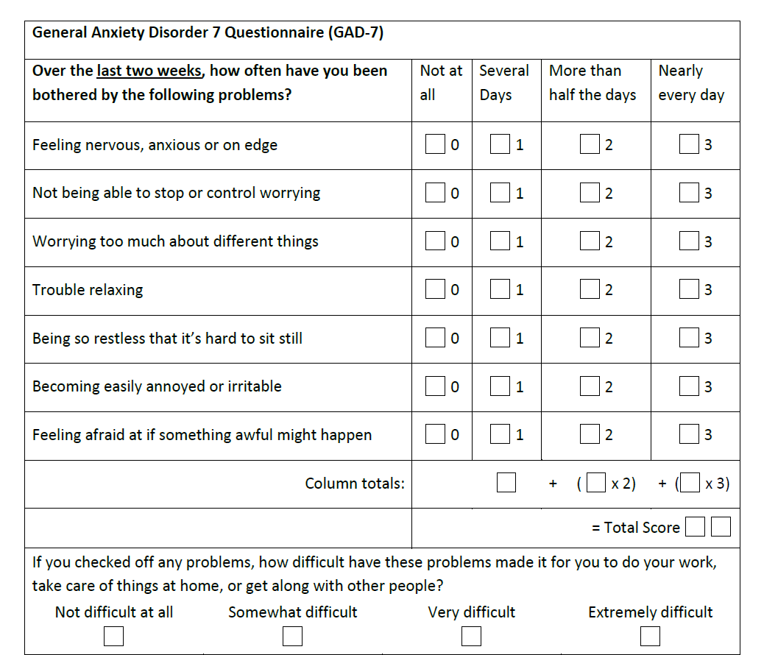

Diet

The next few questions are about your lifestyle including your diet, alcohol intake and drugs. This will help us understand…
The information you provide is completely confidential.

ASK ALL
FRUIT (from Active Lives Survey)
Now for a couple of questions about your diet.

How many portions of fruit did you eat yesterday? Please include all fruit, including fresh, frozen, dried or tinned fruit, stewed fruit or fruit juices and smoothies.

Fruit juice only counts as one portion no matter how much you drink.

INFO: What should I count as a portion?
A portion is half a large fruit such as a grapefruit, avocado, one medium sized fruit such as an apple, orange or pear, 2 small fruits such as plums or satsumas, a handful of grapes or berries, a heaped tablespoon of dried fruit, 3 heaped tablespoons of fruit salad or stewed fruit, 150ml fruit juice. Please do not include more than 150ml of fruit juice (including fruit juice contained within smoothies). This is because only one portion of fruit juice counts towards your 5-a-day.

NUMERIC. MIN 0, MAX 20
Don’t know

ASK IF FRUIT>9
FRTCHK (from Active Lives Survey)
You entered that you ate [^INSERT PORTION FROM FRUIT] portions of fruit yesterday. Is that correct?

1. Yes
2. No – you will be taken back to re-enter the correct portion

IF FRTCHK = 1 GO TO VEG.
IF FRTCHK = 2 GO BACK TO FRUIT

ASK ALL
VEG (from Active Lives Survey)
How many portions of vegetables did you eat yesterday? Please include fresh, frozen, raw or tinned vegetables, but do not include any potatoes you ate.

Beans and pulses only count as one portion no matter how much of them you eat.

INFO: What should I count as a portion?
A portion is 3 heaped tablespoons of vegetables, 3 heaped tablespoons of beans or pulses (such as baked beans, kidney beans or lentils). Beans and pulses only count as one portion no matter how much of them you eat. Potatoes do not count.

NUMERIC. MIN 0, MAX 20
Don’t know

ASK IF VEG>9
VEGCHK (from Active Lives Survey)
You entered that you ate [^INSERT PORTION FROM VEG] portions of vegetables yesterday. Is that correct?

1. Yes
2. No - you will be taken back to re-enter the correct portion

IF VEGCHK = 1 GO TO NEXT SECTION.
IF VEGCHK = 2 GO BACK TO VEG

ASK ALL
SPECDIET1 (Q5.7 from Airwave)
Are you following any special kind of diet right now?
- Yes
- No

ASK IF SPECDIET1=1
SPECDIET2 (Q5.8 from Airwave)
Is your diet for

- Losing weight
- High blood pressure
- Diabetes
- Food allergy
- High cholesterol
- Other.

ASK ALL
FOODGRP1 (from Food and You survey)
Which, if any, of the following applies to you?

Please state all that apply.

- Completely vegetarian
- Partly vegetarian
- Vegan
- Avoid certain food for other reasons, excluding allergies
- None

ASK ALL
FOODGRP2 (from Food and You survey)
At the moment, how often do you eat INSERT FOOD?
FOODS – RANDOMISE LIST – FIX ORDER OF TWO FISH ITEMS
Biscuits, pastries and cakes
Sweets and chocolate
Savoury snacks (e.g. crisps)
Bread, rice, pasta, potatoes and other starchy foods
Fried chips or roast potatoes
Oily fish, like salmon, sardines, mackerel or fresh tuna
Fruit and vegetables

- At least once a day
- 5-6 times a week
- 3-4 times a week
- Once or twice a week
- Once a fortnight
- Once a month
- Less than once a month
- Never
- Don’t know

ASK ALL
FOODGRP3 (from Food and You survey)
Thinking about the last 6 months, that is between (INSERT NAME OF MONTH 6 MONTHS AGO) and now, what, if any, changes have you personally made to the food you eat over the last 6 months?

Please state all that apply.

1. Eating more bread, rice, potatoes, pasta and other starchy foods
2. Eating less bread, rice, potatoes, pasta and other starchy foods
3. Eating more fruit and vegetables
4. Eating more fish, including oily fish
5. Eating less food high in saturated fat
6. Eating less food high in fat in general
7. Eating less food high in sugar
8. Eating less meat
9. Eating less salt, for example eating less salty food, not adding salt during cooking or to a meal before eating
10. Eating fewer calories
11. Eating more calories
12. Eating larger portions
13. Eating smaller portions
14. None of these
15. Other

ASK ALL
FOODGRP4 (Q5.1 from Airwave)
How often do you eat…

Oily fish (herring, kipper, mackerel, salmon, sardines or trout)?
White fish (cod, haddock or tinned tuna)?
White meat (chicken, duck, turkey, lobster, shrimp or
crab)?
Red meat (beef, veal, lamb, mutton or pork)?
Nuts

- Daily
- More than five times a week
- Two to four times a week
- Once a week
- Less than once a week
- Never

ASK ALL
FOODGRP5 (Taken from dietary fat short questionnaire)
On average, how many tablespoons of vegetable oil (e.g. sunflower, olive, sesame, rapeseed oil) do you consume in a given day for frying, salads & out of house meals etc.?
[NUMERIC]
Don’t know

ASK ALL
FOODGRP6 (Taken from dietary fat short questionnaire)
On average, how many tablespoons of olive oil or do you eat in a given day (including oil used for cooking, salads, out-of-home meals etc.)?
[NUMERIC]
Don’t know

ASK ALL
FOODGRP8 (Taken from dietary fat short questionnaire)
Do you exclusively consume low-fat dairy products?
- Yes
- No

ASK ALL
FOODGRP9 (Taken from dietary fat short questionnaire)
How many times per week do you eat fried foods including take away meals?
[NUMERIC]
Don’t know

Alcohol

ASK ALL
DRINK2 (Q4.11 from Airwave)
Q4.11Do you currently drink alcohol?

1 Yes
2 No

ASK IF DRINK2=2
AlwaysTT2 (Q4.12 from Airwave)
Did you ever drink alcohol?
1 Yes
2 No

ASK IF ALWAYSTT2=1
STOPDRINK (Q4.13 from Airwave)
Why did you stop drinking alcohol?

- Financial reasons
- Health reasons
- Addictive reasons
- Prefer not to say

ASK IF ALWAYSTT2=1
STOPDRINK2 (Q4.14 from Airwave)
How old were you when you stopped drinking alcohol?

[NUMERIC]
Can’t remember
Prefer not to say

ASK IF DRINK2=1
DrinkOft2 (Q4.15 from Airwave)
How often do you have a drink containing alcohol?

- Monthly or less
- Two to four times a month
- Two or three times a week
- Four or five times a week
- Daily or almost daily

ASK IF DRINK2=1
DrinkWeek (from Heath Survey for England)
Did you have an alcoholic drink in the last seven days ending yesterday?

1 Yes
2 No

ASK IF DRINKWEEK =1
DrinkDay (from Heath Survey for England)
On how many days out of the last seven did you have an alcoholic drink?
NUMERIC (1-7) days

ASK IF DRINKWEEK =1
DrnkType2 (Q4.16-Q4.20 from Airwave)
In the last seven days how many drinks have you had of each of the following?

Please remember that a drink poured at home could be equivalent to 2 or 3 pub
measures. One bottle of wine is equivalent to six small glasses

- Red wine Small (125mm) glasses
- White wine/champagne Small (125mm) glasses
- Fortified Wine (includes sherry, port and vermouth)
- Spirits/liqueurs (includes whisky, gin, rum, vodka and brandy) Standard (25ml) pub measures
- Beer or cider (include bitter, lager, stout, ale and Guinness) Pint (568ml)

[NUMERIC]

Smoking

ASK ALL
SMOKENOW (from REACT 2)
Do you smoke cigarettes at all nowadays?

1 Yes
2 No
3 Prefer not to say

ASK IF SMOKENOW = 2 or 3
SMOKECIG (from REACT 2)
Have you ever smoked cigarettes?

1 Yes
2 No
3 Prefer not to say

ASK IF SMOKENOW =1
SMOK5YRAGO
Were you a smoker about five years ago?

- Yes
- No
- Don’t know

ASK IF SMOKECIG= 1
SMOKECIGDATE (from REACT 2)
When did you last have a cigarette (as best you can remember)?

WRITE IN DATE
MONTH/YEAR

ASK IF SMOKECIG= 1
SmokQuitReason (from REACT 2)
If you used to smoke and have stopped now what was the main reason for stopping?

1 I had a health problem which meant I needed to quit
2 I wanted to avoid getting health problems
3 I had COVID-19
4 I wanted to avoid getting COVID-19
5 To save money
6 Other, please specify
7 Don’t know
8 Prefer not to say

IF SMOKENOW = 1 or SMOKECIG= 1
SmokAgeFirst (from REACT 2)
How old were you when you had your first cigarette?
If you are not sure please give your best guess.
Age:

IF SMOKENOW = 1 or SMOKECIG= 1
SmokBehav (from REACT 2)
If you smoke now or used to smoke, did you smoke…?

Select all that apply

1. During working time
2. At home indoors
3. At home outdoors
4. When going out to socialize
5. Somewhere else (Please specify)

ASK ALL
VAPNOW (from REACT 2)
Do you vape/use e-cigarettes at all nowadays?

1 Yes
2 No
3 Prefer not to say

IF VAPNOW = 2 or 3
SMOKEVAP (from REACT 2)
Have you ever vaped/used e-cigarettes?

1 Yes
2 No
3 Prefer not to say

IF SMOKEVAP= 1
SMOKEVAPDATE (from REACT 2)
When did you last vape/use e-cigarettes (as best you can remember)?

WRITE IN DATE
MONTH/YEAR

ASK ALL
HOOKAH (Q4.8 from Airwave)
Have you ever smoked any of the following?

- Pipe
- Full size cigars
- Miniature cigars (cigarillos)
- Hookah or Shisha (nicotine-based)
- Hookah or Shisha (non nicotine-based)
- None of these

IF HOOKAH=1-5
HOOKAHDATE
You said you smoked [LIST OF ITEMS FROM HOOKAH]. When did you last smoke any of these (as best you can remember)?

WRITE IN DATE
MONTH/YEAR

ASK ALL
NRNow (adapted from Health Survey for England 2018 http://doc.ukdataservice.ac.uk/doc/8649/mrdoc/pdf/8649_hse_2018_interviewer_and_nurse_documentation.pdf)
Have you used any of these nicotine replacement products in the last 6 months?

1 Nicotine chewing gum
2 Nicotine lozenge/mini lozenge
3 Nicotine patch
4 Nicotine inhaler/ inhalator
5 Nicotine mouthspray
6 Nicotine nasal spray
7 Another nicotine product
8 Electronic cigarette
9 None of these

Drugs

ASK ALL
TREAT1 (adapted from Q20 from UK ME/CFS Biobank)
What medications (including injections and supplements), if any, are you currently taking?

Please type the first few characters of the medication and select it from the list. If the medication is not shown, you can type it in.

If you have taken more than five medications, please enter the six you have taken most often.

Medication 1
[AUTORESPONSE – PREDICTIVE TEXT FROM BNF/NICE LIST]

Medication 2
[AUTORESPONSE – PREDICTIVE TEXT FROM BNF/NICE LIST]

Medication 3
[AUTORESPONSE – PREDICTIVE TEXT FROM BNF/NICE LIST]

Medication 4
[AUTORESPONSE – PREDICTIVE TEXT FROM BNF/NICE LIST]

Medication 5
[AUTORESPONSE – PREDICTIVE TEXT FROM BNF/NICE LIST]

Medication 6
[AUTORESPONSE – PREDICTIVE TEXT FROM BNF/NICE LIST]

None
Prefer not to say

ASK ALL
TREAT2 (Q20 from UK ME/CFS Biobank)
What medications (including injections and supplements), if any, have you taken in the last three months (other than those you are currently taking)?

Please type the first few characters of the medication and select it from the list. If the medication is not shown, you can type it in.
If you have taken more than five medications, please enter the six you have taken most often.

Medication 1
[AUTORESPONSE – PREDICTIVE TEXT FROM BNF/NICE LIST]

Medication 2
[AUTORESPONSE – PREDICTIVE TEXT FROM BNF/NICE LIST]

Medication 3
[AUTORESPONSE – PREDICTIVE TEXT FROM BNF/NICE LIST]

Medication 4
[AUTORESPONSE – PREDICTIVE TEXT FROM BNF/NICE LIST]

Medication 5
[AUTORESPONSE – PREDICTIVE TEXT FROM BNF/NICE LIST]

Medication 6
[AUTORESPONSE – PREDICTIVE TEXT FROM BNF/NICE LIST]

None
Prefer not to say

ASK ALL
TAKESUP (adapted from National Diet and Nutrition Survey. http://doc.ukdataservice.ac.uk/doc/6533/mrdoc/pdf/6533_ndns_yr9_interviewing_documents.pdf)
Have you taken any supplements in the past year, including prescription and non-prescription supplements e.g. Multivitamins, Vitamin D, Vitamin C, Fish oil, Calcium, amino acids etc?

- Yes
- No

IF TAKESUP=1
SUPTYPE
What supplements have you taken in the past year?
Please type the first few characters of the supplement and select it from the list. If the supplement is not shown, you can type it in.

If you have taken more than six supplements, please enter the six you have taken most often. If you are taking multivitamin tablets please write ‘multivitamin’.

Supplement 1
[AUTORESPONSE – PREDICTIVE TEXT FROM UK INTAKE/US INTERMAP REPORTS]

Supplement 2
[AUTORESPONSE – PREDICTIVE TEXT FROM UK INTAKE/US INTERMAP REPORTS]

Supplement 3
[AUTORESPONSE – PREDICTIVE TEXT FROM UK INTAKE/US INTERMAP REPORTS]

Supplement 4
[AUTORESPONSE – PREDICTIVE TEXT FROM UK INTAKE/US INTERMAP REPORTS]

Supplement 5
[AUTORESPONSE – PREDICTIVE TEXT FROM UK INTAKE/US INTERMAP REPORTS]

Supplement 6
[AUTORESPONSE – PREDICTIVE TEXT FROM UK INTAKE/US INTERMAP REPORTS]

ASK ALL
DRQ17A (adapted from Crime Survey for England)
The following questions ask whether or not you have used recreational drugs. Please answer them honestly. The answers you give are completely confidential.

Have you taken anything that you knew or thought was a drug (not prescribed by a doctor or other healthcare professional), in the last 12 months?

1 Yes
2 No
3 Prefer not to say

ASK IF DRQ17A=1
DRUG1 (adapted from Crime Survey for England)
In the last 12 MONTHS have you taken or done any of the following?

- AMPHETAMINES (SPEED, WHIZZ, UPPERS, BILLY, SULPHATE, CRANK, PASTE)?
- METHAMPHETAMINE (CRYSTAL METH, ICE, GLASS, TINA, YABA)?
- CANNABIS (MARIJUANA, GRASS, HASH, GANJA, BLOW, DRAW, SKUNK, WEED, SPLIFF, DOPE)?
- COCAINE POWDER (COKE, CHARLIE)?
- CRACK COCAINE (BASE, ROCK, STONES)?
- ECSTASY ('E', MDMA)?
- HEROIN (SMACK,'H', BROWN)?
- LSD/ACID (TRIPS)?
- MAGIC MUSHROOMS?
- METHADONE or PHYSEPTONE (not prescribed by a doctor or other healthcare professional)?
- TRANQUILLISERS (TEMAZEPAM, VALIUM, ROOFIES, JELLIES) (not prescribed by a doctor or other healthcare professional)?
- ANABOLIC STEROIDS (STEROIDS) (not prescribed by a doctor or other healthcare professional)?
- KETAMINE (K, SPECIAL K, VITAMIN K) (not prescribed by a doctor or other healthcare professional)?
- MEPHEDRONE (Meow Meow, MCAT, Bubble, Drone, Meph, 4MMC)?
- Other (please specify)
- None of these
- Prefer not to say

ASK IF DRUG1=1-18
DRQFREQ (from Crime Survey for England)
How often during the last 12 MONTHS have you taken ANY of the drugs you’ve just mentioned, that were not prescribed by a doctor or other healthcare professional?

1. Every day
2. 3 to 5 days a week
3. Once or twice a week
4. 2 or 3 times a month
5. Once a month
6. Once every couple of months
7. Once or twice this year
8. Don't Know
9. Don't want to answer

Women’s health

ASK IF RESPONDENT IS FEMALE
EVPREG (from Q6.10H Airwave)
Have you ever been pregnant or are you currently pregnant?

- Yes
- No
- Prefer not to say

IF EVPREG = 1
EVBIRTH (Adapted in part from million women study http://www.millionwomenstudy.org/files/mws-web1.pdf and from airwave)
Have you ever given birth to any children (including still births)?

- Yes
- No
- Prefer not to say

IF EVBIRTH =1
NUMBIRTH (Adapted in part from million women study http://www.millionwomenstudy.org/files/mws-web1.pdf and from airwave)
How many children have you given birth to?

[NUMERIC]

- Prefer not to say

ASK IF RESPONDENT IS FEMALE
MENSCYC (Adapted in part from million women study http://www.millionwomenstudy.org/files/mws-web1.pdf and from airwave)
How long is your menstrual cycle usually? This is the number of days between the first day of each menstrual period.

- Less than 26 days
- 26-27 days
- 28 days
- 29-30 days
- 31-33 days
- 34 days or more
- Not sure (irregular cycles)
- My periods have stopped
- I've never had a period
- Don’t know
- Prefer not to say

ASK IF RESPONDENT IS FEMALE
PERSTART (Adapted in part from million women study http://www.millionwomenstudy.org/files/mws-web1.pdf and from airwave)
How old were you when your menstrual periods started?

[NUMERIC]

- Don’t know
- Prefer not to say

IF MENCYC =8
PERSTOP (Adapted in part from million women study http://www.millionwomenstudy.org/files/mws-web1.pdf and from airwave)
How old were you when your menstrual periods stopped?

[NUMERIC]

- Don’t know
- Prefer not to say

IF MENCYC =8
PERSTOPWHY (Adapted in part from million women study http://www.millionwomenstudy.org/files/mws-web1.pdf and from airwave)
Why did your menstrual periods stop?

- Natural menopause
- Hysterectomy
- Oophorectomy
- Oophorectomy and Hysterectomy
- Radiation or chemotherapy
- Other
- Don’t know
- Prefer not to say

ASK IF RESPONDENT IS FEMALE
HORMCONT (Adapted in part from million women study http://www.millionwomenstudy.org/files/mws-web1.pdf and from airwave)
Have you ever taken a hormonal contraceptive?

- Yes
- No
- Don’t know
- Prefer not to say

IF HORMCONT =1
HORMCONTTYPE (Adapted in part from million women study http://www.millionwomenstudy.org/files/mws-web1.pdf and from airwave)
Have you ever taken the following:

- The contraceptive pill (combined pill) e.g. Microgynon, Rigevidon, Ovranette etc?
- The progesterone only contraceptive pill (mini pill/POP)?
- Contraceptive implant?
- Intrauterine system (IUS, progesterone-releasing coil)?

- Yes
- No
- Don’t know
- Prefer not to say

IF HORMCONTYPE1=1, HORMCONTYPE2=1, HORMCONTYPE3=1, HORMCONTYPE4=1
COMBPILLYRS (Adapted in part from million women study http://www.millionwomenstudy.org/files/mws-web1.pdf and from airwave)
For how many years in total did you use the following? If you are unsure please give an estimate. If you stopped at some point and then restarted, please do NOT include any time when you were not using the following.

- [IF HORMCONTYPE1=1] The contraceptive pill (combined pill) e.g. Microgynon, Rigevidon, Ovranette etc?
- [IF HORMCONTYPE2=1] The progesterone only contraceptive pill (mini pill/POP)?
- [IF HORMCONTYPE3=1] Contraceptive implant?
- [IF HORMCONTYPE4=1] Intrauterine system (IUS, progesterone-releasing coil)?

[NUMERIC]
- Under 1 year
- Don’t know

ASK ALL
MULTICODE
HRTUSE (Adapted in part from million women study http://www.millionwomenstudy.org/files/mws-web1.pdf and from airwave)
Have you ever used Hormone Replacement Therapy?

Please select all that apply

- Yes, I have used prescription Hormone Replacement Therapy (HRT)
- Yes, I have used over the counter products (e.g. Soy oestrogen products, red clover)
- No
- Don’t know
- Prefer not to say

IF HRTUSE=1
HRTPRESYEARS (Adapted in part from million women study http://www.millionwomenstudy.org/files/mws-web1.pdf and from airwave)
How many years in total have you used prescription Hormone Replacement Therapy (HRT)? If you are unsure please give an estimate. If you stopped at some point and then restarted, please do NOT include any time when you were not taking prescription Hormone Replacement Therapy (HRT).

[NUMERIC]

- Under 1 year
- Don’t know

IF HRTUSE=1
HRTPRESNOW (Adapted in part from million women study http://www.millionwomenstudy.org/files/mws-web1.pdf and from airwave)
Are you currently using Hormone Replacement Therapy (HRT)?

- Yes
- No
- Don’t know
- Prefer not to say

IF HRTUSE=2
HRTCOUNTERYEARS (Adapted in part from million women study http://www.millionwomenstudy.org/files/mws-web1.pdf and from airwave)
How many years in total have you used over the counter products (e.g. Soy oestrogen products, red clover)? If you stopped at some point and then restarted, please do not include any time when you were not taking over the counter products.

[NUMERIC]

- Under 1 year
- Don’t know

IF HRTUSE=2
HRTCOUNTERNOW (Adapted in part from million women study http://www.millionwomenstudy.org/files/mws-web1.pdf and from airwave)
Are you currently using over the counter products (e.g. Soy oestrogen products, red clover)?

- Yes
- No
- Don’t know
- Prefer not to say

Final questions

The final questions are about you and your household to help us make sure we are hearing from a range of people.

Employment

ASK ALL
EMPL (from REACT 1)
At present are you…?

If you are furloughed, please select the job that you are furloughed from at the moment. If you are not furloughed, please select your current job.

1. Employee in full time-job (30+hours a week)
2. Employee in part-time job (less than 30 hours a week)
3. Self-employed
4. Government supported training
5. Unemployed and available for work
6. Wholly retired from work
7. Full-time education at school, college or University
8. Looking after home/ family
9. Permanently sick / disabled
10. Doing something else
11. Prefer not to say

ASK ALL
What is your current job title __________________________________

ASK ALL
How would you describe the main business / industry your work in _________________________________________________________________________________________________________________________________________________________________________________________________________________________________

ASK ALL
HOMEEXCL (from Nested Case-Control Study)
Since the COVID-19 outbreak, have you worked exclusively from home?

1.Yes
2. No
3. Prefer not to say

IF HOMEEXCL =2
JOBRETEN (from Nested Case-Control Study)
Since the COVID-19 outbreak, have you been off work on a job retention /furlough scheme?
1.Yes
2. No
3. Prefer not to say

OR

ASK ALL
FURL (from REACT2)
Have you been furloughed or been made redundant since the lockdown began?
1. I have been furloughed
2. I have been made redundant
3. Not applicable to my situation

IF EMPL = 1, 2 or 3

WORKTYP1 (from Nested Case-Control Study)
Do you work in health and social care and have you been in direct contact with confirmed or suspected COVID-19 patients?
1.Yes
2. No
3. Prefer not to say

OR

IF EMPL = 1, 2 or 3
WORKTYP1 (from REACT1 and REACT2)
Are you …

Select all that apply

- A healthcare worker with direct patient contact
- A healthcare worker with no patient contact
- Working in a care home with direct contact with clients
- Working in a care home without contact with clients
- An essential/ key worker (as currently defined by the Government)
- None of these
- Don’t know

IF EMPL = 1, 2 or 3
COVIDCOLL (from Nested Case-Control Study)
Are you aware of any of your close work colleagues that have had COVID-19?
1.Yes
2. No
3. Prefer not to say

IF EMPL = 1, 2 or 3
COVIDCONTACT (from Nested Case-Control Study)

Would you consider that your job brings you in potential close contact with many (e.g. more than 50 per week) different members of the public?
1.Yes
2. No
3. Prefer not to say

Disability

ASK ALL
DISAB1
Do you have any physical or mental health conditions or illnesses that have lasted or are expected to last 12 6 months or more?

Please select one answer

- Yes
- No
- Prefer not to say

ASK IF DISAB1=1
DISAB2
Do these physical or mental health conditions or illnesses have a substantial effect on your ability to do normal daily activities?

Please select one answer

- Yes
- No
- Prefer not to say

ASK IF DISAB1 = 1
DISTYP
Does this disability or illness affect you in any of the following areas?

Please select all that apply

- Long term pain
- Chronic health condition
- Mobility
- Dexterity
- Mental health
- Visual
- Breathing
- Memory
- Hearing
- Learning
- Speech
- Behavioural
- Other (specify)
- None of these
- Prefer not to say

INFO for categories above:
Long term pain: persistent or chronic pain as a result of tissue damage or inflammation (for example from arthritis) or to do with the nervous system (for example from diabetes).

Chronic health conditions: conditions for which there is currently no cure, and which are managed with medication and other treatment, for example: diabetes, coronary heart disease, stroke, epilepsy and hypertension.

Mobility: the ability to move around. Problems with mobility may cause unsteadiness and difficulty walking or moving. It can be caused by many things including muscle weakness, joint problems, pain or neurological conditions.

Dexterity: using the hands or body for fine motor skills or small movements. Problems with dexterity may affect picking things up, maintaining a hold on items, buttoning clothing, or writing.
Mental health: Mental health problems can affect the way people think, feel and behave. This includes anxiety disorders, bipolar disorder, depression, eating disorders, personality disorders, psychosis and schizophrenia.

Visual: a limitation in one or more functions of the eye or visual system. This includes total blindness as well as visual impairment or low vision that cannot be corrected with standard glasses or contact lenses.

Breathing: medical conditions that affect the lungs and respiratory system and may result in breathlessness, asthma attacks or fatigue. Includes obstructive conditions (e.g. bronchitis), restrictive conditions (e.g. fibrosis), vascular diseases (e.g. pulmonary edema) or infectious, environmental and other "diseases" (e.g. tuberculosis, asbestosis).

Memory: difficulty consistently remembering information which impacts on daily life. It can be a result of brain trauma, stroke, dementia and other conditions.

Hearing: includes partially or wholly lacking hearing, in one or both ears, at birth, through disease early in life, or later in life. Also known as hard of hearing, hearing loss, deaf, deafness.

Learning: reduced intellectual ability and difficulty with everyday activities. Also known as intellectual disability or learning difficulty.

Speech: a disruption in normal speaking patterns that makes verbal communication difficult. This can include lisps and stammering, dyspraxia and dysarthria.

Behavioural: Behaviour traits that have a negative effect on daily life and/or social interactions or that make certain tasks more difficult.

Other‎: Any other physical or mental health conditions or illnesses that have lasted, or are expected to last, 12 months or more, that are not listed above.

We would now like to ask you about a couple of things that may have changed since you completed the previous survey.

HEIGHT
ASK ALL
HEIGHT
What is your height?
{Two boxes in Feet and Inches and one box in centimetres}
_ Feet_Inches
_ cm
1. Cannot give estimate
2. Prefer not to say

WEIGHT

ASK ALL
WGTCHANGE (adapted from Q11.6 Airwave)
Would you say you have gained or lost weight in the last 6 months, or have you stayed about the same weight?

1. Gained weight
2. Lost weight
3. My weight stayed about the same
4. Don’t know
5. Prefer not to say

IF WGTCHANGE =1
WGTGAIN (adapted from Q11.7 Airwave)
How much weight did you gain? Please choose to enter in either pounds(lbs) or kilograms(kg).

{Two boxes in stones and pounds and one box in kg}
_ stones _ pounds
_ kg
1. Cannot give estimate
2. Prefer not to say

IF WGTCHANGE =2
WGTLOST (adapted from Q11.8I Airwave)
How much weight did you lose? Please choose to enter in either pounds(lbs) or kilograms(kg).

{Two boxes in stones and pounds and one box in kg}
_ stones _ pounds
_ kg
1. Cannot give estimate
2. Prefer not to say

[‘SUBMIT MY ANSWERS’ BUTTON]

END SCREEN
Your answers have now been submitted.
Thank you very much for taking part in this important study. The results will help us understand why some people who are infected with coronavirus are asymptomatic or mildly affected and why a minority of people have much more severe symptoms. The results may help identify new treatments or vaccines.
The results of the study will be available on the Imperial College London dedicated REACT webpage in due course: https://www.imperial.ac.uk/medicine/research-and-impact/groups/react-study/real-time-assessment-of-community-transmission-findings/
To find out more about the REACT research programme and the latest results click here. For the current Government guidance about COVID-19, please visit https://www.gov.uk/coronavirus
You can exit the questionnaire by closing your internet browser.

