Imperial College REDCap Service

Table of Contents
Service Definition 3
1. Abbreviation Table 3
2. Purpose 3
3. Requirements to setting up a REDCap project 4
4. Service Delivery 4
5. Service Definition 5
6. ICT Obligations 5
7. RGIT Obligations 5
8. ICTU Obligations 5
9. Research group / PI Obligations 5
Data Management Guidance 6
10. References 6
11. Introduction 6
12. Objectives of ECRF Design 7
13. eCRF Design 7
14. Standard eCRF Forms 9
15. eCRF Review and Approval 9
16. eCRF Amendments 9
17. eCRF Completion Guidelines 9
18. Using an Electronic Data Capture (EDC) System 10
REDCap Archiving steps 10
19. Pre-requisites to archiving 10
20. Archiving dataset 10
21. Archiving audit trail (logging) 12
22. Archiving of project without data 12
23. Archiving of project with data 14

Service Definition

Abbreviation Table

GDPR | General Data Protection Regulation
CPMP | Committee for Proprietary Medicinal Products
CTIMP | clinical trial of an investigational medicinal product
EC | European Commission
eCRF | Electronic Case Report Form
EDC | Electronic Data Capture
EU | European Union
FoM | Faculty of Medicine
ICH | International Conference on Harmonisation
ICTU | Imperial Clinical Trials Unit
MHRA | Medicines and Healthcare products Regulatory Agency
PID | Participant Identifier
RGIT | Research Governance and Integrity Team
SAP | Statistical Analysis Plan
SCDM | Society for Clinical Data Management
STATS | Statisitician
XML | Extensible Markup Language

Purpose

There are a number of Research groups within College who currently use REDCap on locally owned servers, whilst ICT have received several requests directly to provide research groups with REDCap.

In addition, a GDPR audit conducted with FoM has highlighted Research groups have databases storing personal data on a long term basis in a variety of hosting locations without consistent assurance or audit of security and compliance procedures.

A centrally hosted instance of REDCap was requested in order to aid in consistency and oversight over installations. This should provide a greater level of assurance over the data residency and security of the environment and its data in order to meet College GDPR obligations.

REDCap is being offered to Research groups to build their own clinical studies (subject to approval from the RGIT).

Requirements to setting up a REDCap project

There are three requirements to setup the study on REDCap. These are:
- The study must be a non-CTIMPstudy
- The study cost code must be provided. The studies are charged £100 per year for their space on the server
- The DPIA (Data Protection Impact Assessment) Reference number. This is required for all REDCap projects. If you do not have the number, the form and the DPO contacts can be found in the College’s Data Protection web pages.
- The DPIA is to ensure that GDPR guidelines are being followed and is different to the ethics approvalThe study cost code and DPIA Reference number can be provided after initial submission of request, however, the database space can only be created once the ICTU REDCap Administrators have received this information.

Service Delivery

The steps below show the project life-cycle for REDCap.
- The Study team requests REDCap project space via the ‘New space request’ form.
  - The Grant/Departmental Budget Reference (project code cost) and the DPIA Reference number are mandatory requirements before the database can be setup.
  - The request can be sent to RGIT to approve without the DPIA Reference number or study cost code but this is required to be sent to the REDCap Administrators before setting up a database space.
- RGIT approves the new REDCap project space request.
  - This is to ensure that the studies are suitable to run on REDCap (i.e. non CTIMP studies).
- The project space set-up by the ICTU REDCap Administrator.
- Responsibility for study design, test, data entry, data quality, subject management and archiving would rest with the research group/team.
- ICTU will create the users and group user accounts with appropriate rights specified by the Study team.
- ICTU will collect a yearly fee of 100GBP non pro-rated from the study cost code provided in the New space request form. Payment will commence annually after the project has been created in REDCap.
- The Study team archives the REDCap project when the study has finished.
- ICTU team will delete REDCap study after archiving process has been completed.

Service Definition

- The REDCap service is intended to be a cost effective service to the Imperial research community. Therefore high availability or disaster recovery services for REDCap are not provided as part of this service.
- The service will not be fully validated in accordance with Good Clinical Practice guidelines and hence the service is not appropriate for CTIMP studies, or blinded RCTs involving NIMPs.
- There will be a flat fee of £100 per study for use of REDCap. Billing will be on an annual basis not pro-rated starting when the project is created on REDCap.
- REDCap is for electronic data capture of study data only. It is not a long term clinical data repository. When the study is fully completed the research group are expected to export the study and study data for secure long term storage and preservation.
- The College REDCap instance is not designed to support significant volumes of files and images in the context of subject data capture. Please discuss with ICTU if you have any file storage requirements in connection with electronic data capture.

ICT Obligations

- To provide a production and test environment of REDCap. Test envioronment is only available for College users on a request basis.
- To perform system updates to both the test and production environments on a monthly basis.
- To ensure that the system is backed up on a daily basis.

RGIT Obligations

- To triage initial requests for REDCap from Research groups.
- To ensure that study meets the governance criteria for REDCap approval and hence the request to use REDCap is approved.

ICTU Obligations

- To create the project space in REDCap for each approved study.
- To create the REDCap database space for each project, the mandatory requirements are that the study cost code and DPIA Reference number are provided.
- To manage user provisioning and allocation of users to project spaces.
- To triage incidents / service requests relating to user management and admin user aspects of the REDCap service.
- To manage annual billing for the service.

Research group / PI Obligations

- Individual research groups should be aware that ICT would be performing monthly updates to the production environment to keep the REDCap system up-to-date.
- Individual research groups are expected to design, build, test and maintain electronic data capture forms in REDCap. See the data management guidance section in this document for guidance on building the eCRF. Self-service resources are available from the REDCap community website.
- Individual research groups are responsible for the data quality and data integrity of the data entered into the study.
- Individual research groups are responsible for conforming to FoM GDPR guidelines regarding subject identifiable and subject sensitive data.
- Individual research groups are responsible for regression testing of their studies following REDCap software updates. This is includes logging any issues uncovered as a part of testing.
- Individual research groups are responsible for ensuring that subject data is correctly entered into the study.
- Individual research groups are responsible for closing the REDCap project when the study has finished. This includes exporting the data out of REDCap and into a long term storage / analysis location. See section on how to archive a REDCap project later in this document.
- Individual research groups are responsible for trial-specific and EDC software training.

Data Management Guidance

References

- ICH-E6 R2: Good Clinical Practice Guideline (2017)
- ICH-E6 R2: Good Clinical Practice Guideline (2017)
- Note for Guidance on Good Clinical Practice (CPMP/ICH/135/95)
- European Directive for the implementation of GCP 2001/20/EC
- Good Clinical Data Management Practice, Version 4, SCDM, October 2005
- Good Clinical Practice Guide – MHRA (2012)
- GDPR - EU General Data Protection Regulation (May 2018)

Introduction

Case Report Forms (CRF) are “printed, optical or electronic document designed to record all the protocol required information to be reported to the sponsor on each trial subject.” ICH GCP section 1.11.

It should be study protocol driven, robust in content and designed to record all of the protocol required information on each study subject and should comply with GDPR regulations.

The design of the eCRF and its completion has a direct impact on the quality of the data collected during a clinical study. A well designed eCRF ensures that: no essential data are missed, data queries are kept to a minimum, aids good data management practice and assists with statistical analysis and reporting. This enables the researcher to test the hypothesis or answer the study related questions.

Objectives of ECRF Design

Primary: is to collect all the data required by the protocol in such a way that it can be analysed according to the protocol and Statistical Analysis Plan (SAP). For example, Visits, Procedures to be performed, data field/variables.
All the data elements/points within the eCRF must support the identifiable objectives of the protocol, in the form of the primary and secondary outcomes and safety endpoints.

Secondary: is to reduce the number of queries to the site that ask for clarification of the data responses. For example, avoid duplicating data in data collection and eliminating missing and/or ambiguous responses.

It should also serve to ensure the safety and eligibility of the participant. It should also demonstrate compliance with study procedures and where possible, adherence to Good Clinical Practice (GCP) and Principles of Good Data Management.
In order to achieve these goals, the following points below should be adhered to when designing eCRFs:
- Subject identifiers must not be used anywhere on the eCRF, such as subject’s name, initials, address, hospital number etc., in order to maintain the confidentiality of the subject. This is known as Pseudonymisation.
- Do not collect the full date of birth. Consider either collecting the Month/Year or Year only. If age is an inclusion criterion, collect age instead.
- Only collect data related to the protocol
- Collect the raw data measurements rather than implied result (with the exception of age as explained above)
- Use coded entries and drop down codelist entries
- Consider the format type of each data variable and associated unit
- Minimise the use of text fields
- Avoid using abbreviations that are ambiguous or could be interpreted differently.
- When completing the eCRF, avoid using abbreviations in text fields (other than NA - Not Applicable, ND - Not Done, NK - Not Known and UNK - Unknown) and acronyms, unless they are approved medical abbreviations known to be acceptable.

eCRF Design

The eCRF can be one single form covering all aspects of the study or a collection of separate forms.
- The initial design of the eCRF can use a final draft version of the protocol provided the eCRF design is reviewed against the final protocol once available.
- Based on the approach used and regardless of the format, the eCRF should be version controlled during the draft process and also once it has been finalised. If there are changes, the version number and date should be updated accordingly. Versioning format should follow the sequence for draft versions 0.1, 0.2, 0.3 etc. and for final versions 1.0, 2.0, 3.0 etc.
- eCRFs must not contain any participant’s identifiable information (i.e. participant’s name, address etc.), the participant’s identity should remain anonymised. The participant should only be identified on the eCRF by means of the allocated study number, participants should be allocated a Participant Identifier (PID) when enrolled/randomised onto a clinical study.
- Sufficient information should be included in the header of the eCRF to attribute every page or form to a participant e.g. study identifier, participant number.
- The header information should detail which time point during the study each page belongs to, clearly identifying the visit or data collection time point as defined in the protocol and the date the data was collected.
- For multi-centre studies the site should also be identifiable on the eCRF.
- All visits and study specific procedures should be recorded on the eCRF as the protocol schedule of assessments demands.
- eCRF pages should be arranged in chronological order as per the visit schedule.
- The arrangement of the data fields should be clear, logical, concise and user friendly.
- The use of free text in data fields should be minimised wherever possible due to the difficulty of analysing free text responses. Consider whether text data can be collected in another format i.e. selecting form a drop down codelist.
- Where appropriate, a combination of definitive answers and an option to enter ‘other’ and specify will allow for additional information to be collected.
- Avoid collecting extraneous data – if the data are not required to be collected according to the protocol and will not be analysed, do not include in the eCRF.
- Avoid collecting derived data, to minimize calculation errors. In particular, avoid this if designing a pCRF.
- Specify decimal points and number of places required where actual values are required for certain data points.
- Unit measurements should always be specified.
- The use of tick boxes, radio buttons, multi-select and drop down list should be incorporated in the eCRF.
- In addition, maximise the use of standard eCRF forms/modules from the global library (which will have already been designed, developed and tested) where possible.

Standard eCRF Forms

In addition to the procedures listed in a protocol visit schedule, there are some types of questions that are generally required in the eCRF. These questions collect essential data that will be used both for analysis and regulatory submissions.
Typically, these should include but are not limited to:
- Demographic data (sex or gender, ethnicity, Date of Birth*)
- Inclusion and Exclusion Criteria – (Participant’s eligibility)
- Relevant History e.g. Medical, Medication, Surgical
- End of Treatment Information
- End of Study Information
*Please note: The full Date of Birth should not be collected, only Month and Year, or Year, to comply with GDPR regulations.

eCRF Review and Approval

The eCRF design should be reviewed at all stages and approved by the CI and Statistician (or person assigned to analyse the data) to ensure:
- Only the appropriate data have been collected.
- The data are consistent with the study protocol.
- Data have been collected to answer the research questions being asked.
- Has been reviewed for accuracy and completeness, is fit for use and has captured all the relevant data points to ensure the objectives have been met.

Any issues identified during the review process should be discussed with the research team; input will be sought from the person responsible for final statistical analysis of the study for issues which could affect data collected.

eCRF Amendments

If protocol amendments are required during the conduct of the study which affect the design of the eCRF, these amendments will also need to be reflected on the eCRF.
The new amendments to the eCRF will require approval from the CI or delegate and all relevant personnel and must be released under version control.

eCRF Completion Guidelines

A study specific eCRF completion guideline should be generated for each study. This document explains the activities involved in eCRF completion, correction, signing and general data handling.
This document will provide page by page clear instructions for site personnel on how to accurately complete the eCRF. It should be prepared in a way that it enables the site personnel to complete the eCRFs with ease and legibility and to facilitate consistency of data entry across sites. The eCRF completion guidelines document will be version controlled and amendments should be done as and when required. The CI or delegate should approve the CRF Completion guidelines document before distribution and use by participating sites.

Using an Electronic Data Capture (EDC) System

- Never share your password with anyone or write it down.
- After a set period of inactivity, you will be automatically logged out of the system.
- It is good practice to log out once you have finished using the EDC application. This is particularly important if you are not using your own computer.
- Data entry for a completed visit should be performed in an ongoing, timely manner.
- Data entry must only be completed by authorised personnel who have received trial-specific and EDC Software training and are competent in eCRF completion.
- Data queries should be answered in an ongoing timely manner.

REDCap Archiving steps

Pre-requisites to archiving

The REDCap Research group/PI should have contacted the REDCap administrator to place the study in the Study Analysis/Cleanup status from Production.

Archiving dataset

  - Click on “Data Exports, Reports, and Stats”
  - Then, select “Data Export”

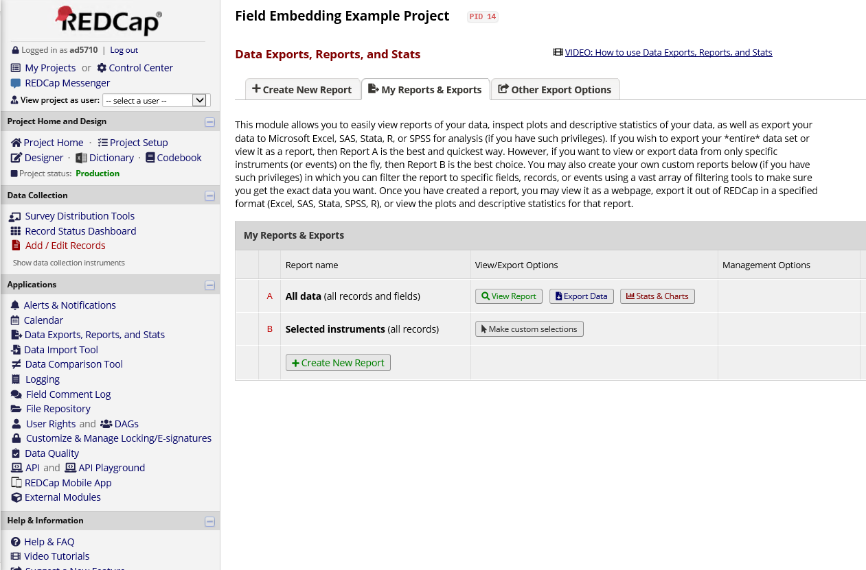

  - Select the format you require and any optional settings before clicking on “Export Data”
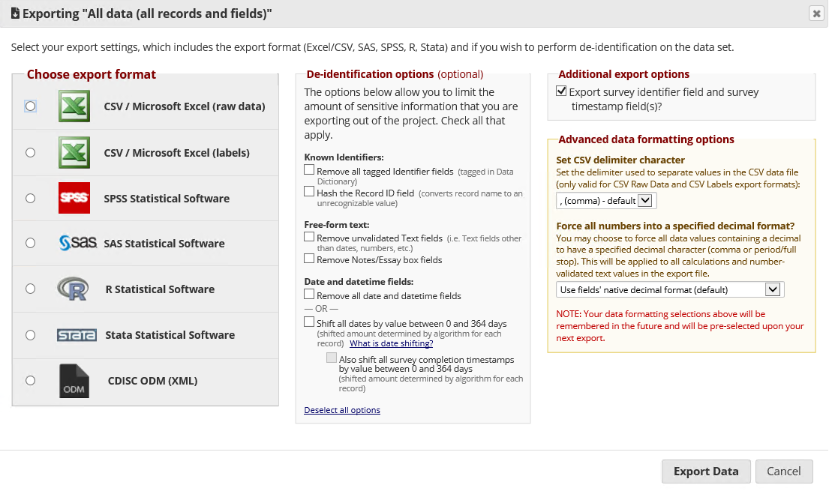

Archiving audit trail (logging)

  - Click on “Logging”
  - Then select “All Logging”

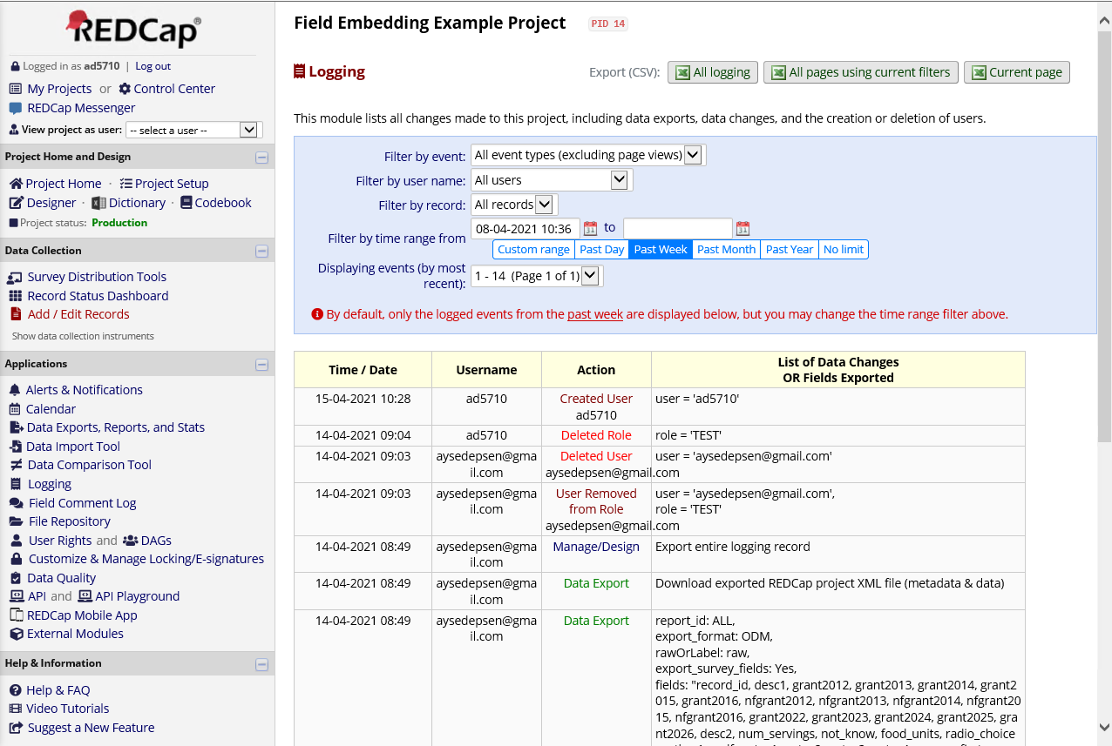

  - Save the file

Archiving of project without data

  - This step can only be performed by users who have ‘Project Design and Setup’ access privileges
  - Click on “Other Functionality” tab
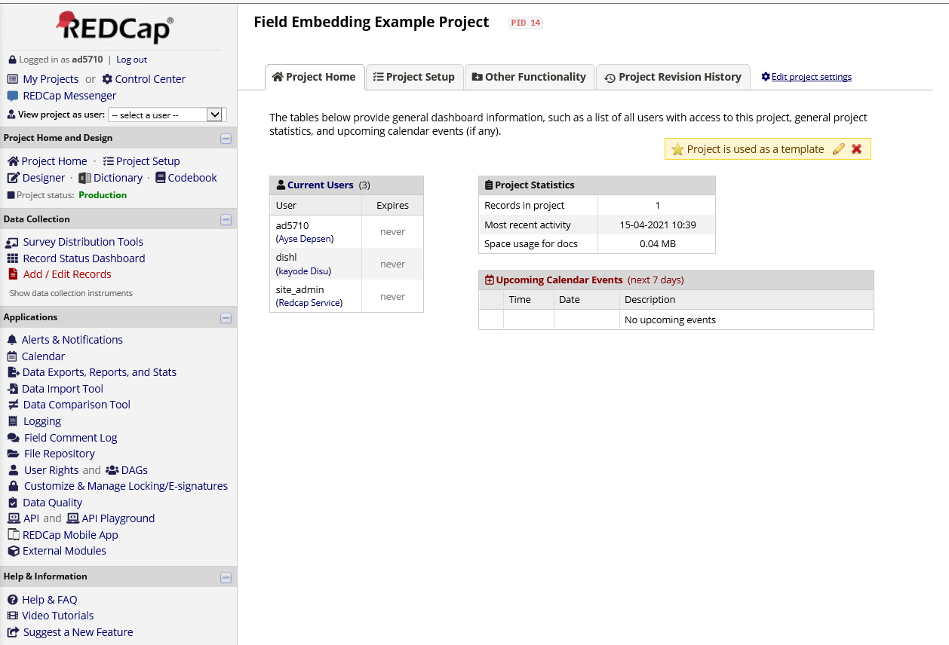

  - Then click on “Download metadata only (XML)”
  - Select save
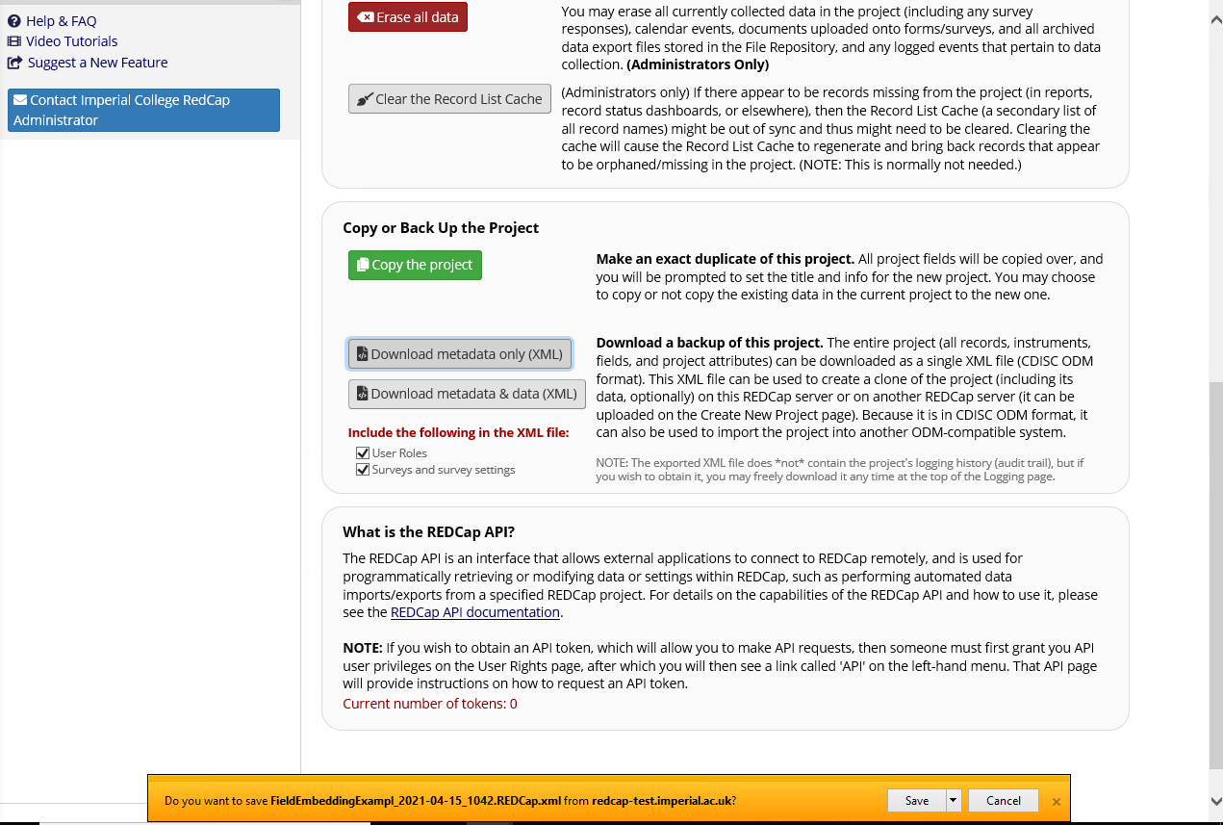

Archiving of project with data

  - This step can only be performed by users who have ‘Project Design and Setup’ access privileges
  - Click on “Other Functionality” tab

  - Then click on “Download metadata & data (XML)”
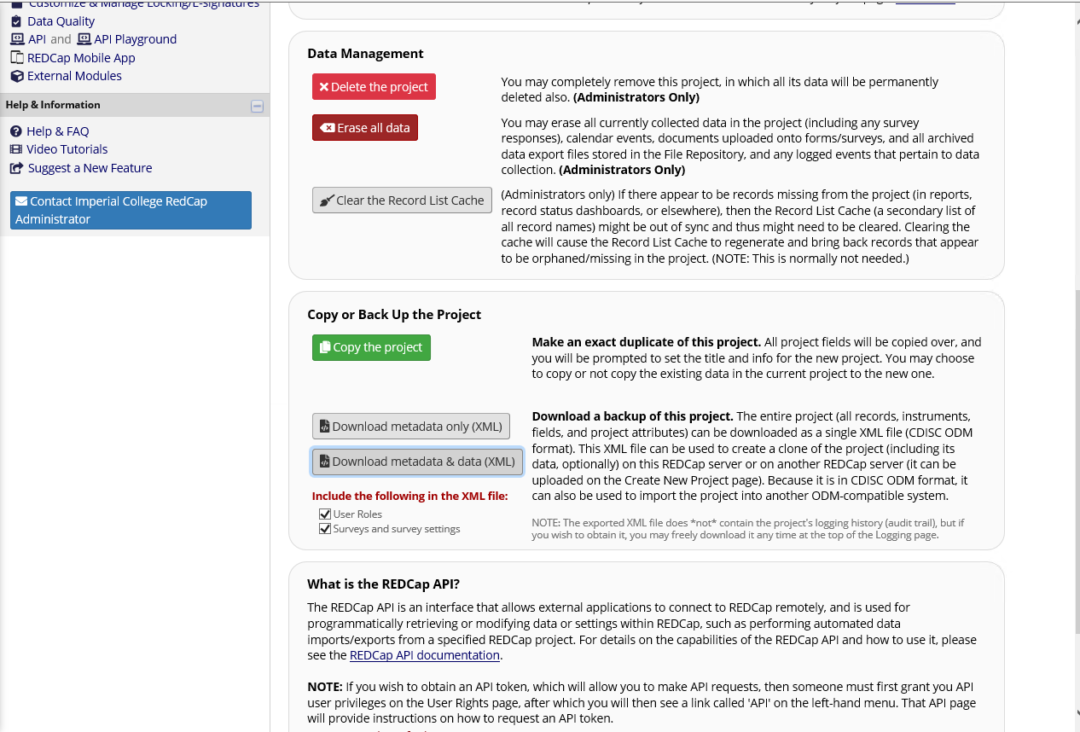
  - Select any options before clicking on “Export Entire Project (metadata & data)”
