# How to import publications from BibTeX

1. Make sure that the file is saved in BibTeX format by opening the .txt file in Notepad and saving it as a .bib file (change ‘Save as type’ from ‘.txt.’ to ‘All files’) 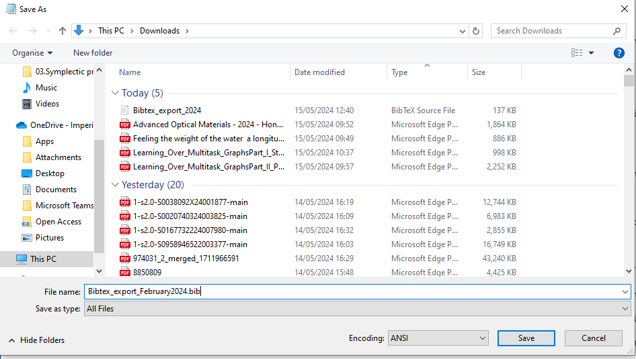
2. If you are depositing on another author’s behalf, impersonate them on Symplectic



1. Go to ‘My Profile’ – ‘Tools’ – ‘Import Publications’ 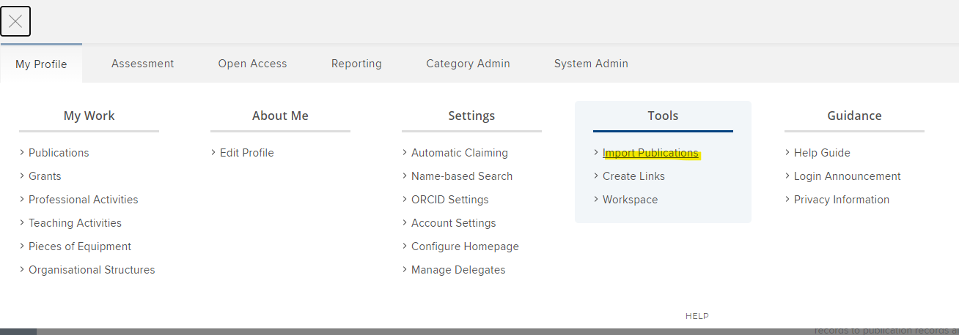
2. Choose the file and click ‘Upload’ 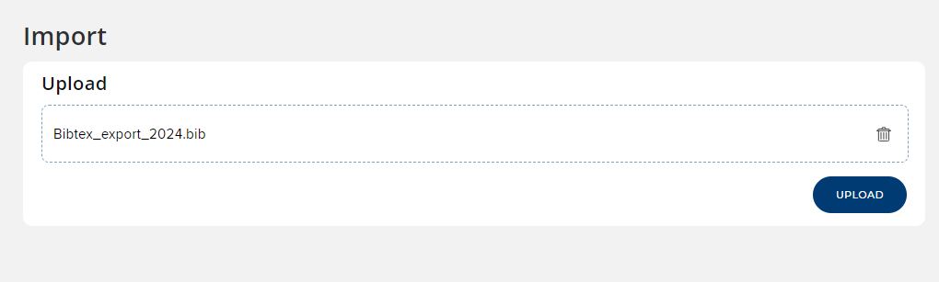
3. For each item in the file, you can choose whether you want to just add a link, create a new publication, add a link to a manual record. You can also skip to ignore the record when there are multiple in the list but you only want to import some. Once you have chosen click ‘Import’.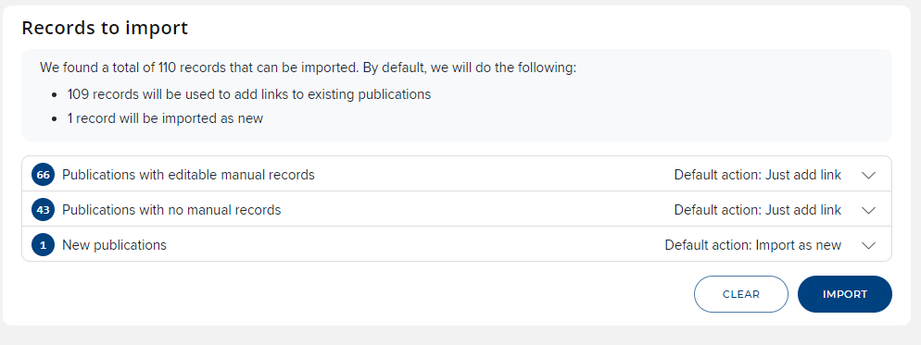
4. The publications should now appear in your ‘My publications’ list on your homepage.



1. From the ‘View all’ page, you can click on each record to deposit files and add/edit a manual record.