Abstract Template for IEPC 2025
First A. Author, and Second B. Author
Business or Academic Affiliation 1, City, State, Zip Code, Country
Third C. Author
Business or Academic Affiliation 2, City, Province, Zip Code, Country

Abstract Submission Instructions (delete before submitting the abstract)
Please follow the guidelines below to ensure your abstract is complete and meets the submission requirements. The abstract must not exceed 2 pages, including figures, tables, and references. All files must be submitted electronically via the submission portal in PDF format. Visit the conference website (https://www.imperial.ac.uk/iepc2025/) for more details.

Motivation and Background
(This section sets the context for your work by identifying its topic area with respect to the conference topics.)
Provide a brief overview of the background and significance of your research. Clearly outline the problem or gap your work addresses and its relevance to the electric propulsion community, particularly within the chosen conference topic area. Include enough detail to convey the focus and importance of your study.

Approach
(This section helps reviewers understand your methodology and the most suitable session for your work.)
Describe the primary methods, techniques, or approaches you are employing to address the identified problem. Emphasize innovative aspects, if any, and provide a concise explanation of why your chosen approach is appropriate for the research question. This will help reviewers group your work with similar studies in the appropriate session.

Preliminary and/or Anticipated Results
(This section informs reviewers of your progress and expected contributions by the full-length paper deadline.)
Summarize any preliminary findings or expected outcomes of your study. If your work is still in progress, outline the results you anticipate achieving and their potential impact. Be specific but concise, highlighting how your results contribute to advancing the field.

Conclusion
(A conclusion is not mandatory, but is encouraged if it provides additional context for your anticipated results.)
Use this section to briefly discuss the broader implications of your research or future directions, if applicable. Alternatively, you may elaborate on the planned work and anticipated outcomes. You can focus on how your study aligns with the general theme of the IEPC 2025 – “Electric Propulsion, a Gateway to the Cosmos.”

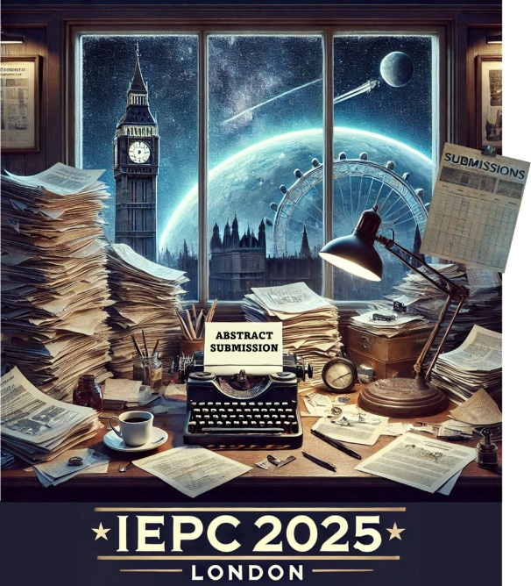
Figure 1: You may decide to include a figure or two.

Key dates
Abstract deadline | 1 March 2025
Notification of acceptance | End of May 2025
Table 1: You may also decide to include a table.

References:
[To update the reference list, use the table format. Add rows as needed via the Table Layout tab, and insert cross-references in the text through the References tab using the options Numbered Item and **Paragraph number (no context).] (delete before submitting the abstract)
F Lastname1, F Lastname2, F Lastname3 et al., “title,” Journal/Conference Proceeding Vol. No. (date)
F Lastname1, F Lastname2, F Lastname3 et al., “title,” Journal/Conference Proceeding Vol. No. (date)

Insert Job Title, Department Name (if any), Email address for first author
Insert Job Title, Department Name (if any), Email address for second author
Insert Job Title, Department Name (if any), Email address for third author

