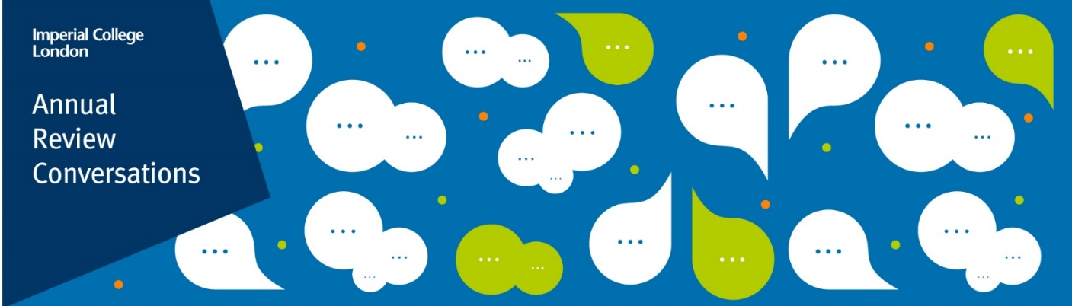
Guided Personal Reflection
How to use this document
This document has been created to guide your personal reflections ahead of an Annual Review Conversation (ARC). This is not a mandatory part of the ARC process and is a completely optional tool that may be helpful to some.

You don’t have to answer all the questions. If the question does not work for you then skip over it. Use this document as a starting point for what you would like to reflect on for your ARC.

If you prefer to take notes more visually e.g., as a mindmap, then use a separate piece of paper for your reflection notes.

My goals for my next Annual Review Conversation:

Topic | Reflection Questions | Reflection Notes
Review: performance and previous objectives | - What have you delivered and contributed to in the past year including with regard to your objectives? well.  - Which aspects of your work and contribution(s) are you particularly proud of and why?  - How does your work further the department / faculty / College strategy?
Reflect: reflections and learning from the previous year | - What skills and strengths have contributed to your achievements in the last year?  - What from the last year would you do differently?  - What feedback have you received in the last year? How did it make you feel and what did you learn from it?  - What elements of your role have you found most rewarding?  - What challenges did you face, and how did you overcome them?
Working well: wellbeing, workload and support needs | - What about your wellbeing and workload enables and inhibits you to work at your best for the year ahead?  - What support, resources, or changes in your work environment would help you maintain a positive wellbeing?
Career: career support, aspirations and development needs | - What do you most enjoy in your role that you would want to keep doing?  - What are your ambitions for the future?  - What are your thoughts on your career in the future? Where do you see yourself?  - How does your current role fit in with your career goals?  - What do you want to learn about/be able to do? What difference will this make in your current role / working towards a future career move?
Plan: objective setting and work planning | - What do you need clarity on for your work plan for the year ahead?  - What support or resources do you need to achieve your objectives effectively?
Imperial.ac.uk/staff-development | POD_Imperial
Level 5, Sherfield Building, London SW7 2AZ

